**Appendix A**

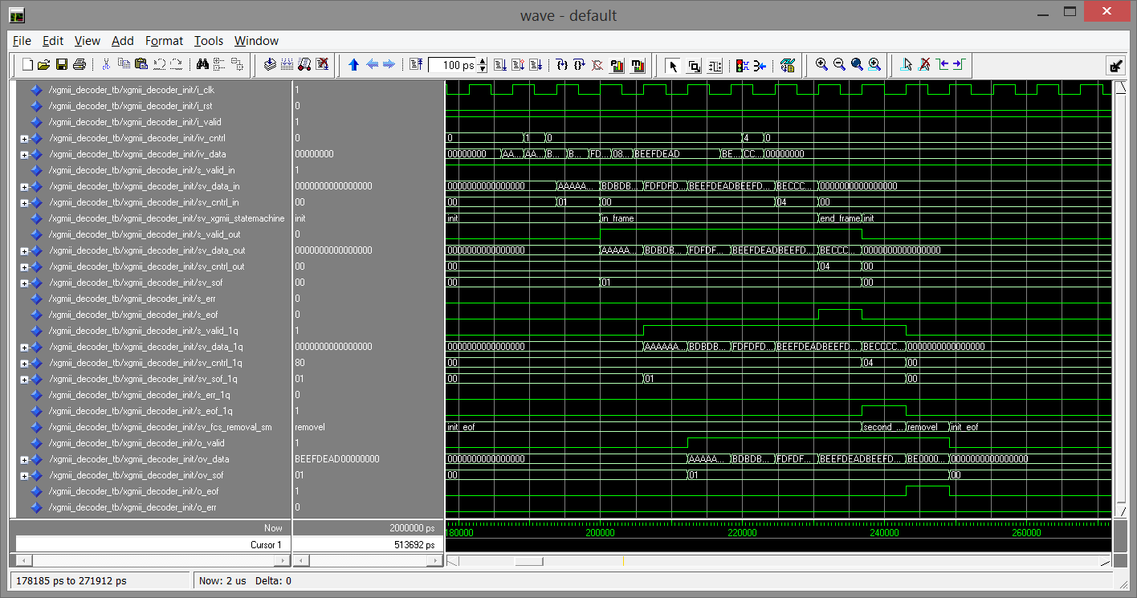

XGMII FCS Removal FSM Test Case 0, Test Frame 2

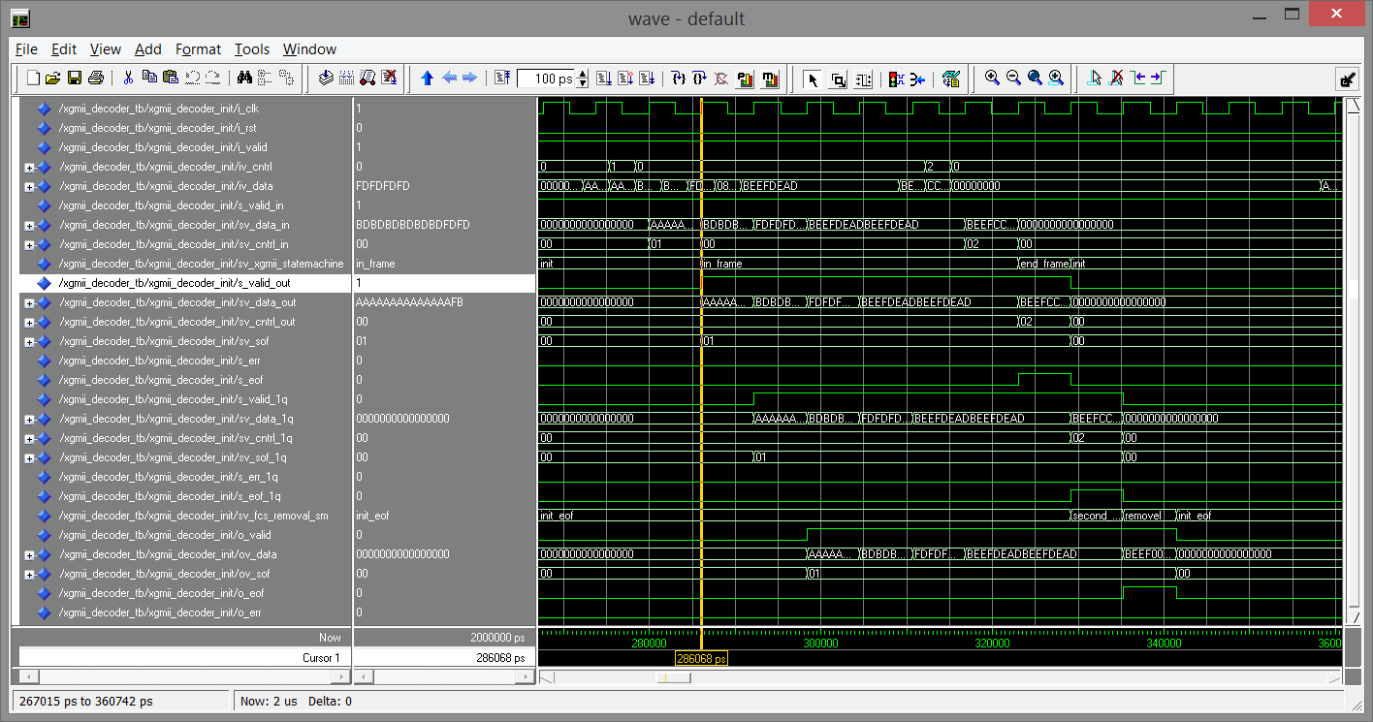

XGMII FCS Removal FSM Test Case 0, Test Frame 3

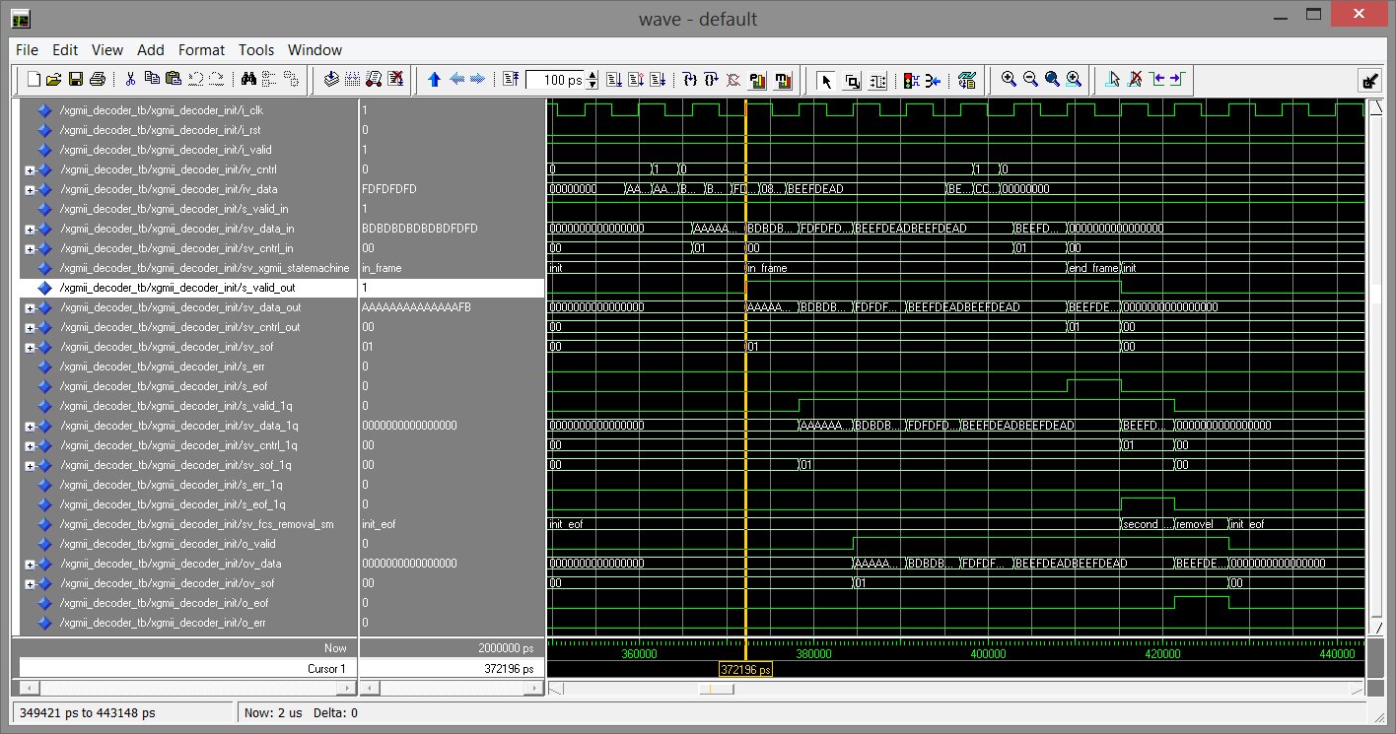

XGMII FCS Removal FSM Test Case 0, Test Frame 4

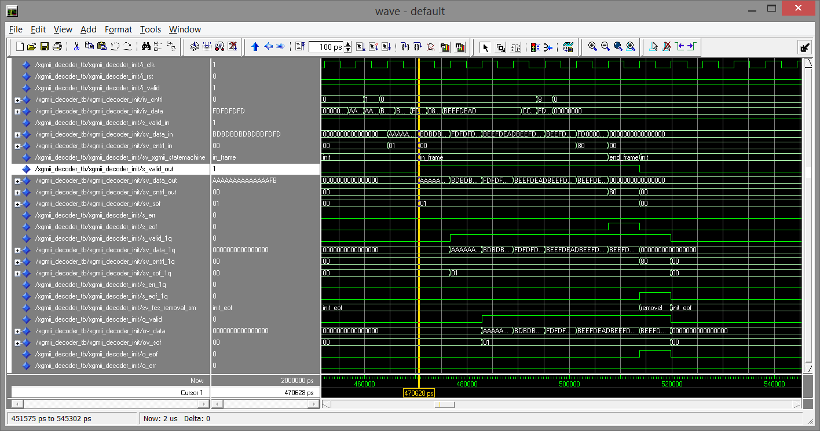

XGMII FCS Removal FSM Test Case 0, Test Frame 5

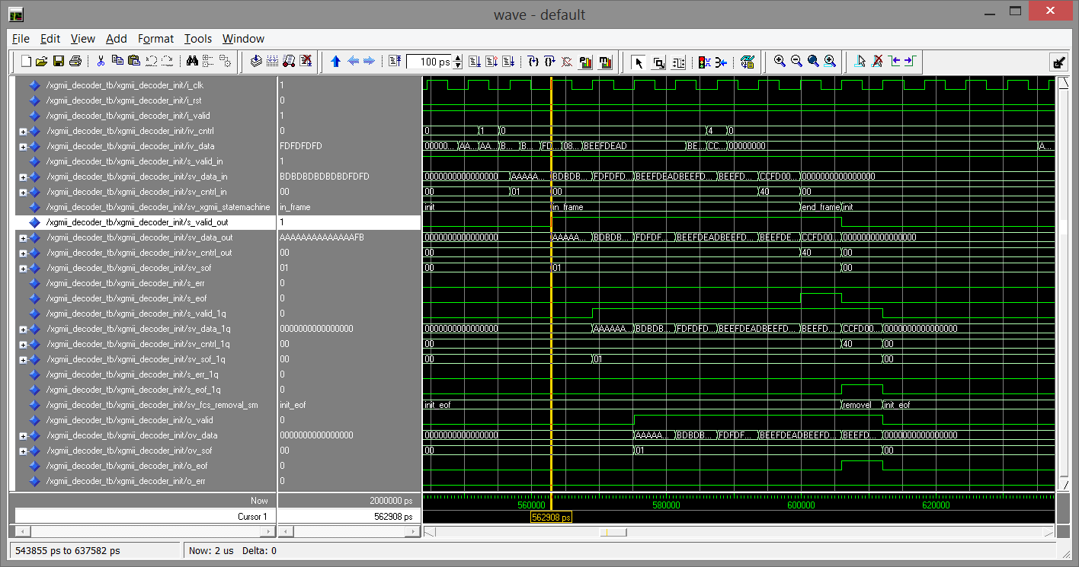

XGMII FCS Removal FSM Test Case 0, Test Frame 6

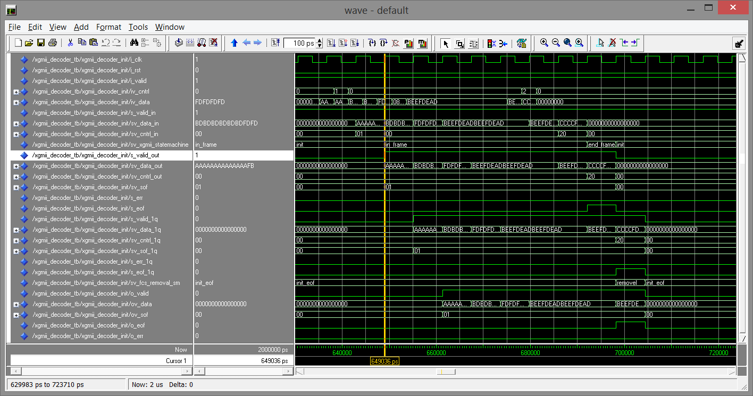

XGMII FCS Removal FSM Test Case 0, Test Frame 7

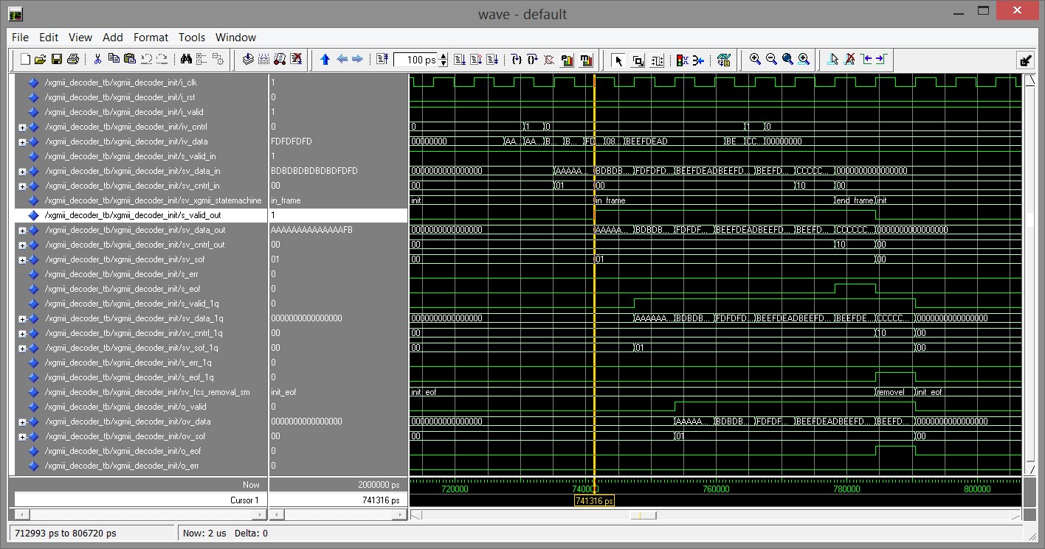

XGMII FCS Removal FSM Test Case 0, Test Frame 8

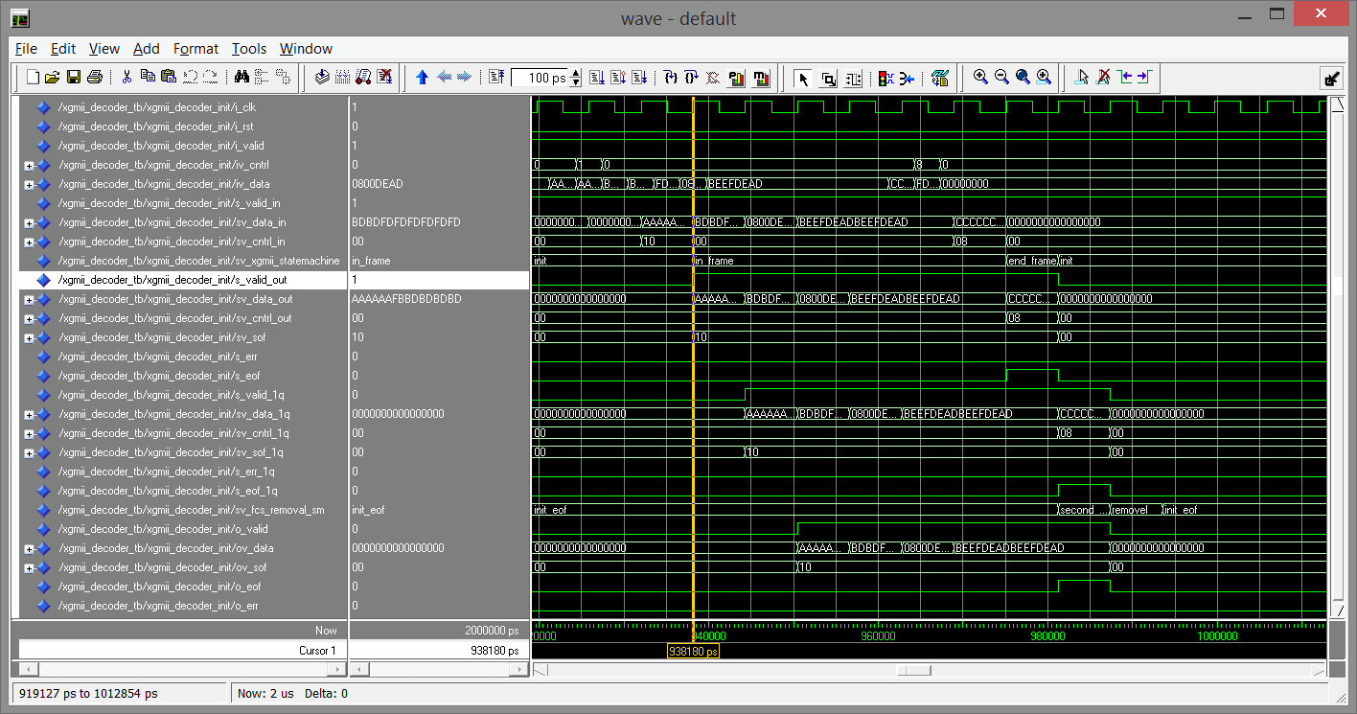

XGMII FCS Removal FSM Test Case 0, Test Frame 9

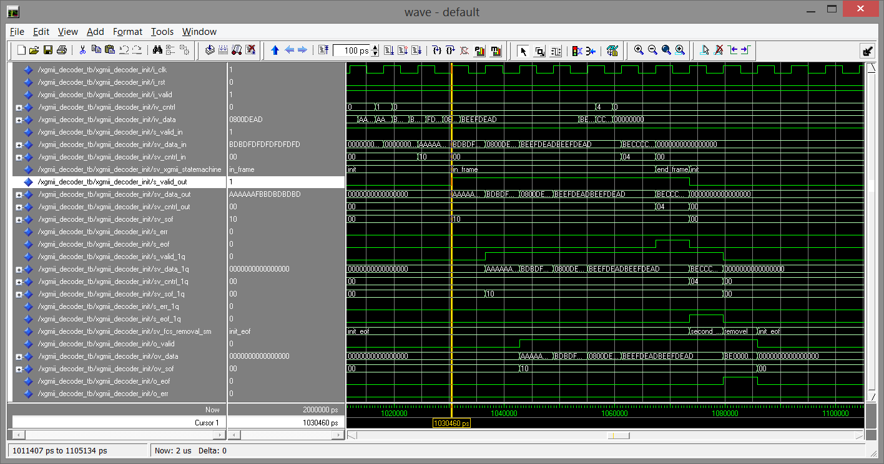

XGMII FCS Removal FSM Test Case 0, Test Frame 10

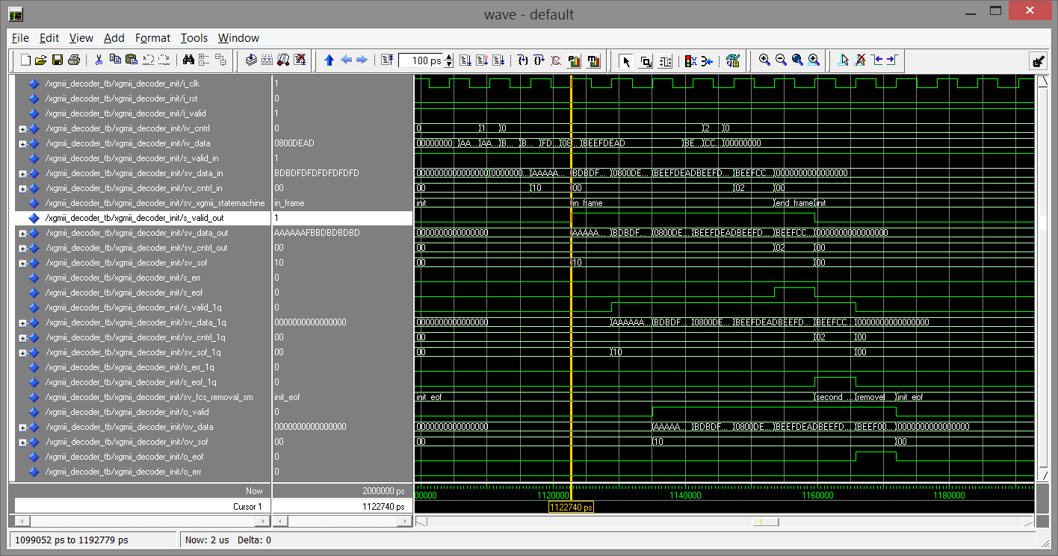

XGMII FCS Removal FSM Test Case 0, Test Frame 11

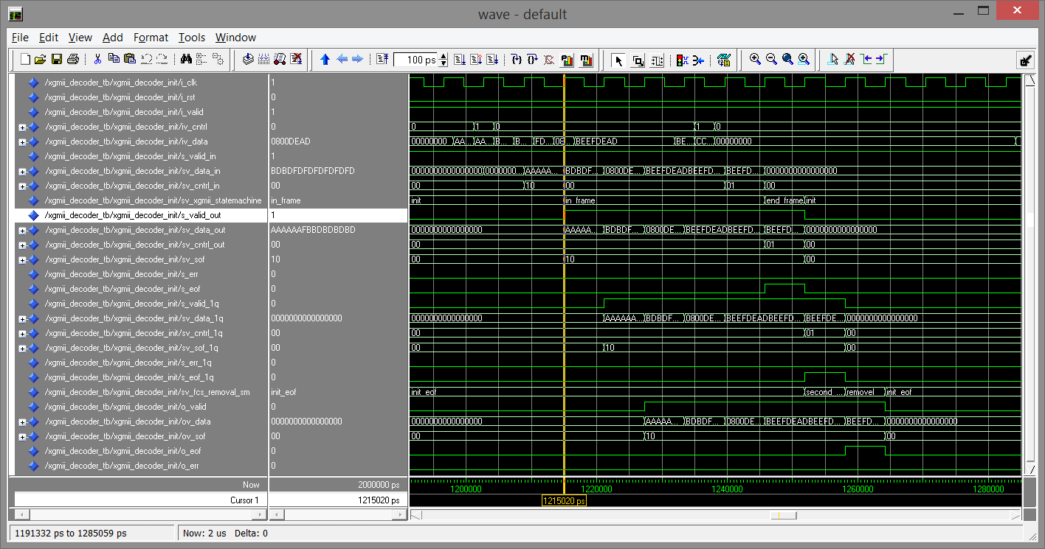

XGMII FCS Removal FSM Test Case 0, Test Frame 12

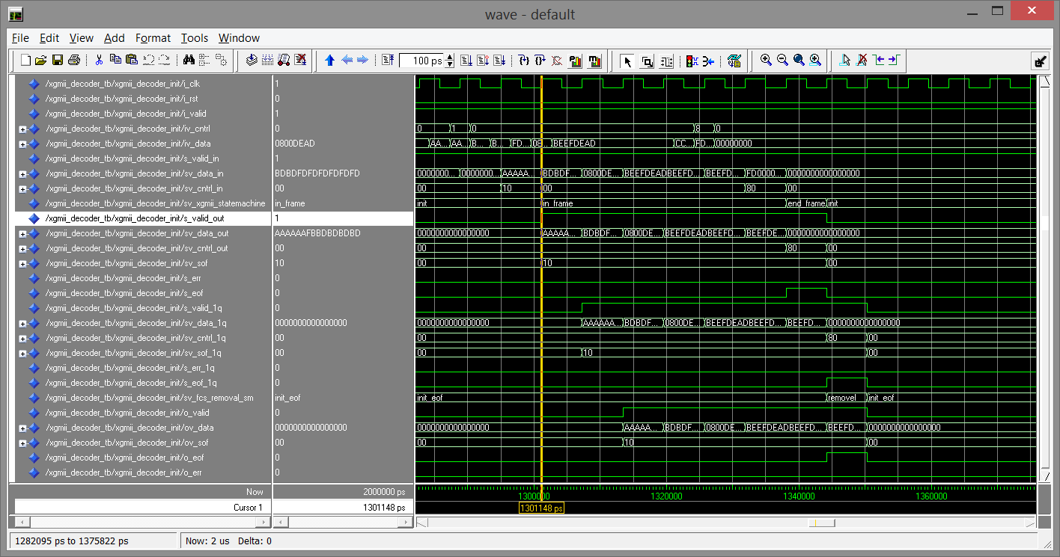

XGMII FCS Removal FSM Test Case 0, Test Frame 13

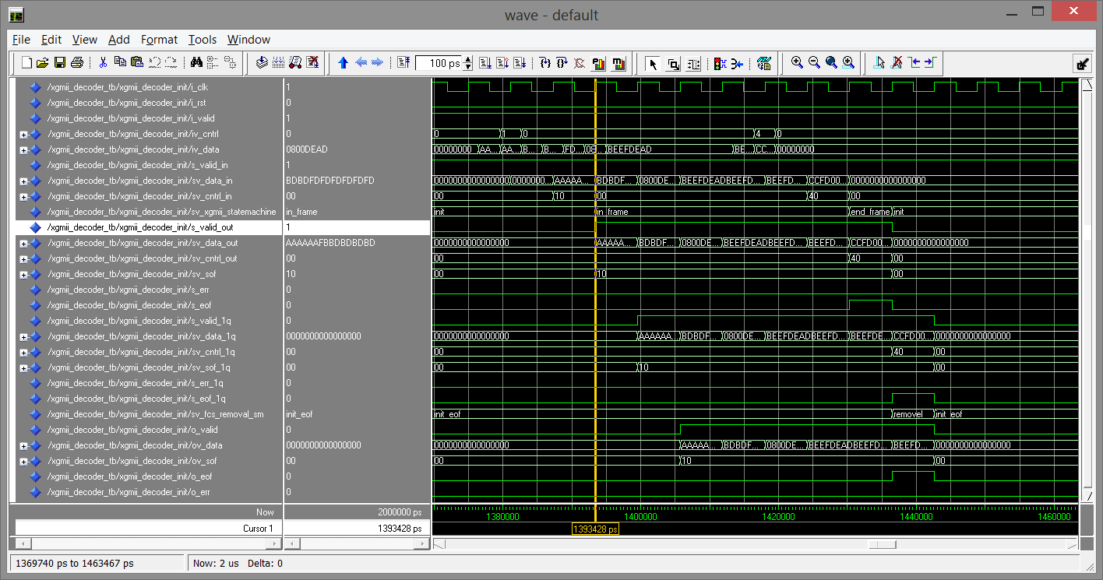

XGMII FCS Removal FSM Test Case 0, Test Frame 14

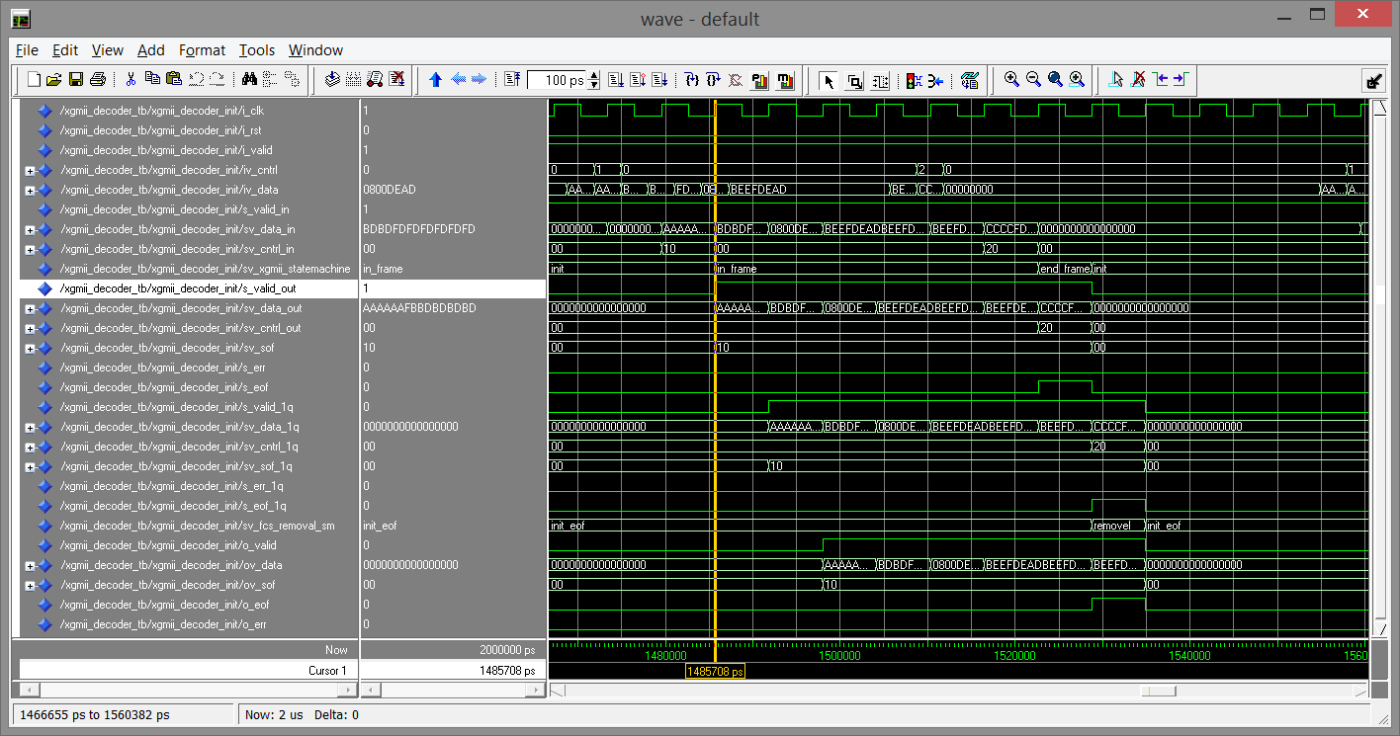

XGMII FCS Removal FSM Test Case 0, Test Frame 15

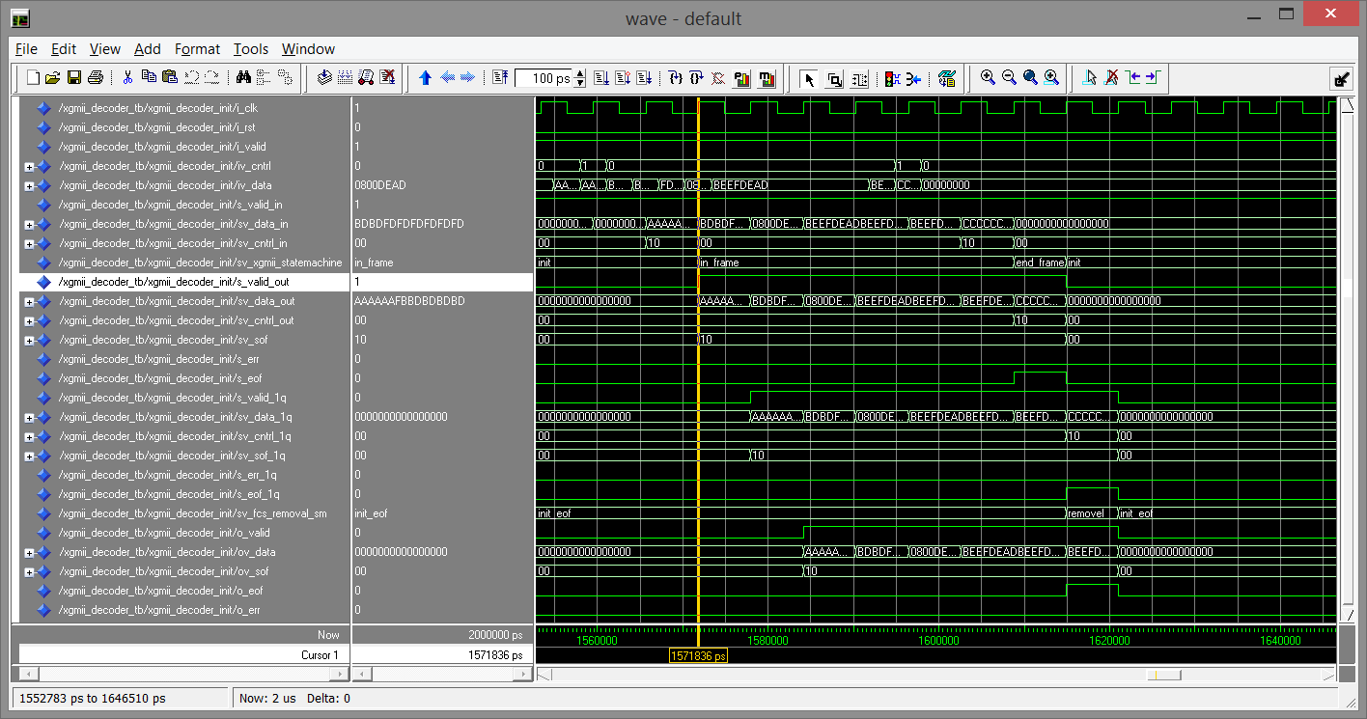

XGMII FCS Removal FSM Test Case 0, Test Frame 16

**Appendix B**

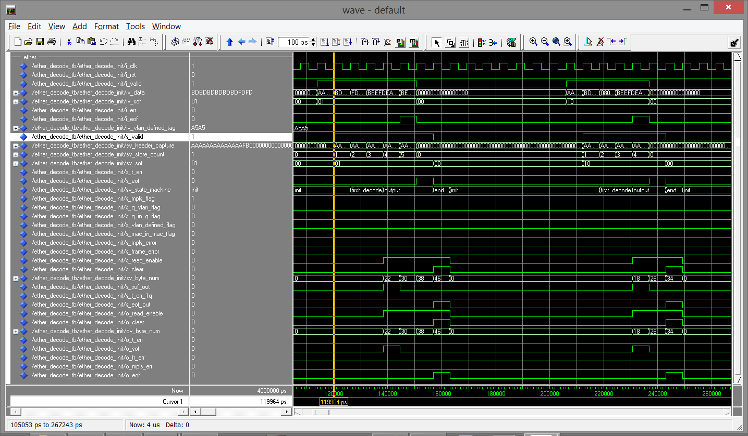

Ether-type FSM Test Case 0, Test Frame 1 and 2

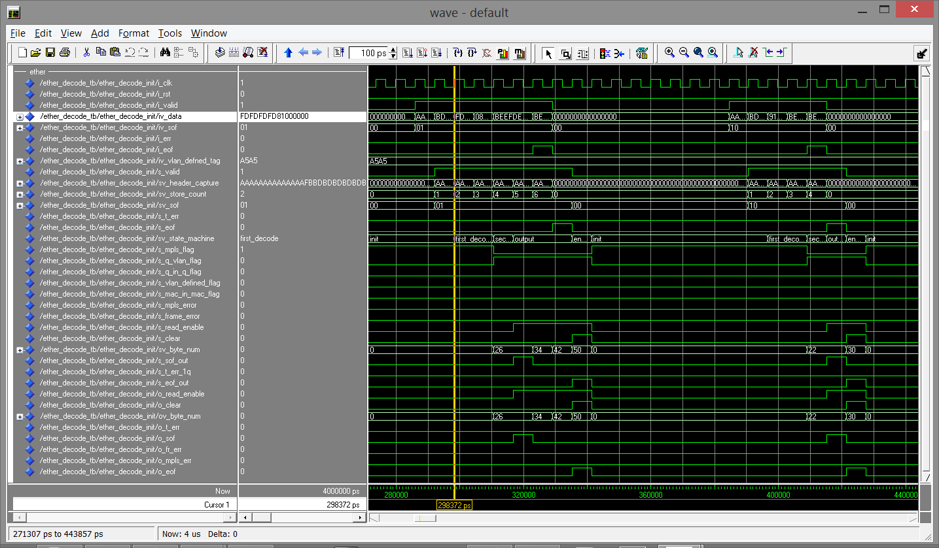

Ether-type FSM Test Case 0, Test Frame 3 and 4

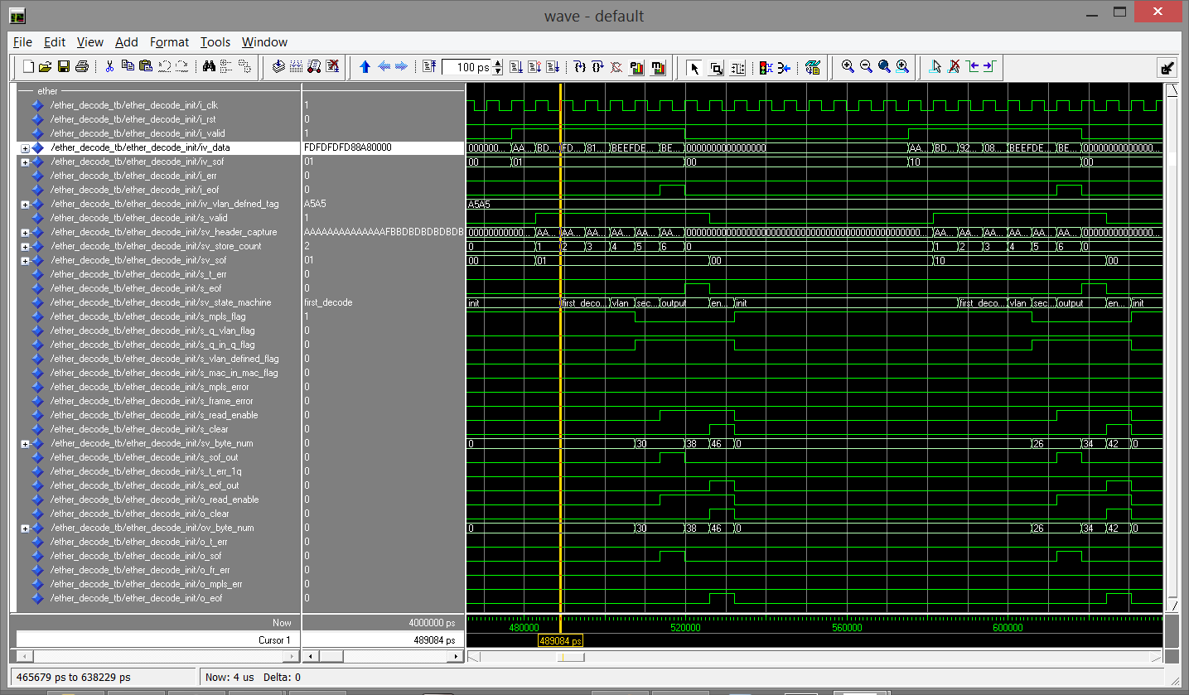

Ether-type FSM Test Case 0, Test Frame 5 and 6

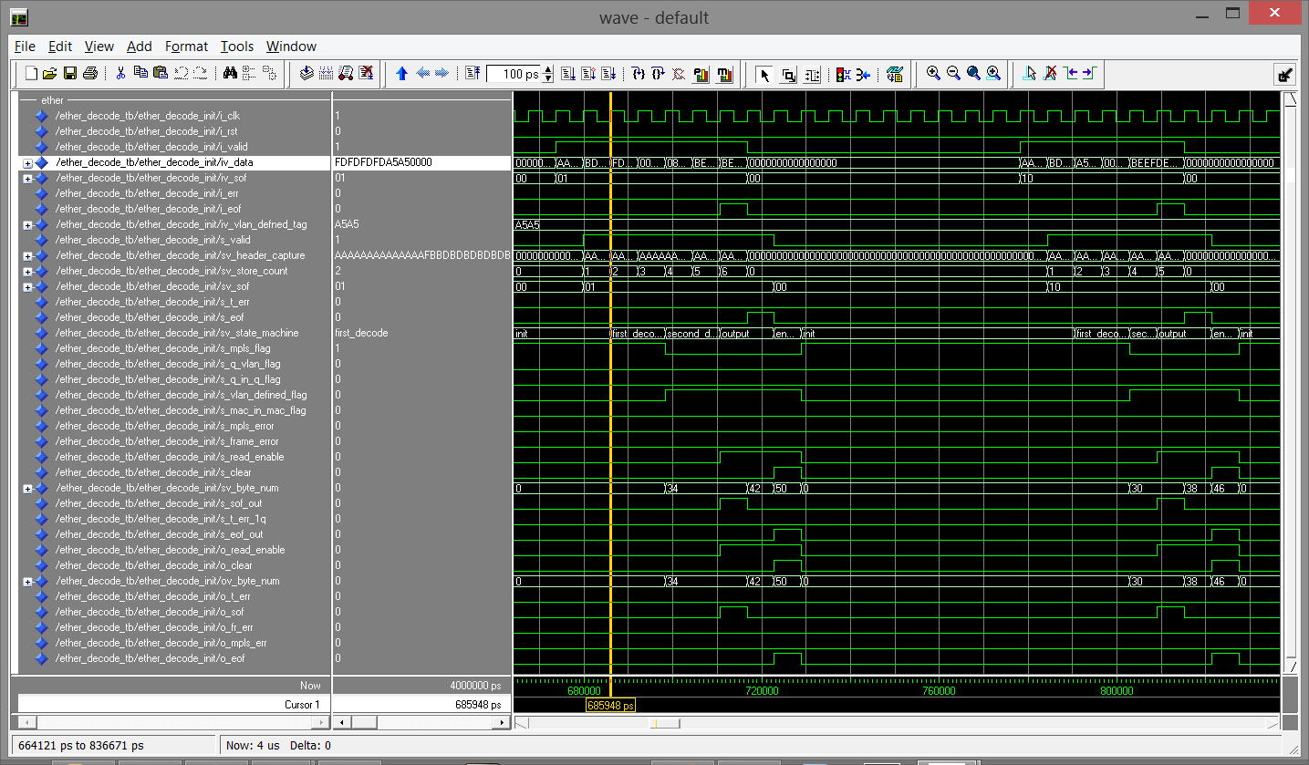

Ether-type FSM Test Case 0, Test Frame 7 and 8

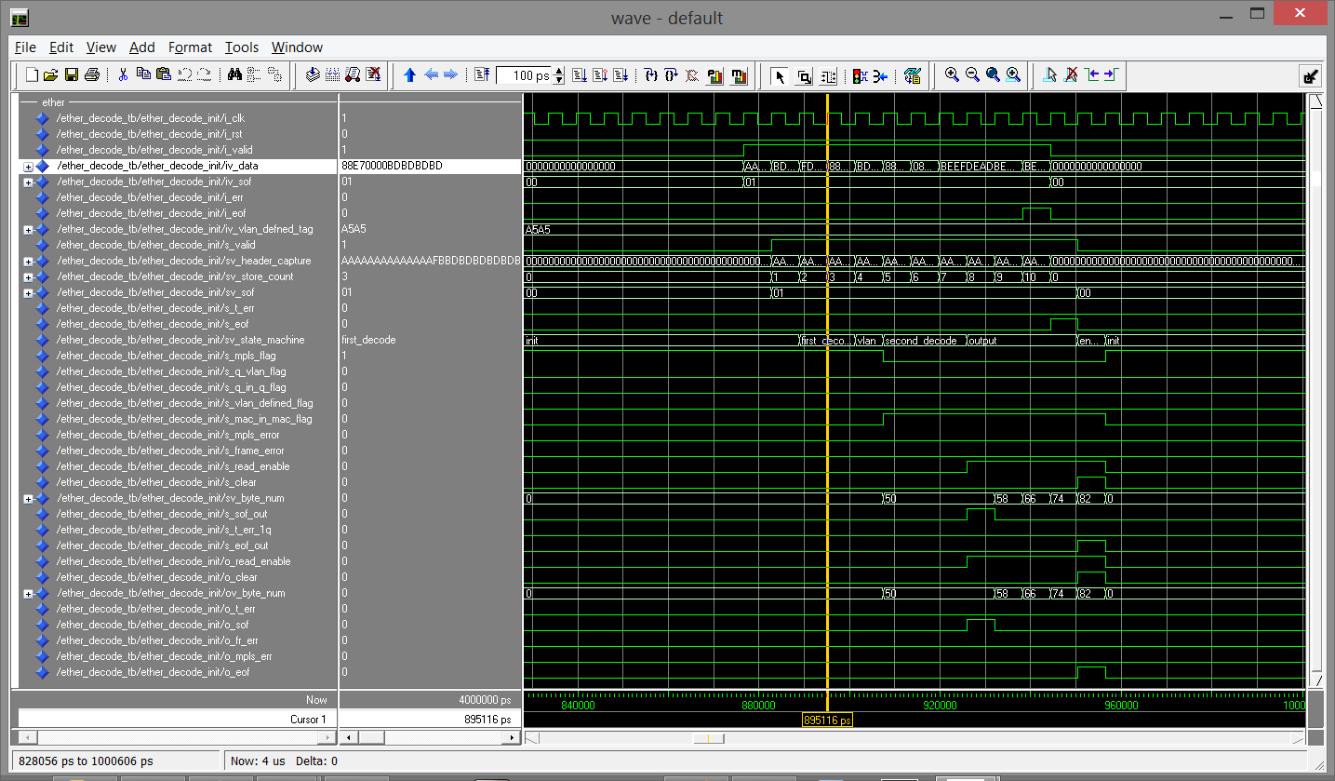

Ether-type FSM Test Case 0, Test Frame 9

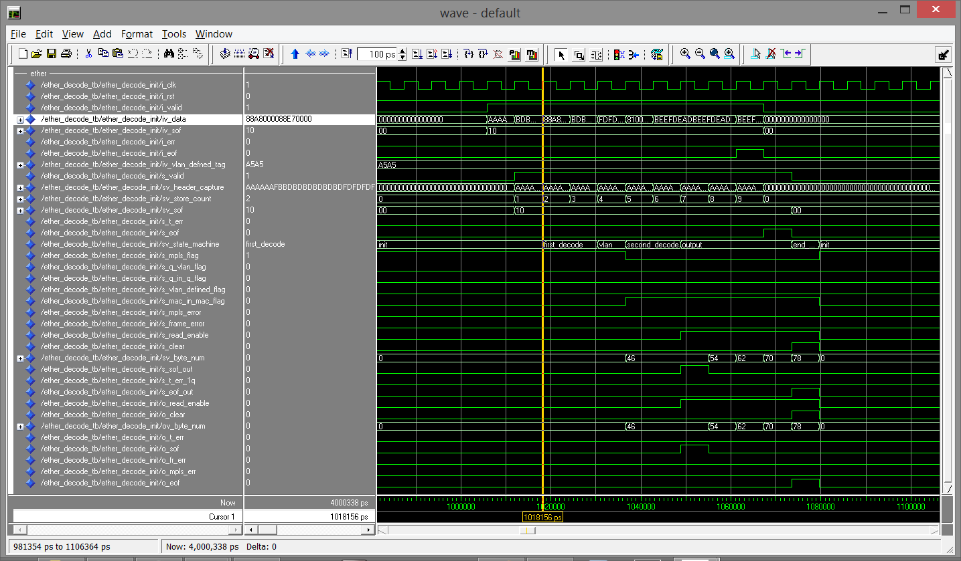

Ether-type FSM Test Case 0, Test Frame 10

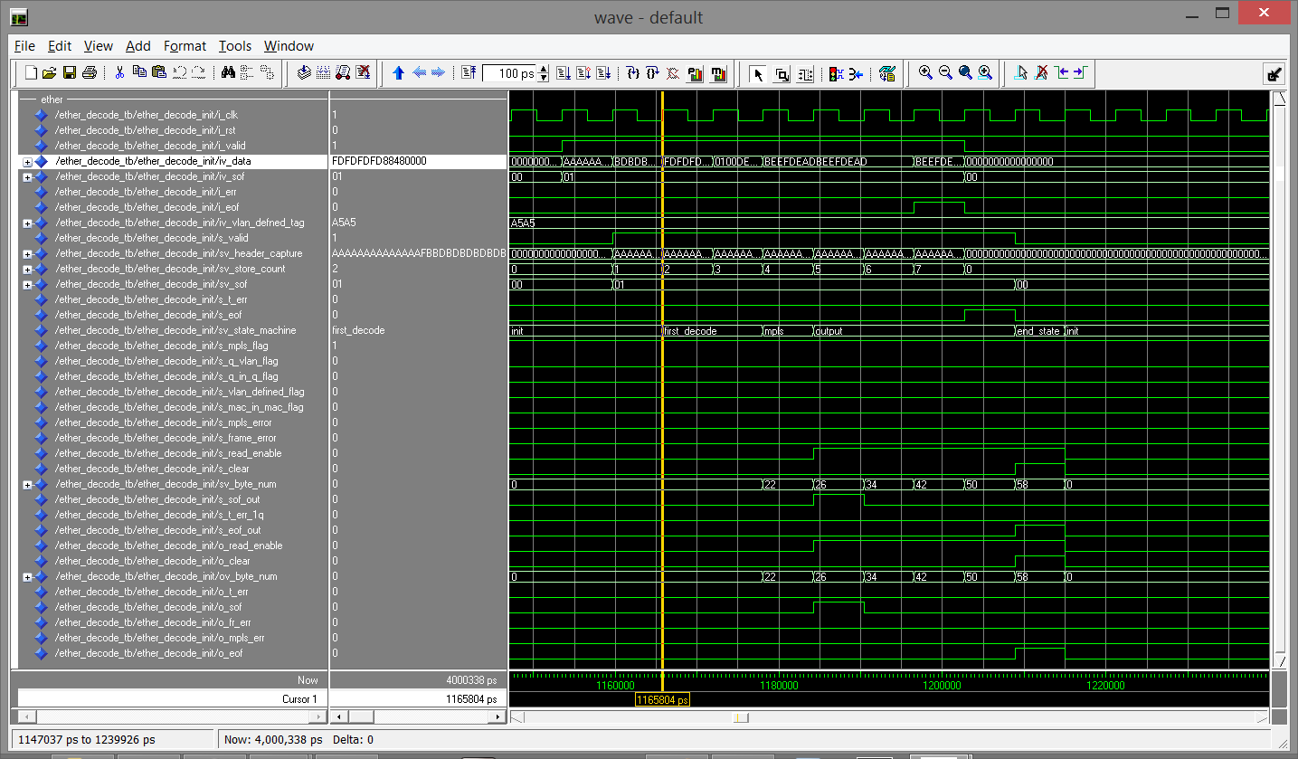

Ether-type FSM Test Case 0, Test Frame 11

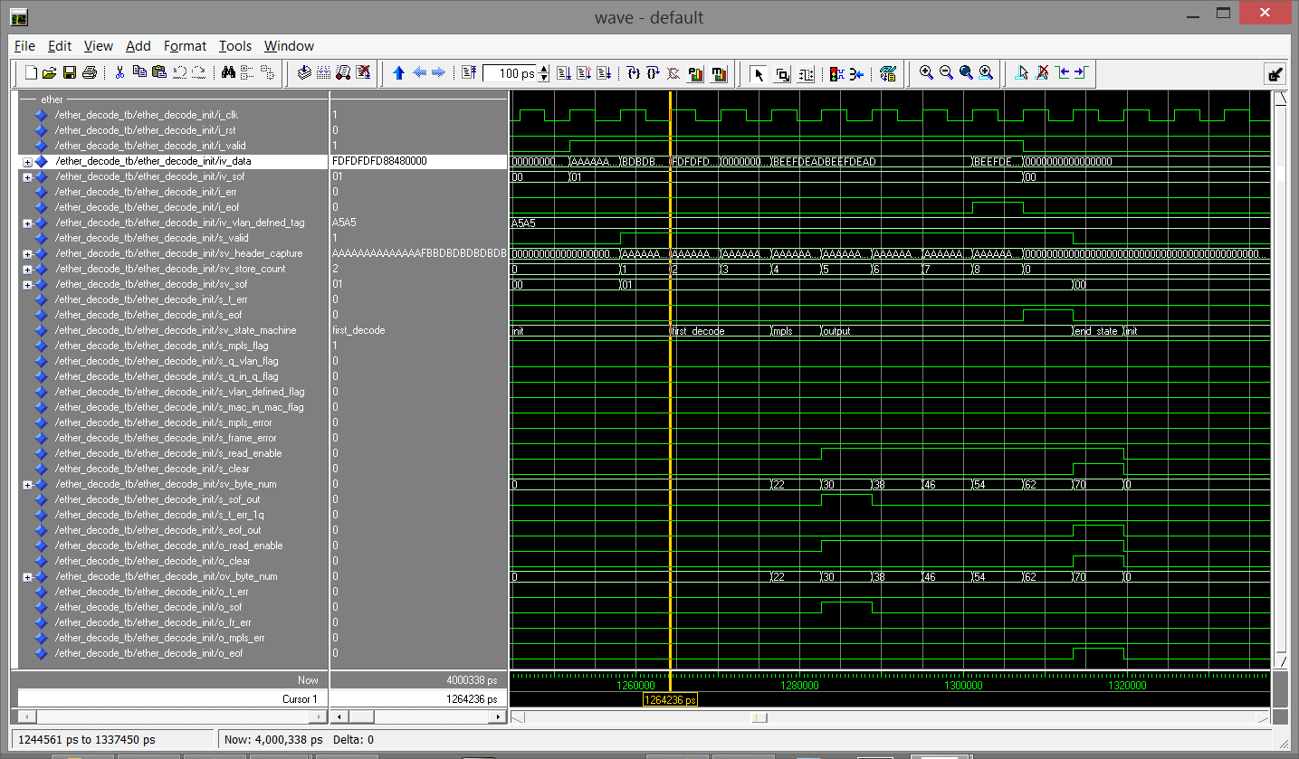

Ether-type FSM Test Case 0, Test Frame 12

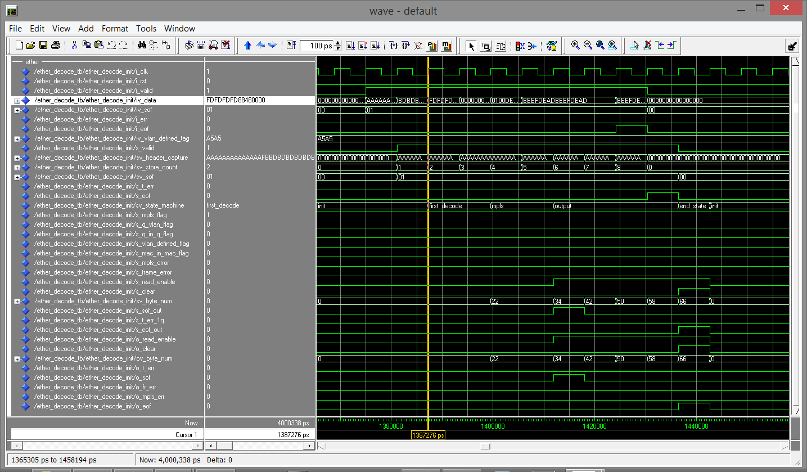

Ether-type FSM Test Case 0, Test Frame 13

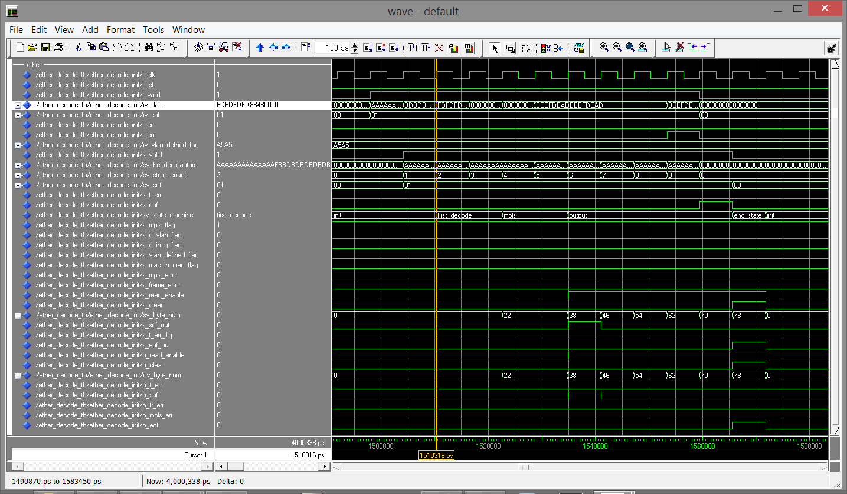

Ether-type FSM Test Case 0, Test Frame 14

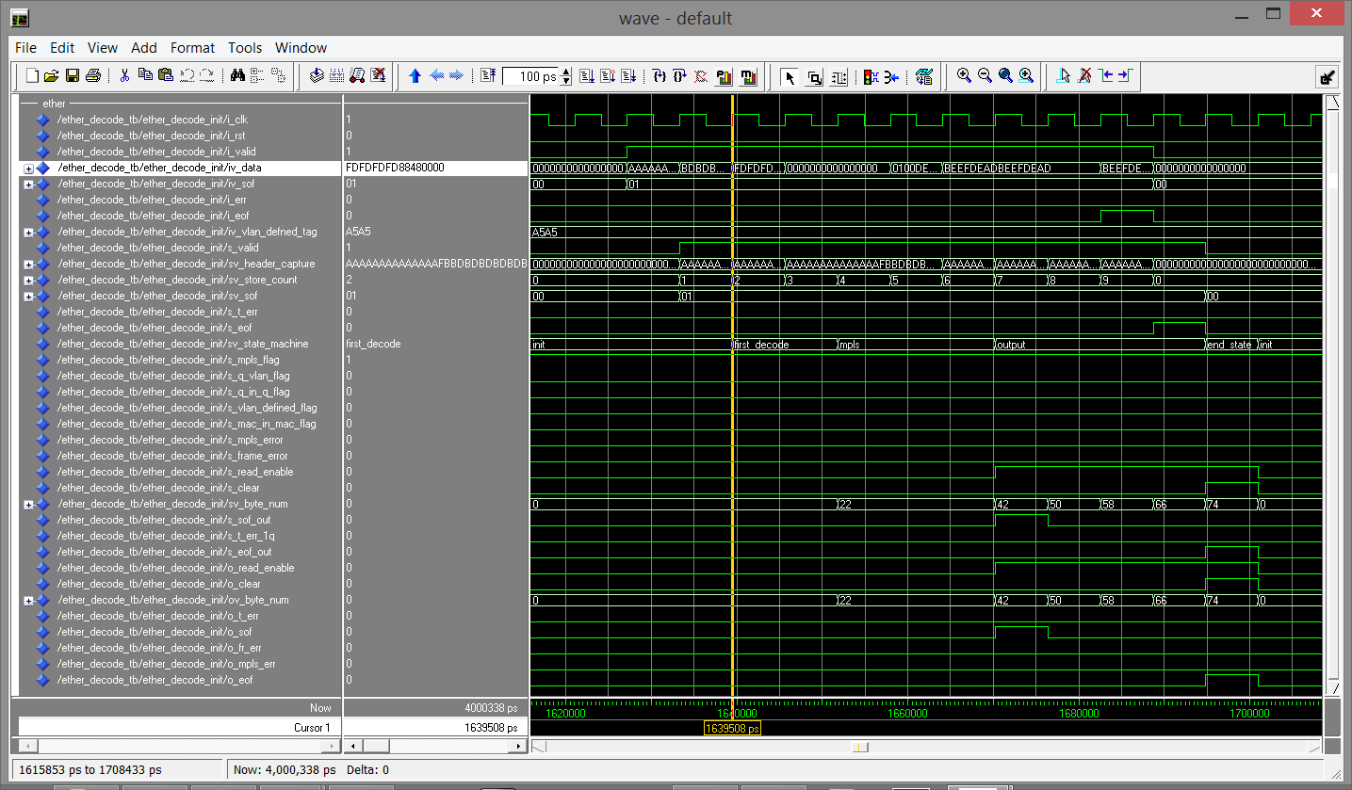

Ether-type FSM Test Case 0, Test Frame 15

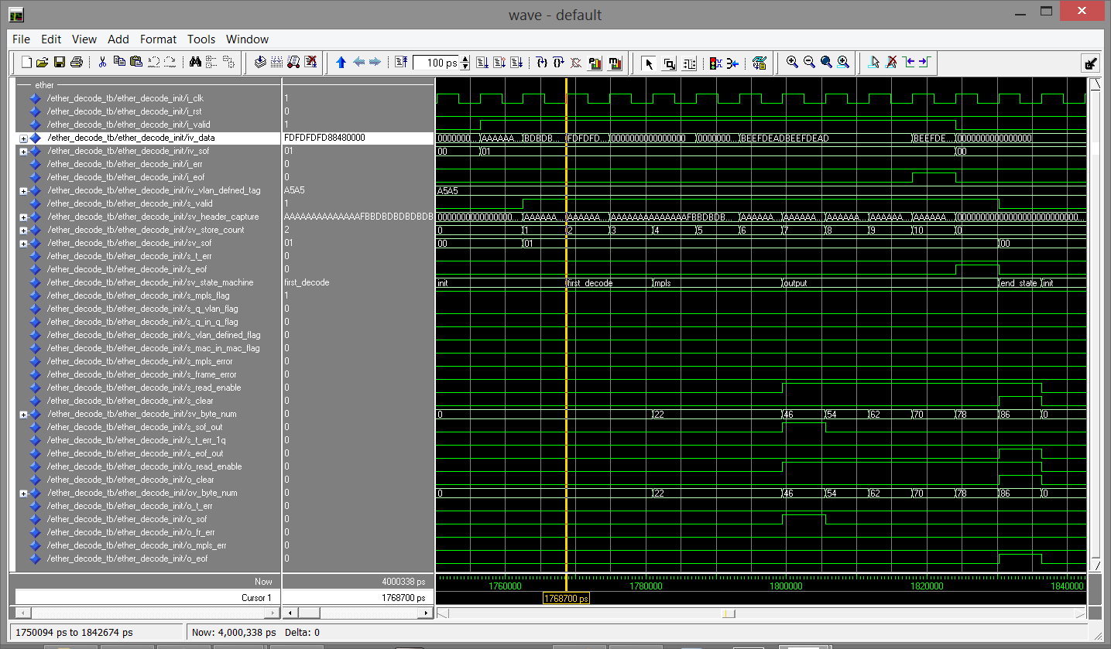

Ether-type FSM Test Case 0, Test Frame 16

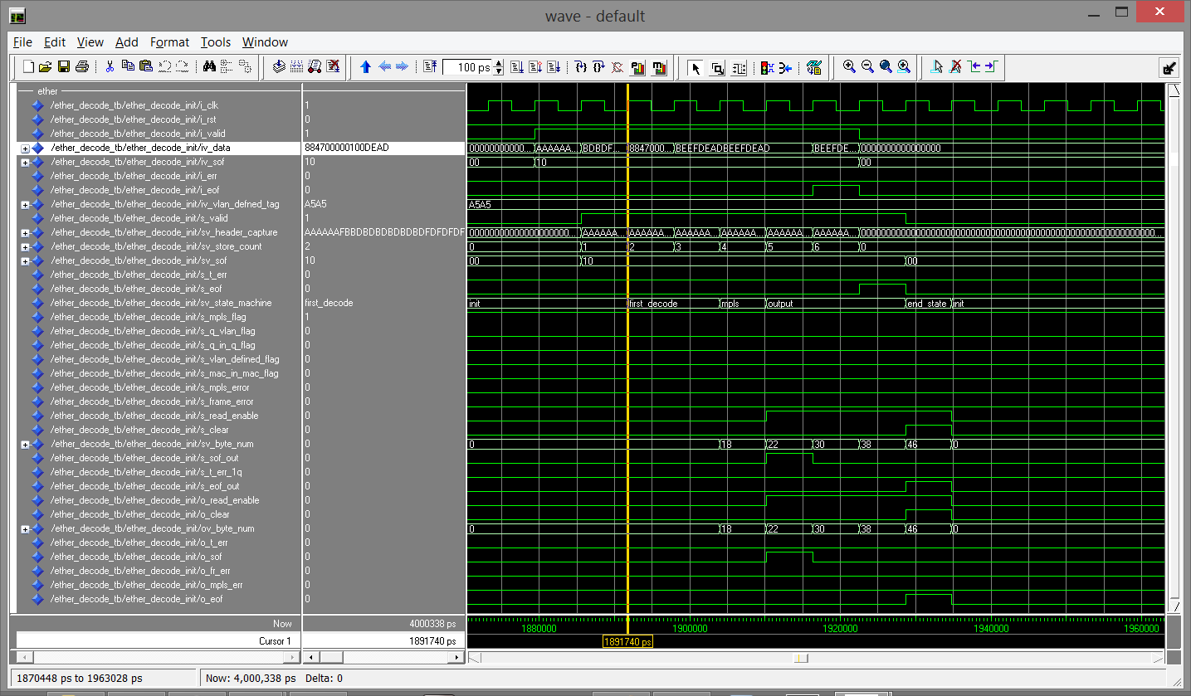

Ether-type FSM Test Case 0, Test Frame 17

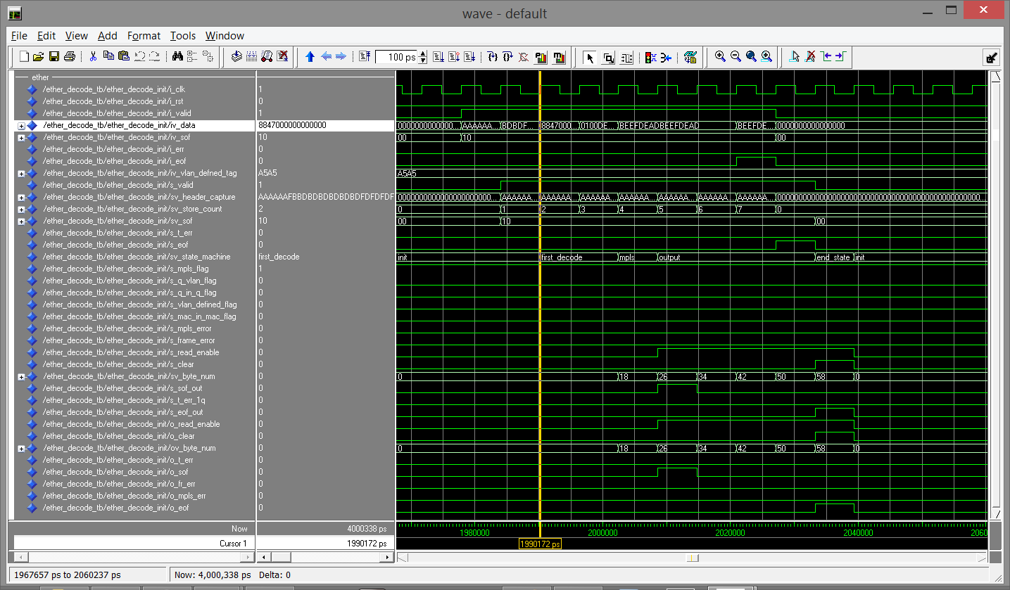

Ether-type FSM Test Case 0, Test Frame 18

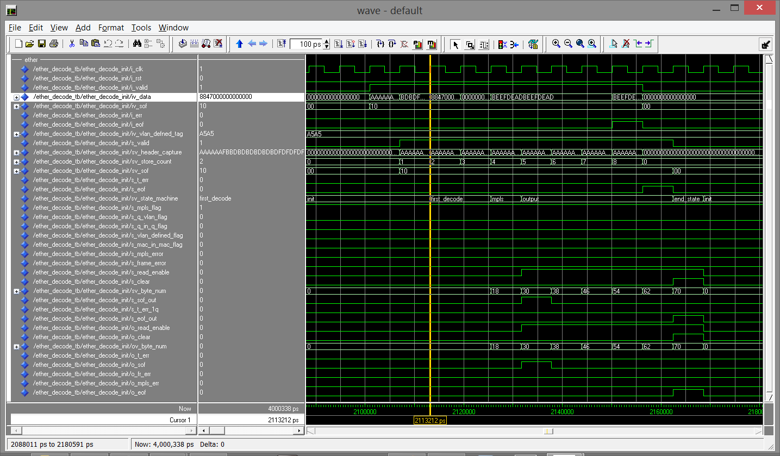

Ether-type FSM Test Case 0, Test Frame 19

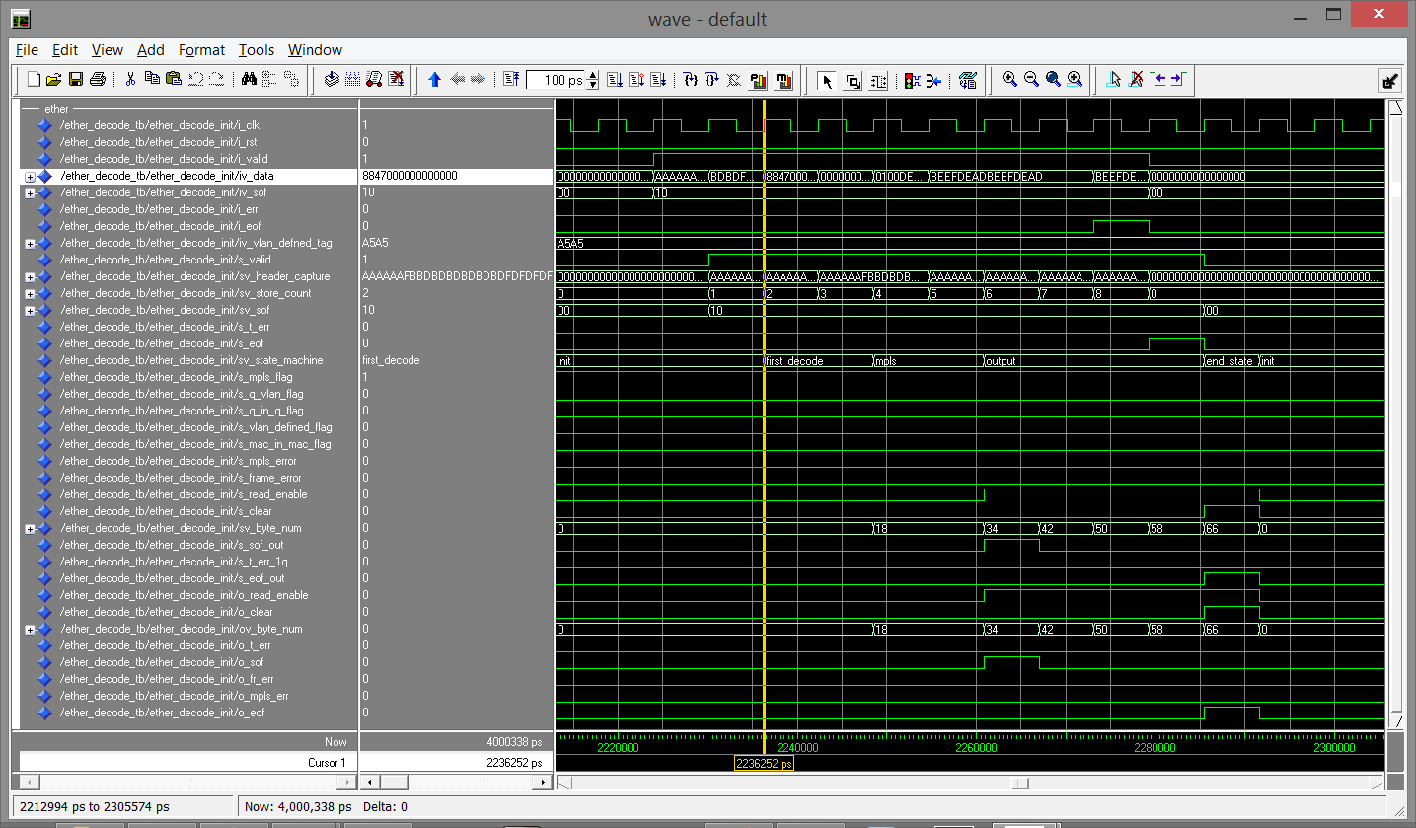

Ether-type FSM Test Case 0, Test Frame 20

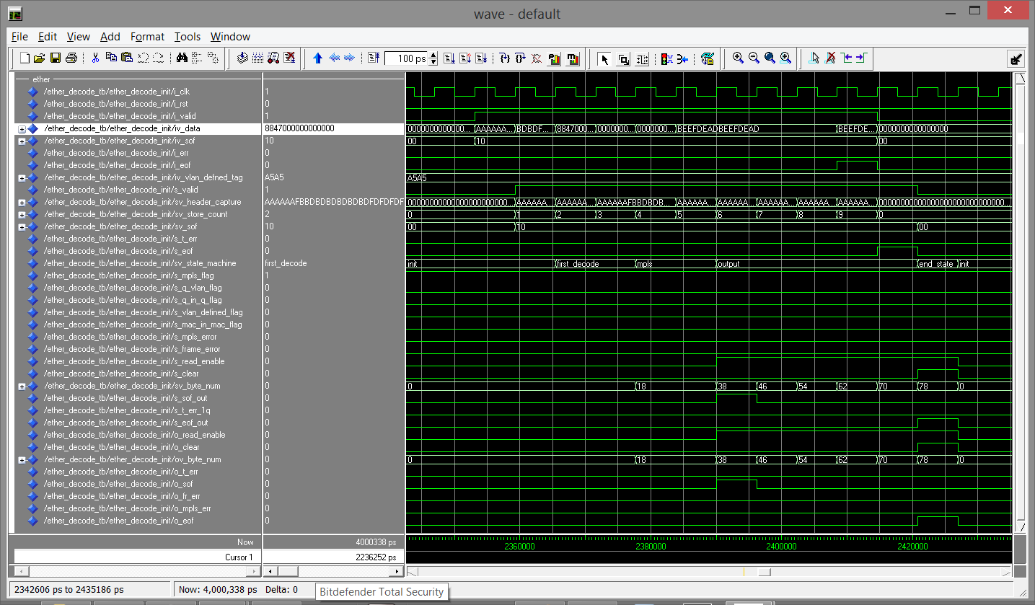

Ether-type FSM Test Case 0, Test Frame 21

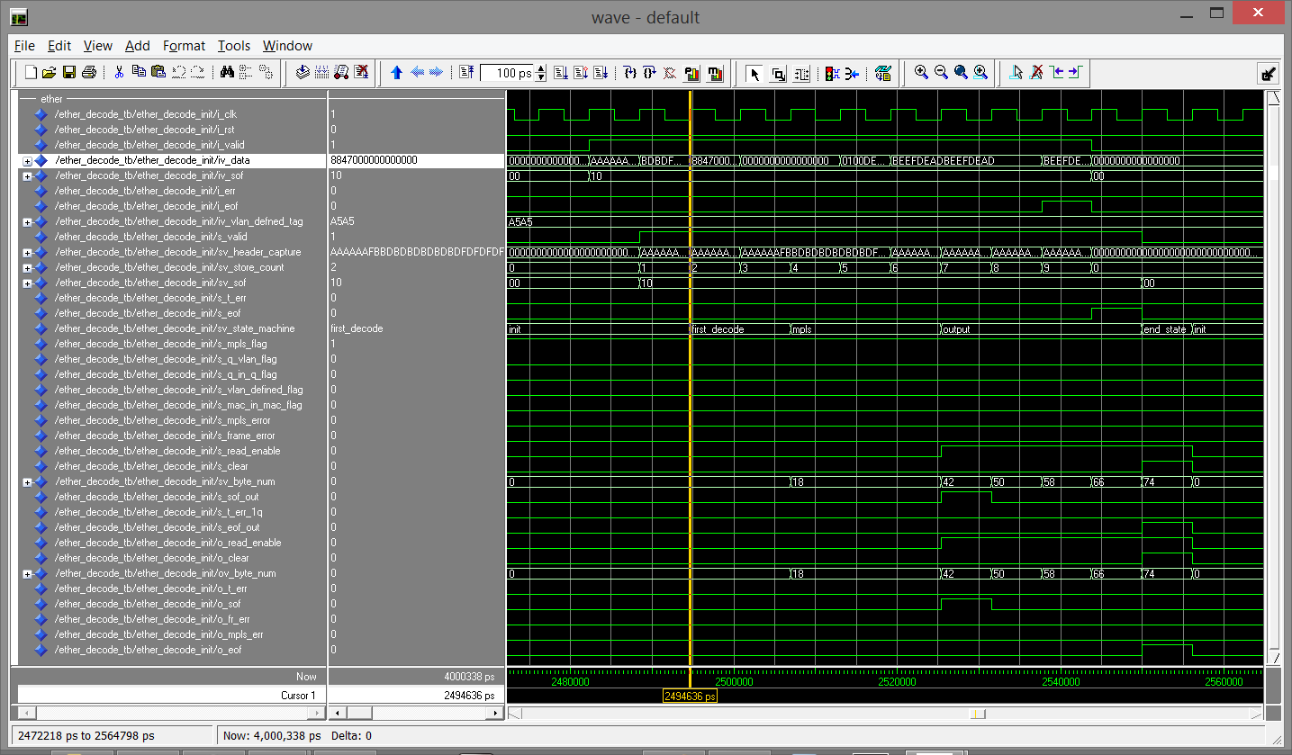

Ether-type FSM Test Case 0, Test Frame 22

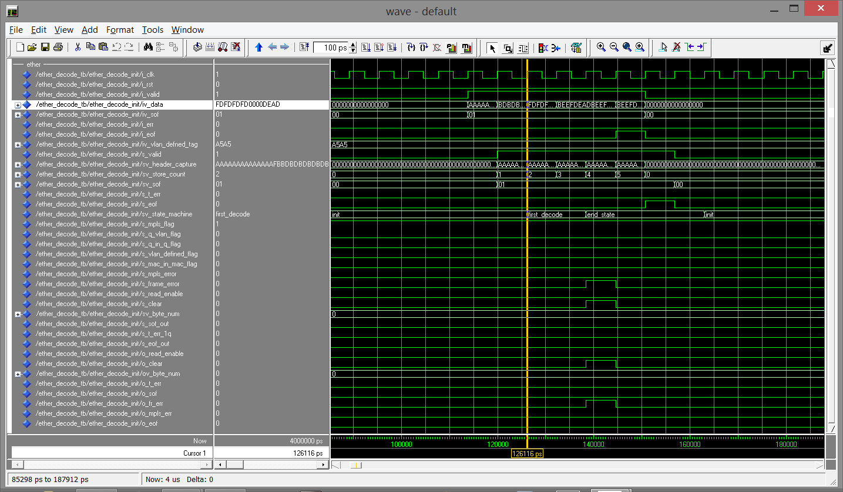

Ether-type FSM Test Case 7, Test Frame 1

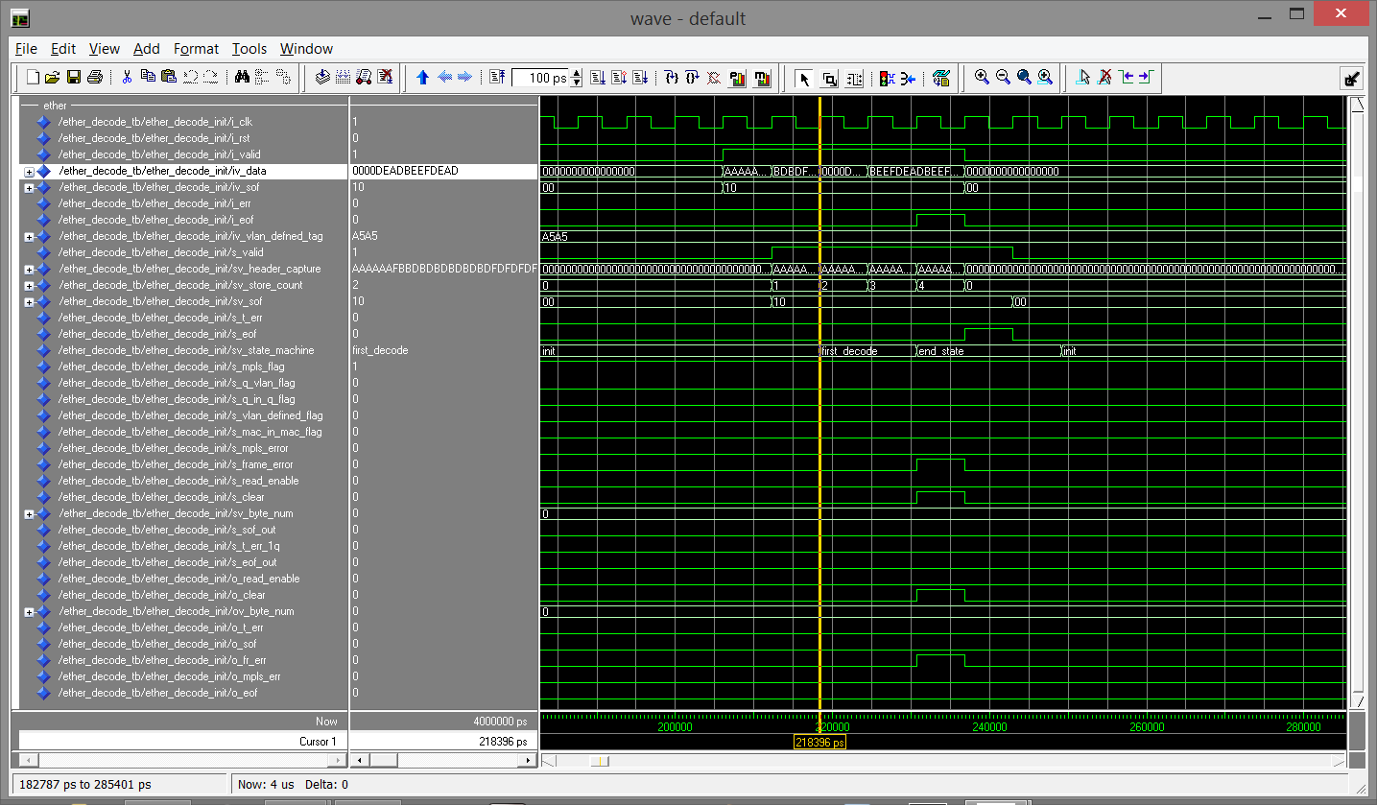

Ether-type FSM Test Case 7, Test Frame 2

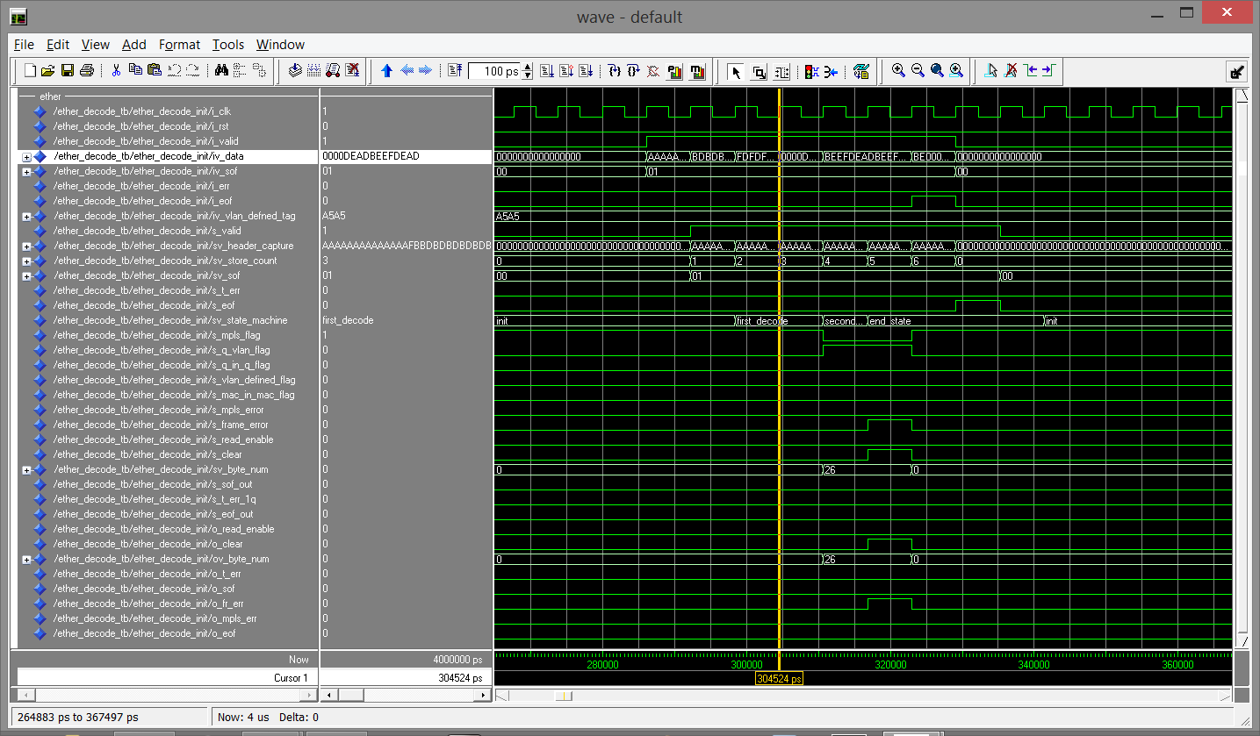

Ether-type FSM Test Case 7, Test Frame 3

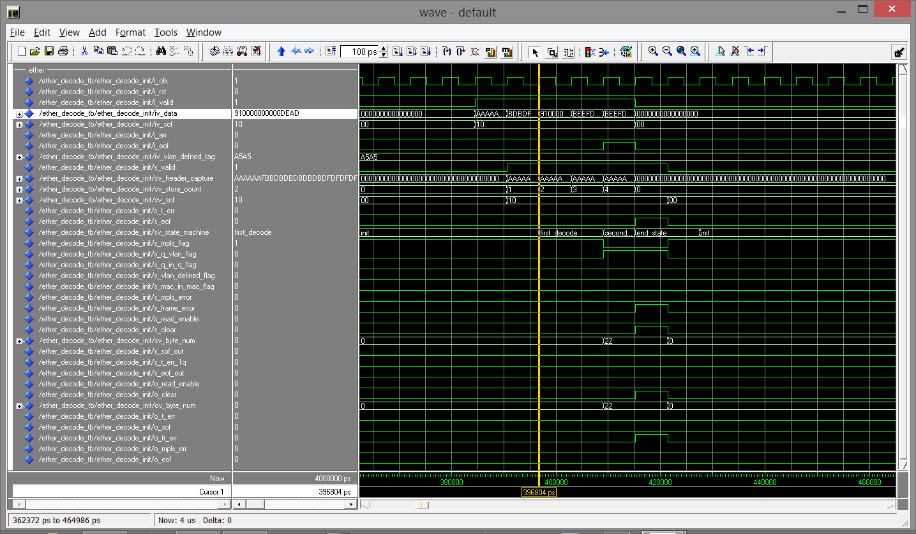

Ether-type FSM Test Case 7, Test Frame 4

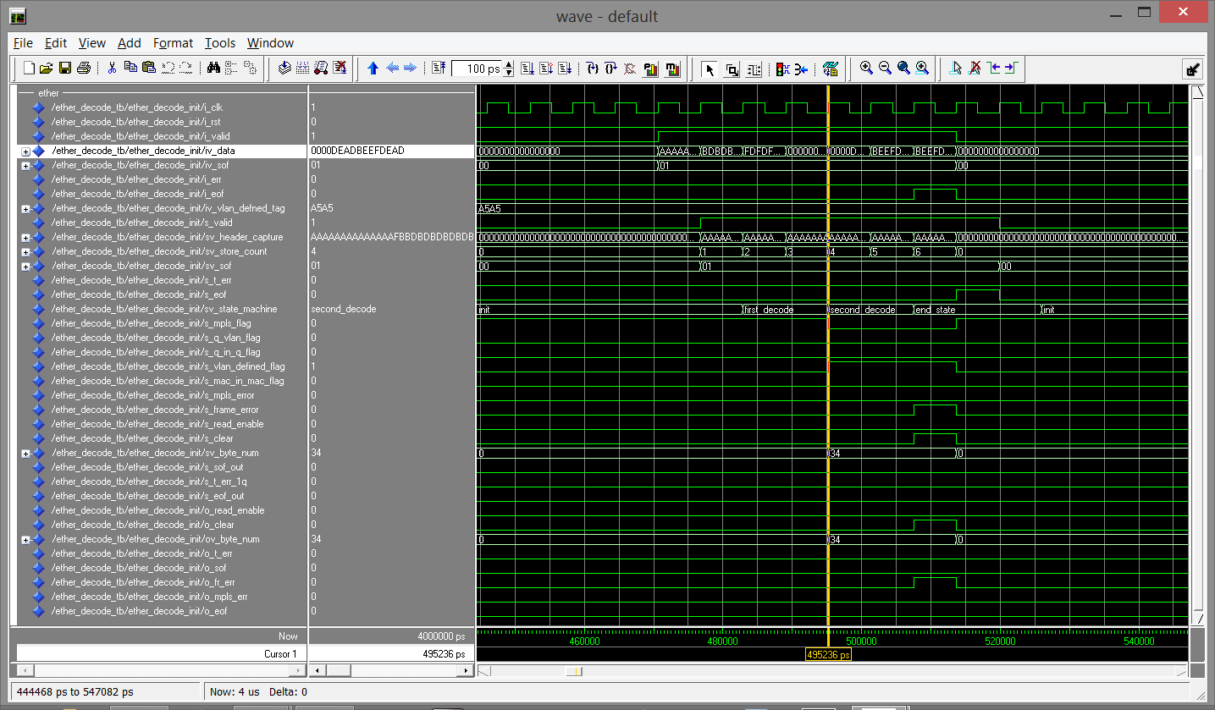

Ether-type FSM Test Case 7, Test Frame 5

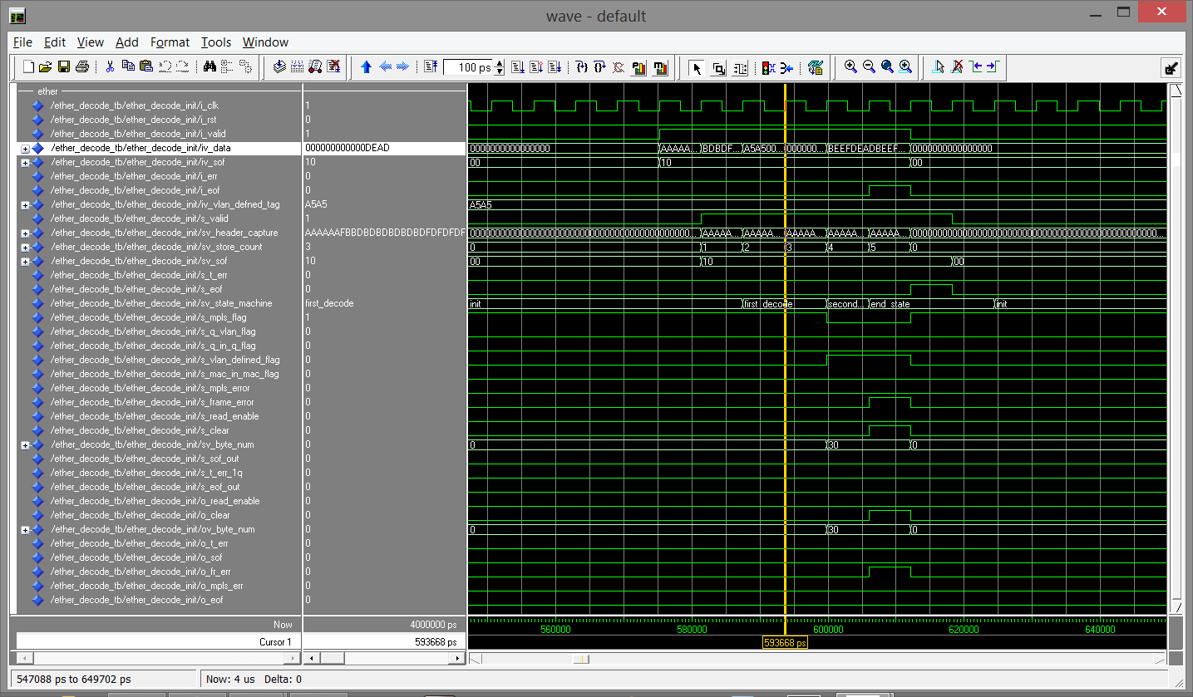

Ether-type FSM Test Case 7, Test Frame 6

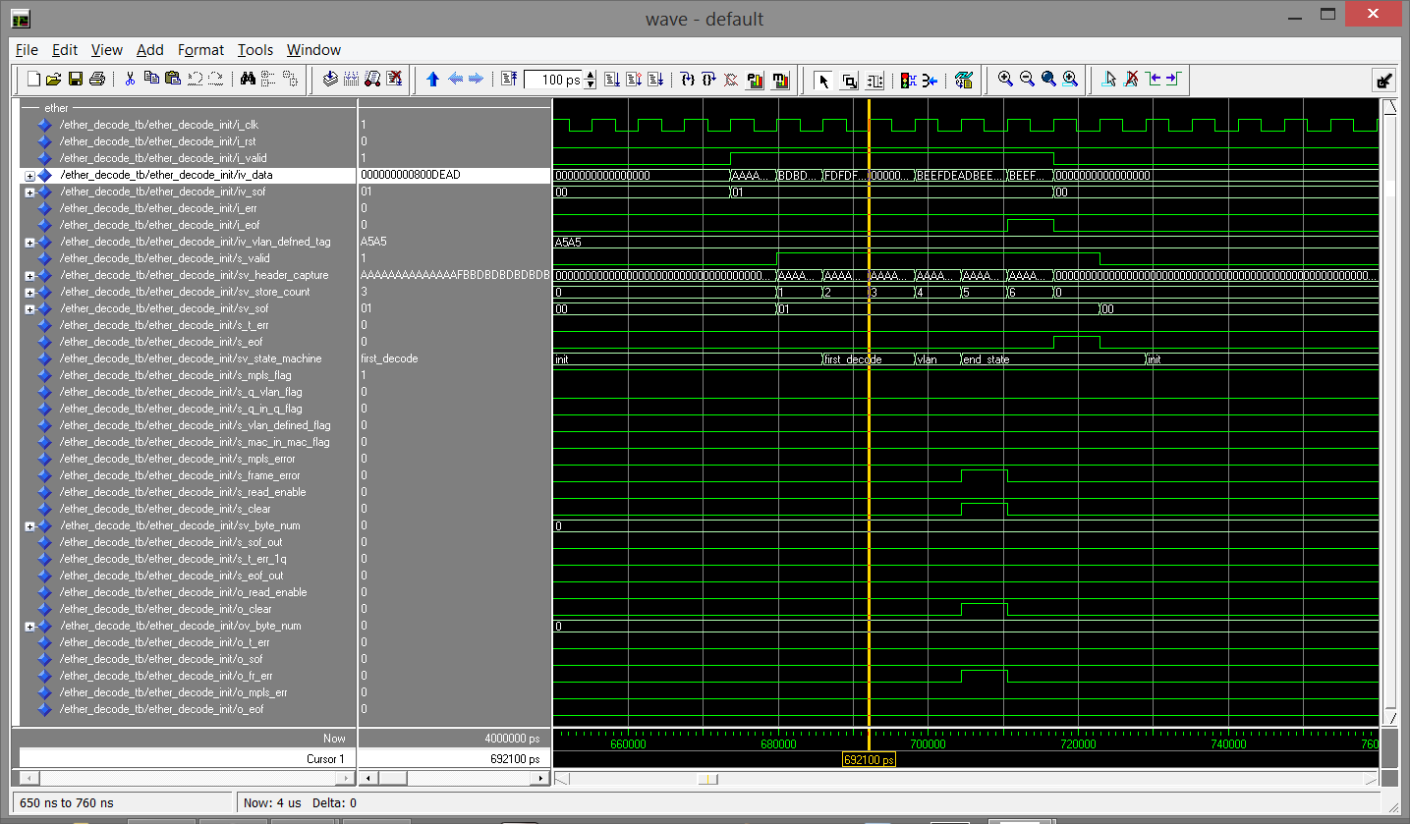

Ether-type FSM Test Case 7, Test Frame 7

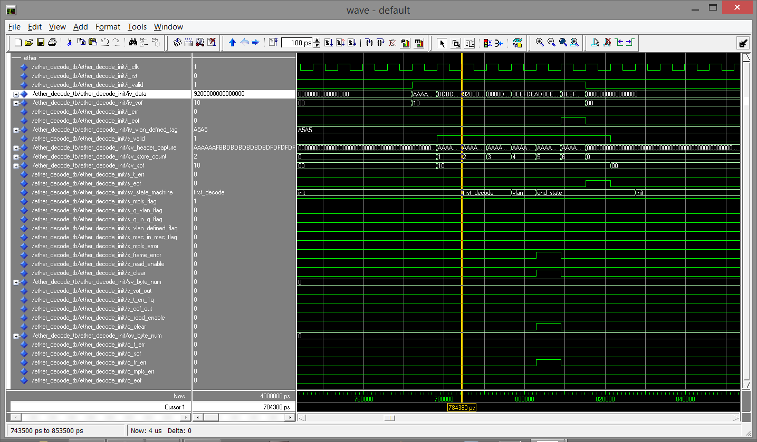

Ether-type FSM Test Case 7, Test Frame 8

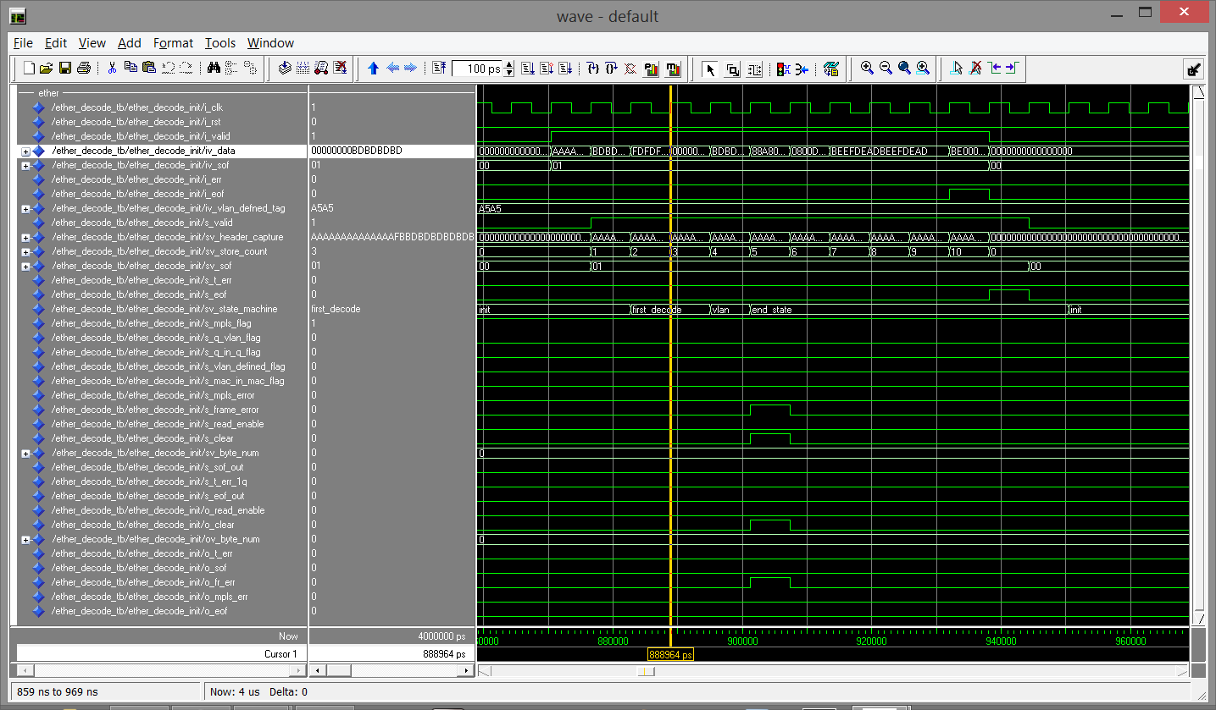

Ether-type FSM Test Case 7, Test Frame 9

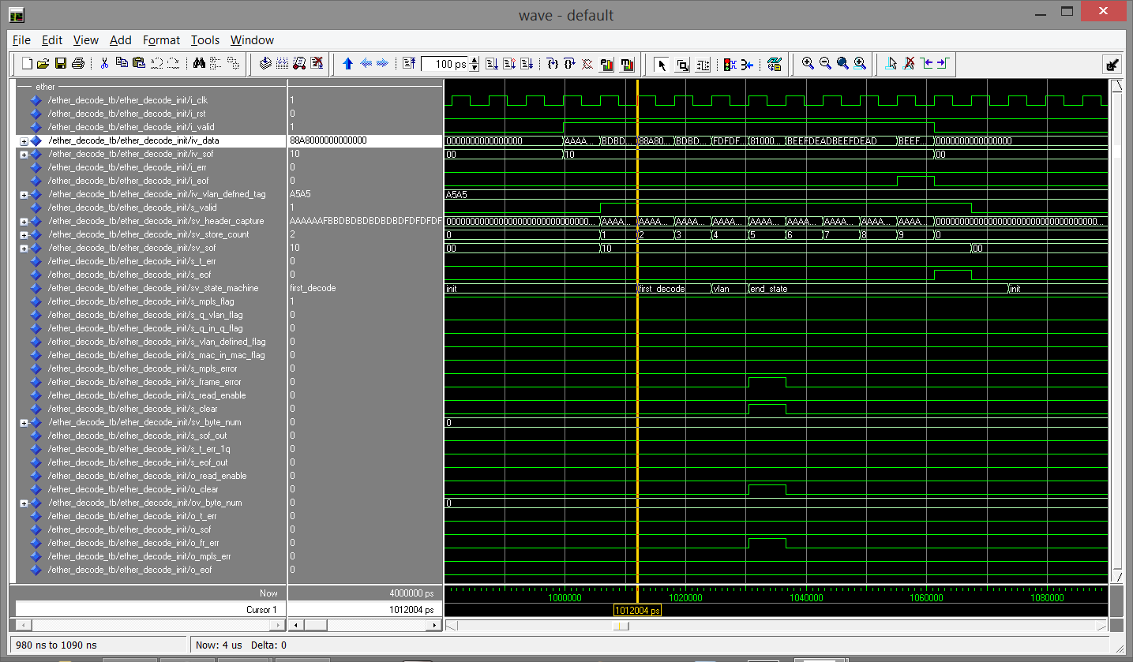

Ether-type FSM Test Case 7, Test Frame 10

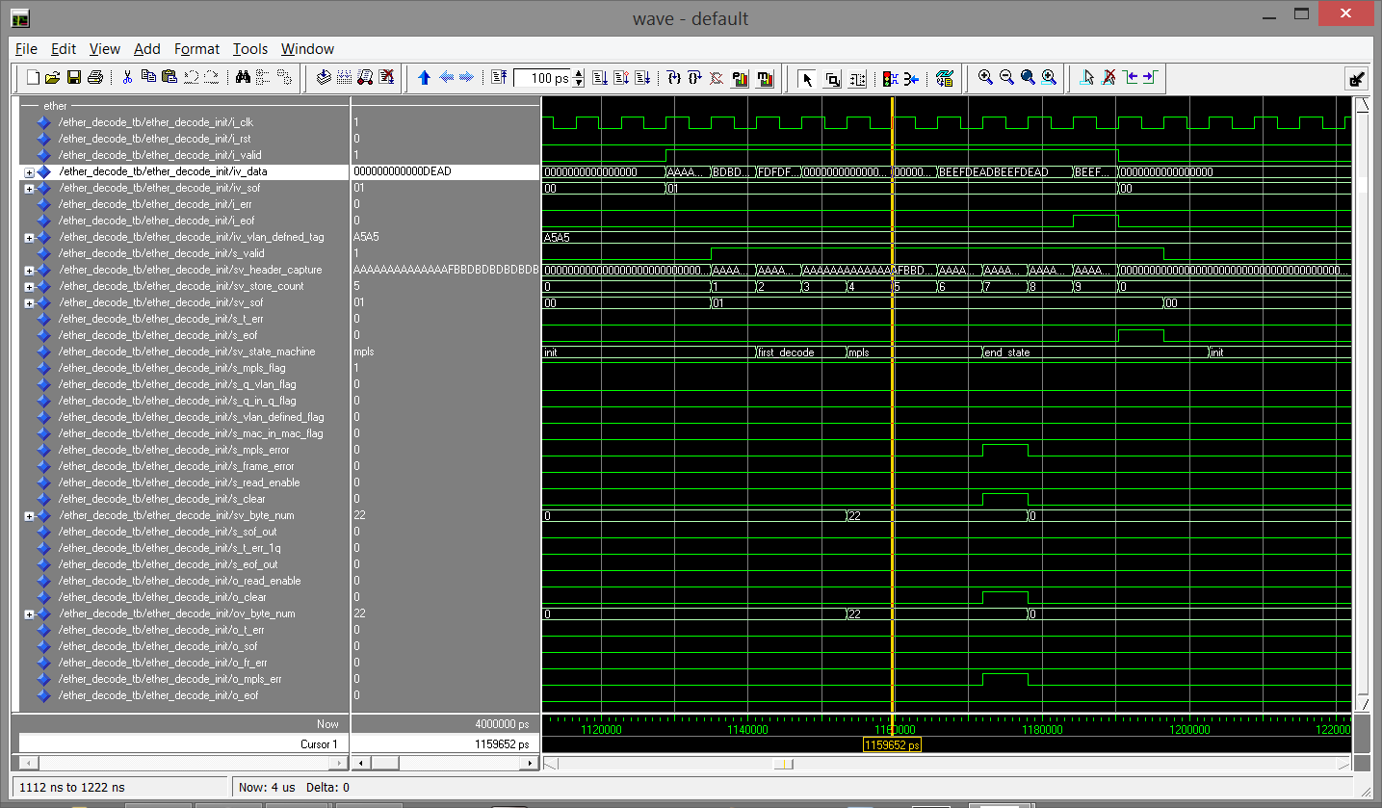

Ether-type FSM Test Case 7, Test Frame 11

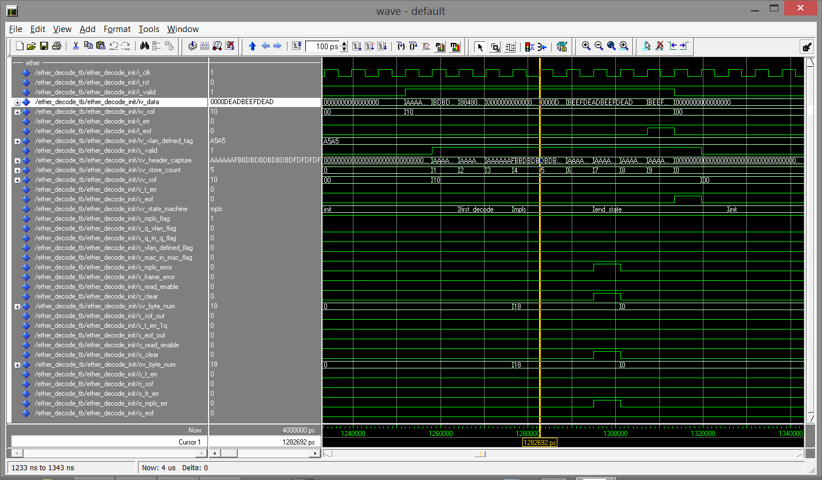

Ether-type FSM Test Case 7, Test Frame 12

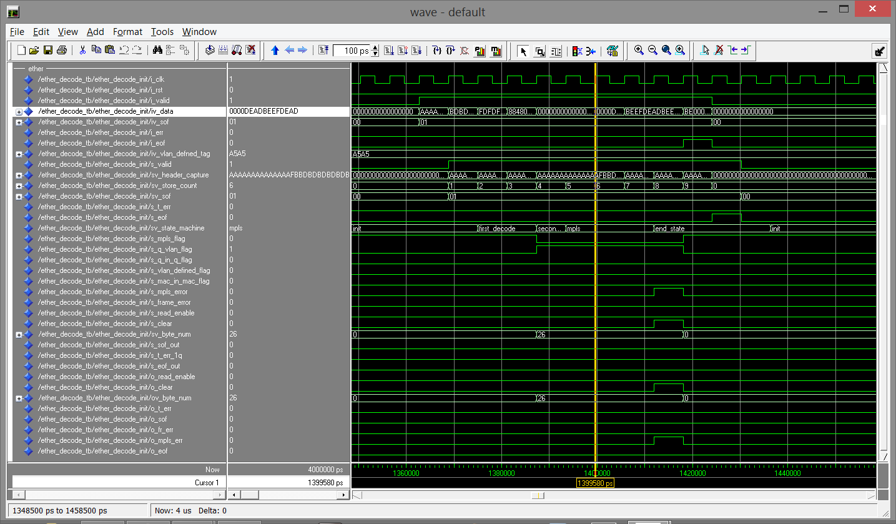

Ether-type FSM Test Case 7, Test Frame 13

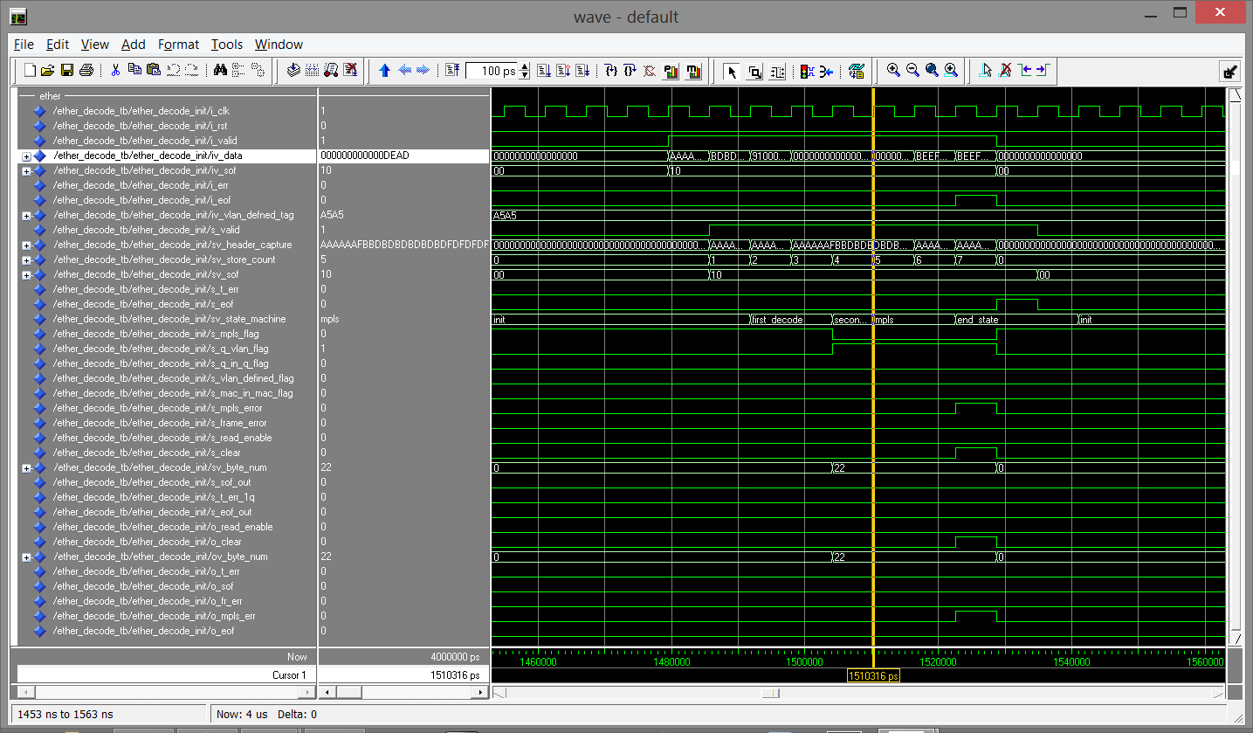

Ether-type FSM Test Case 7, Test Frame 14

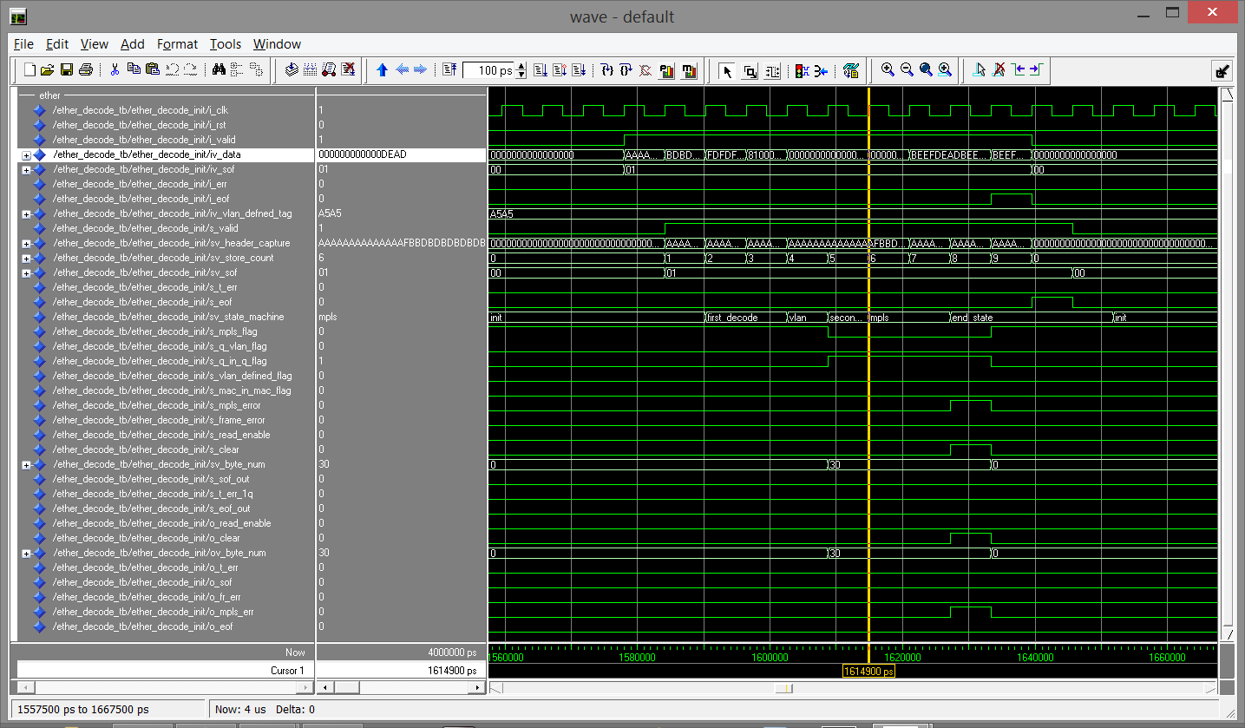

Ether-type FSM Test Case 7, Test Frame 15

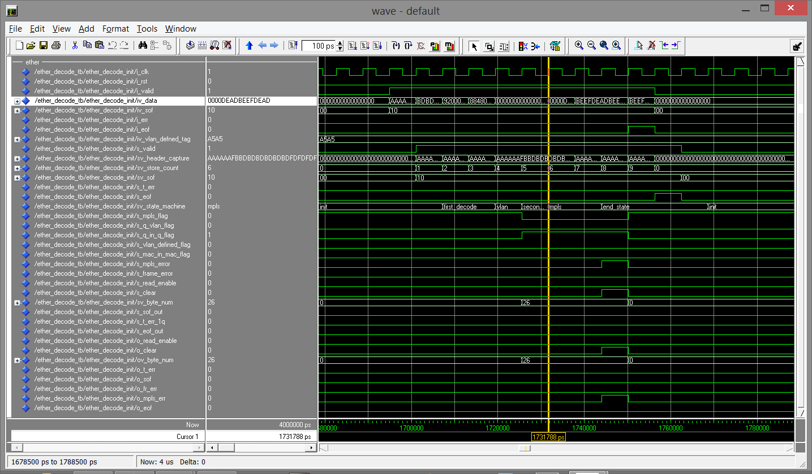

Ether-type FSM Test Case 7, Test Frame 16

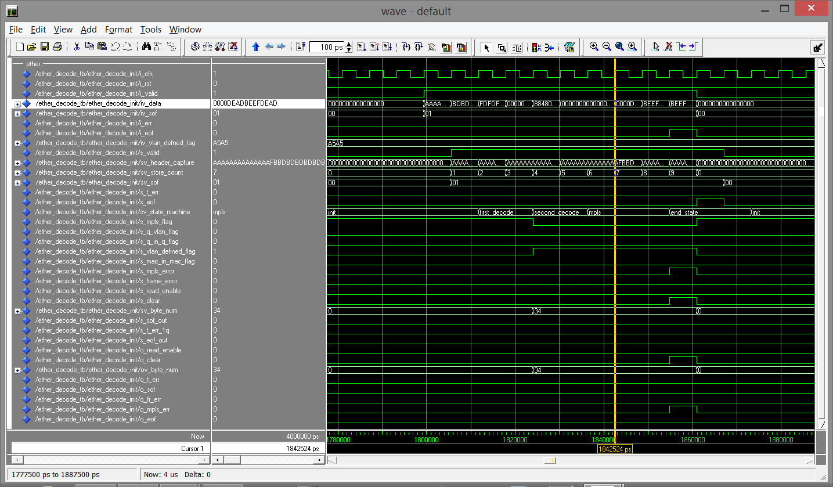

Ether-type FSM Test Case 7, Test Frame 17

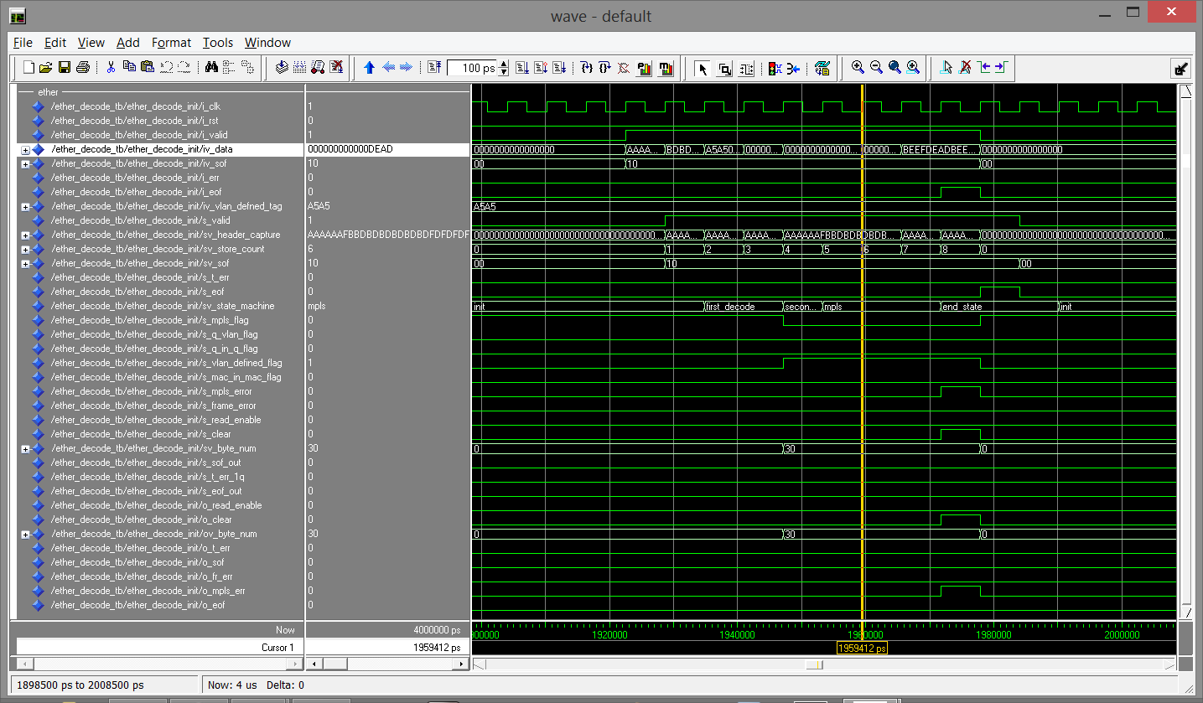

Ether-type FSM Test Case 7, Test Frame 18

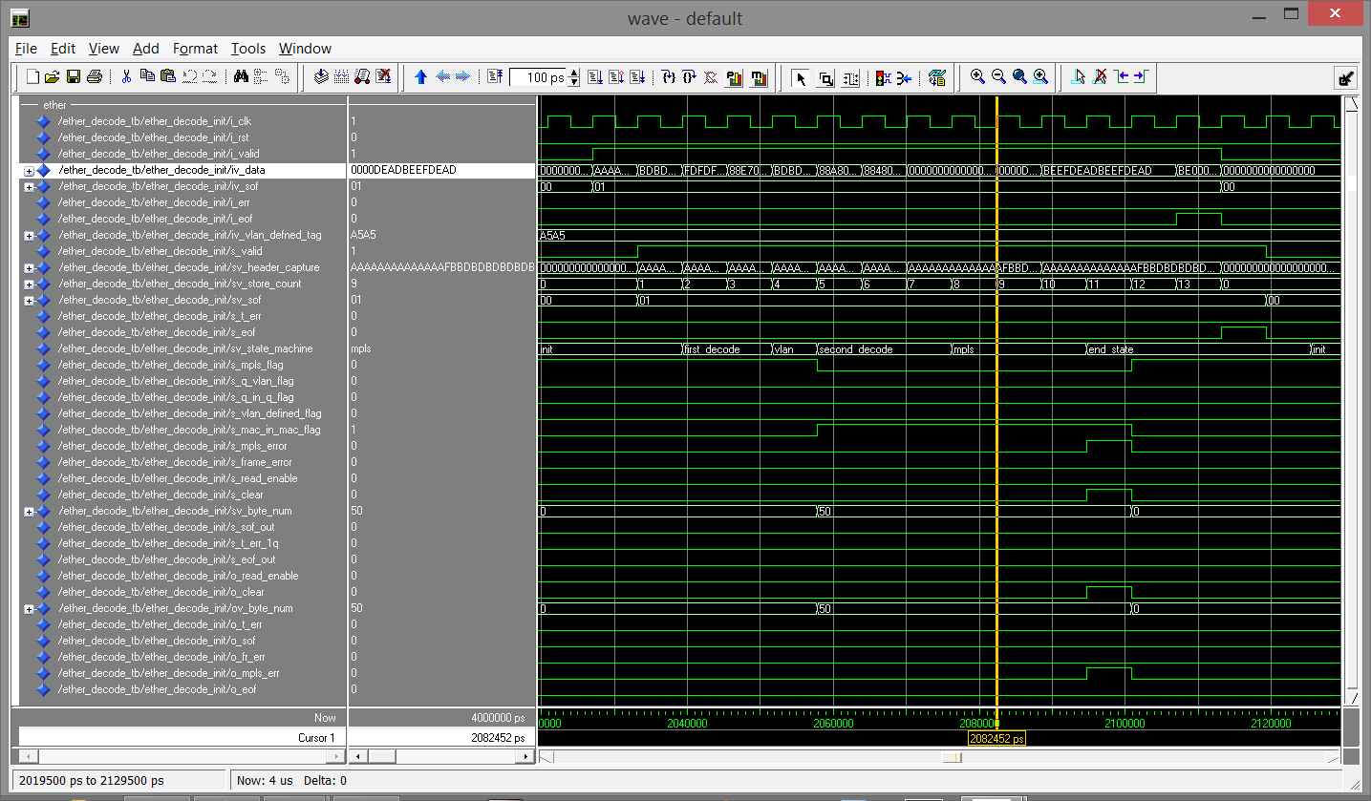

Ether-type FSM Test Case 7, Test Frame 19

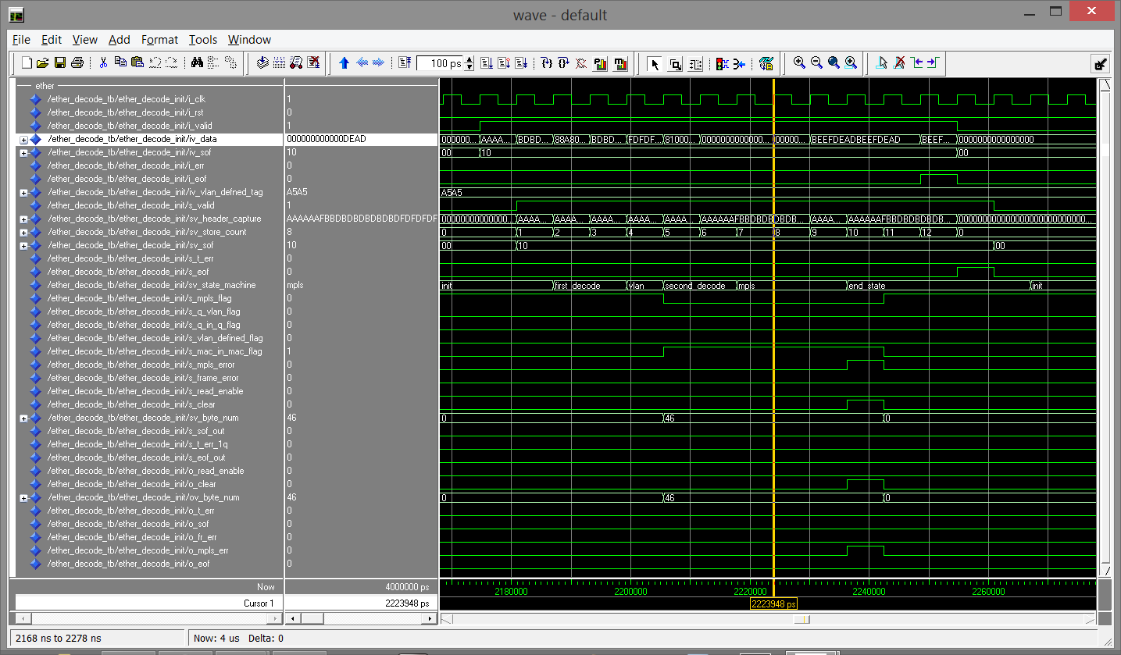

Ether-type FSM Test Case 7, Test Frame 20

**Appendix C**

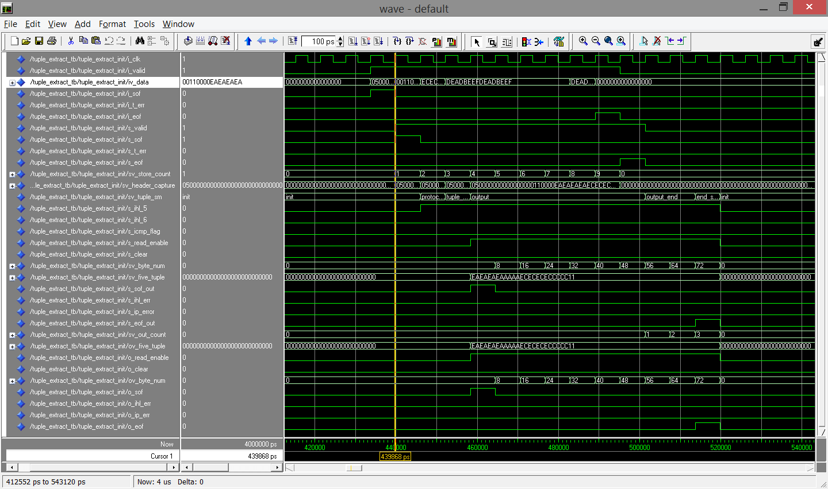

5 Tuple FSM Test Case 0, Test Frame 3

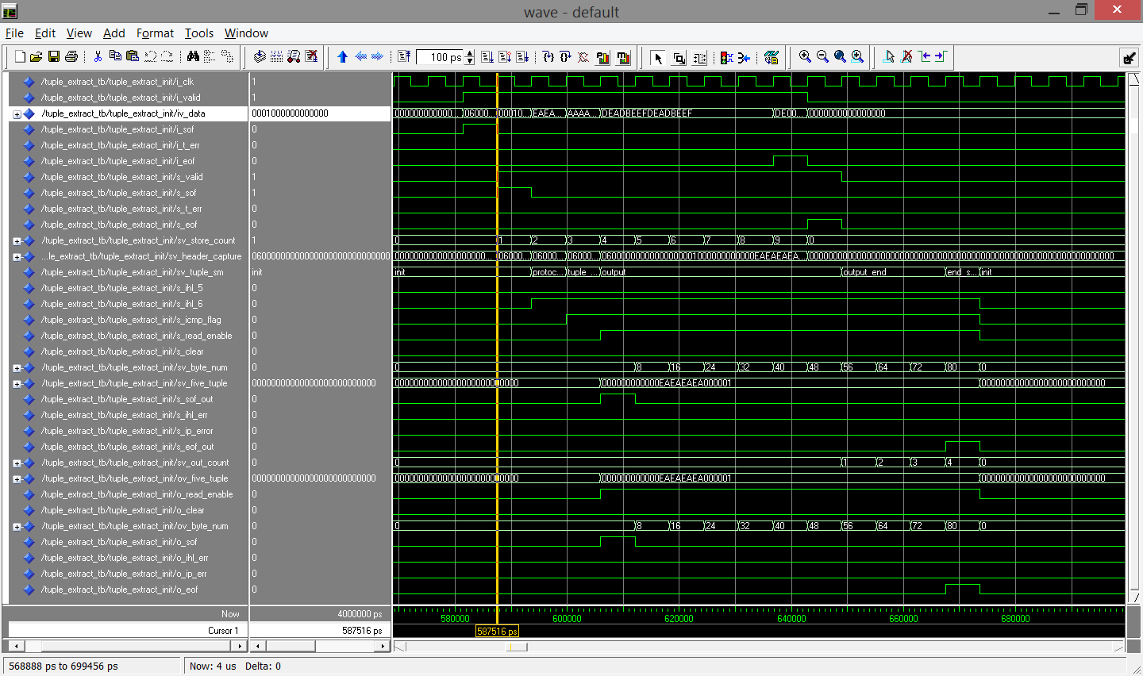

5 Tuple FSM Test Case 0, Test Frame 4

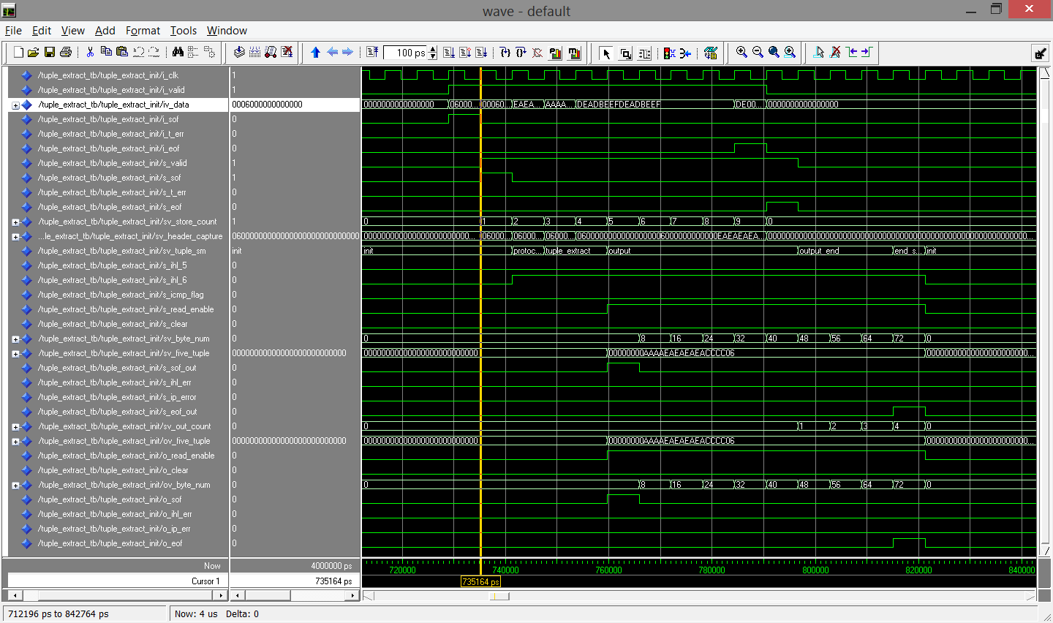

5 Tuple FSM Test Case 0, Test Frames 5

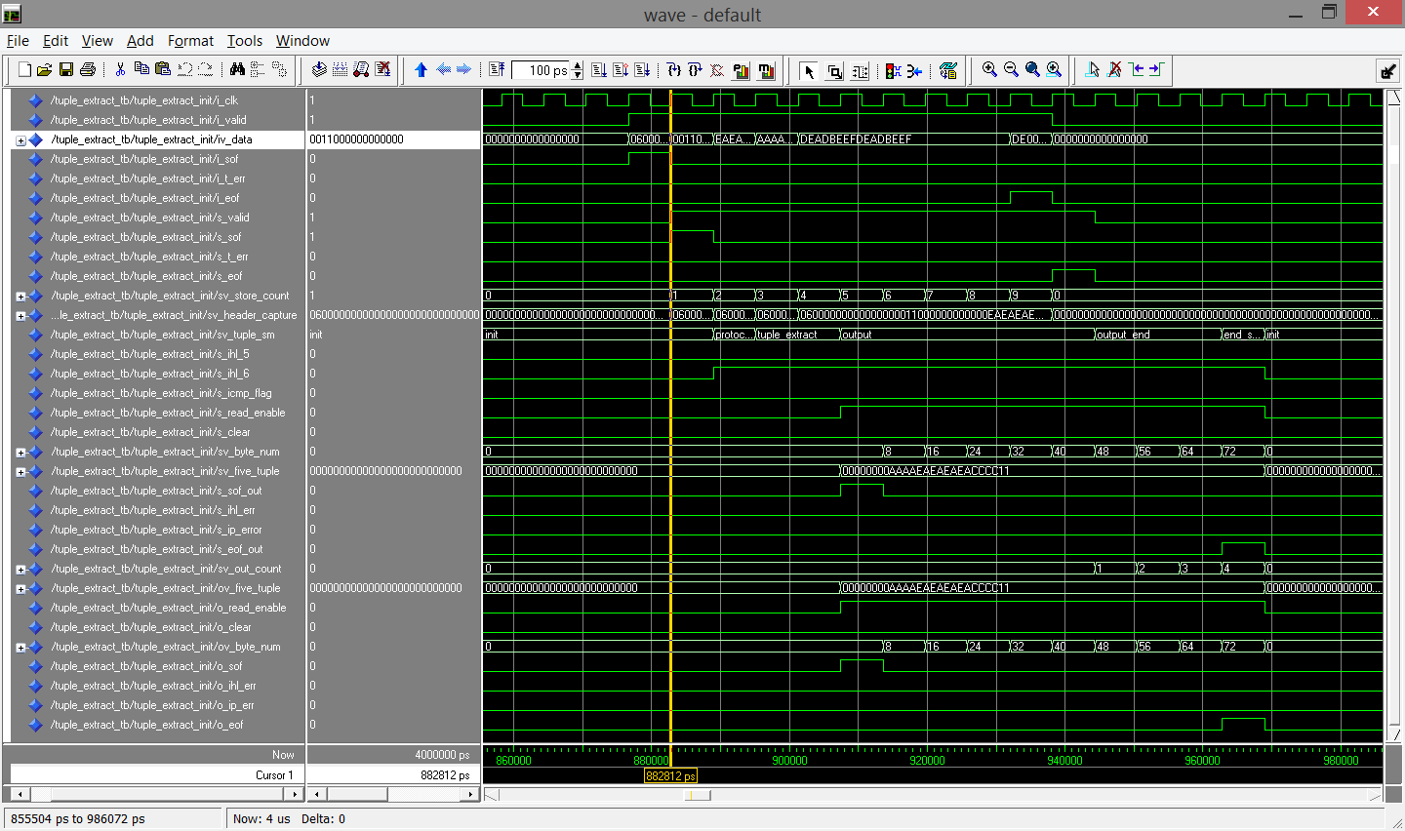

5 Tuple FSM Test Case 0, Test Frame 6

**Appendix D**

**File Pump Verilog Code**

`timescale 1ps/1ps

module file_pump #(

parameter DATA_WIDTH = 8 )(

input wire i_clk,

input wire i_rst,

input wire i_enable,

output reg o_data_valid,

output reg[DATA_WIDTH-1:0] ov_data

);

integer data_file, read_file ;

reg[DATA_WIDTH-1:0] data;

`define NULL 0

`define EMPTY 32'hffff_ffff

//-----------------------------------------------------------------------

//-- file extraction

//-----------------------------------------------------------------------

initial begin

data_file = $fopen("input_config.txt", "r");

if (data_file == `NULL) begin

$display("data_file handle was NULL");

$finish;

end

end

always @(posedge i_clk or negedge i_rst) begin

if (i_rst) begin

read_file <= 0;

o_data_valid <= 1'd0;

data <= {DATA_WIDTH{1'b0}};

ov_data <= {DATA_WIDTH{1'b0}};

end else begin

if (i_enable) begin

read_file = $fscanf(data_file, "%x", data);

if (read_file != `EMPTY) begin

o_data_valid <= 1'd1;

ov_data <= data;

end else begin

o_data_valid <= 1'd0;

ov_data <= {DATA_WIDTH{1'd0}};

end

end else begin

o_data_valid <= 1'd0;

ov_data <= {DATA_WIDTH{1'd0}};

end

end

end

endmodule

**Barrel Shifter VHDL Code**

-------------------------------------------------------------------------------

-- barrel_shifter.vhd

--

-- delays signals for a set number of clock cycles

--

-------------------------------------------------------------------------------

library ieee;

use ieee.std_logic_1164.all;

use ieee.std_logic_arith.all;

use IEEE.numeric_bit.all;

use IEEE.numeric_std.all;

use IEEE.std_logic_unsigned.all;

-------------------------------------------------------------------------------

ENTITY barrel_shifter IS

PORT(

i_clk : IN STD_LOGIC;

i_rst : IN STD_LOGIC;

i_valid : IN STD_LOGIC; --input data valid

iv_data : IN STD_LOGIC_VECTOR (64-1 DOWNTO 0); --input data

iv_byte_num : IN STD_LOGIC_VECTOR (12-1 DOWNTO 0); --input start of frame

i_read_enable : IN STD_LOGIC; --input error signal, used to reset the state machine and barrel shifter

i_clear_reg : IN STD_LOGIC; --input end of frame

o_valid : OUT STD_LOGIC; --output read enable to enable reading from the barrel shifter

ov_data : OUT STD_LOGIC_VECTOR (64-1 DOWNTO 0) --output byte number to indicate to the barrel shifter where to read from next

);

END barrel_shifter;

-------------------------------------------------------------------------------

ARCHITECTURE rtl OF barrel_shifter IS

-------------------------------------------------------------------------------

-------------------------------------------------------------------------------

-- input_store_reg -- MTU is 1526 bytes for a simple IP packet including preammble and SFD

-- -- with PBB VLAN and max MPLS MTU is 1578 bytes

SIGNAL sv_store_count : STD_LOGIC_VECTOR(6-1 DOWNTO 0);

SIGNAL sv_frame_capture : STD_LOGIC_VECTOR(64*198-1 DOWNTO 0); -- 1578 * 8

-- output_data_reg

SIGNAL s_valid : STD_LOGIC;

SIGNAL sv_data_out : STD_LOGIC_VECTOR(64-1 DOWNTO 0);

-------------------------------------------------------------------------------

BEGIN -- rtl

-------------------------------------------------------------------------------

-------------------------------------------------------------------------------

-- capture the input data into the barrel

-------------------------------------------------------------------------------

input_store_reg: PROCESS(i_clk, i_rst)

BEGIN

IF (i_rst = '1') THEN

sv_store_count <= (OTHERS => '0');

sv_frame_capture <= (OTHERS => '0');

ELSIF (i_clk'event and i_clk = '1') THEN

IF (i_clear_reg = '1') THEN

sv_store_count <= (OTHERS => '0');

sv_frame_capture <= (OTHERS => '0');

ELSE

IF (i_valid = '1') THEN

sv_store_count <= sv_store_count + 1;

sv_frame_capture((((198-CONV_INTEGER(sv_store_count))*64)-1) DOWNTO (((198-CONV_INTEGER(sv_store_count))-1)*64)) <= iv_data;

ELSE

sv_store_count <= sv_store_count;

sv_frame_capture <= sv_frame_capture;

END IF;

END IF;

END IF;

END PROCESS input_store_reg;

-------------------------------------------------------------------------------

-- output from barrel starting at byte sv_byte_num when read enable is high

-------------------------------------------------------------------------------

output_data_reg: PROCESS(i_clk, i_rst)

BEGIN

IF (i_rst = '1') THEN

s_valid <= '0';

sv_data_out <= (OTHERS => '0');

ELSIF (i_clk'event and i_clk = '1') THEN

s_valid <= '0';

sv_data_out <= (OTHERS => '0');

IF (i_read_enable = '1') THEN

s_valid <= '1';

sv_data_out <= sv_frame_capture((((1584 - CONV_INTEGER(iv_byte_num))*8)-1) DOWNTO ((1576 - CONV_INTEGER(iv_byte_num))*8));

END IF;

END IF;

END PROCESS output_data_reg;

o_valid <= s_valid;

ov_data <= sv_data_out;

END ARCHITECTURE rtl;

**Double Data Rate Converter VHDL Code**

-- ddr_to_sdr.vhd

--

-- converts a double data rate to a single data rate on the same clock

--

-------------------------------------------------------------------------------

library ieee;

use ieee.std_logic_1164.all;

use ieee.std_logic_arith.all;

-------------------------------------------------------------------------------

ENTITY ddr_to_sdr IS

GENERIC (

DATA_WIDTH_IN : INTEGER

);

PORT(

i_clk : IN STD_LOGIC;

i_rst : IN STD_LOGIC;

i_valid : IN STD_LOGIC; --input data valid

iv_data : IN STD_LOGIC_VECTOR (DATA_WIDTH_IN-1 DOWNTO 0); --input data

o_valid : OUT STD_LOGIC; --output data valid

ov_data : OUT STD_LOGIC_VECTOR ((DATA_WIDTH_IN*2)-1 DOWNTO 0) --output data

);

END ddr_to_sdr;

-------------------------------------------------------------------------------

ARCHITECTURE rtl OF ddr_to_sdr IS

-------------------------------------------------------------------------------

-------------------------------------------------------------------------------

-- ddr_to_sdr_reg -- signals

SIGNAL s_single_rate_valid : STD_LOGIC;

SIGNAL sv_r_double_rate_date : STD_LOGIC_VECTOR(DATA_WIDTH_IN-1 DOWNTO 0);

SIGNAL sv_f_double_rate_date : STD_LOGIC_VECTOR(DATA_WIDTH_IN-1 DOWNTO 0);

SIGNAL sv_single_rate_date : STD_LOGIC_VECTOR((DATA_WIDTH_IN*2)-1 DOWNTO 0);

SIGNAL s_test : STD_LOGIC;

-------------------------------------------------------------------------------

BEGIN -- rtl

-------------------------------------------------------------------------------

-------------------------------------------------------------------------------

-- register data on both edges of the clock and then re-register on then rising edge

-------------------------------------------------------------------------------

s_test <= i_valid xor i_clk;

ddr_to_sdr_reg: PROCESS(i_clk,i_rst)

BEGIN

IF i_rst = '1' THEN

s_single_rate_valid <= '0';

o_valid <= '0';

sv_r_double_rate_date <= (OTHERS => '0');

sv_f_double_rate_date <= (OTHERS => '0');

sv_single_rate_date <= (OTHERS => '0');

ELSIF (i_clk'event and i_clk = '1') THEN --rising

s_single_rate_valid <= i_valid ;

o_valid <= s_single_rate_valid;

sv_single_rate_date <= sv_r_double_rate_date & sv_f_double_rate_date;

IF ( i_valid = '1') THEN

sv_r_double_rate_date <= iv_data;

END IF;

ELSIF (i_clk'event and i_clk = '0') THEN --falling

IF ( i_valid = '1') THEN

sv_f_double_rate_date <= iv_data;

END IF;

END IF;

END PROCESS ddr_to_sdr_reg;

ov_data <= sv_single_rate_date;

END ARCHITECTURE rtl;

--------------------------------------------------------------

**XGMII FCS Removal FSM VHDL Code**

-------------------------------------------------------------------------------

--

-- xgmii_decoder.vhd

--

-- converts a double data rate to a single data rate on the same clock

--

-------------------------------------------------------------------------------

library ieee;

use ieee.std_logic_1164.all;

use ieee.std_logic_arith.all;

use work.component_package.all;

-------------------------------------------------------------------------------

ENTITY xgmii_decoder IS

PORT(

i_clk : IN STD_LOGIC;

i_rst : IN STD_LOGIC;

i_valid : IN STD_LOGIC; --input data valid

iv_cntrl : IN STD_LOGIC_VECTOR (4-1 DOWNTO 0); --input xgmii control

iv_data : IN STD_LOGIC_VECTOR (32-1 DOWNTO 0); --input data

o_valid : OUT STD_LOGIC; --output data valid

ov_data : OUT STD_LOGIC_VECTOR (64-1 DOWNTO 0); --output data

ov_sof : OUT STD_LOGIC_VECTOR (2-1 DOWNTO 0); --output start of frame

o_err : OUT STD_LOGIC; --output frame error

o_eof : OUT STD_LOGIC --output end of frame

);

END xgmii_decoder;

-------------------------------------------------------------------------------

ARCHITECTURE rtl OF xgmii_decoder IS

-------------------------------------------------------------------------------

-------------------------------------------------------------------------------

TYPE XGMII_SM_TYPE IS (INIT, IN_FRAME, END_FRAME);

TYPE FCS_REMOVAL_SM_TYPE IS (INIT_EOF, SECOND_EOF, REMOVEL);

-- ddr_to_sdr_reg -- signals

SIGNAL s_valid_in : STD_LOGIC;

SIGNAL sv_data_in : STD_LOGIC_VECTOR (64-1 DOWNTO 0); -- double input data

SIGNAL sv_cntrl_in : STD_LOGIC_VECTOR (8-1 DOWNTO 0); -- double input xgmii control

SIGNAL sv_xgmii_statemachine : XGMII_SM_TYPE;

SIGNAL s_valid_out : STD_LOGIC;

SIGNAL sv_data_out : STD_LOGIC_VECTOR (64-1 DOWNTO 0); -- output data

SIGNAL sv_cntrl_out : STD_LOGIC_VECTOR (8-1 DOWNTO 0); -- xgmii control used to remove FCS

SIGNAL sv_sof : STD_LOGIC_VECTOR (2-1 DOWNTO 0);

SIGNAL s_err : STD_LOGIC;

SIGNAL s_eof : STD_LOGIC;

-- delay_sigals_reg -- signals

SIGNAL s_valid_1q : STD_LOGIC;

SIGNAL sv_data_1q : STD_LOGIC_VECTOR (64-1 DOWNTO 0); -- output data

SIGNAL sv_cntrl_1q : STD_LOGIC_VECTOR (8-1 DOWNTO 0); -- xgmii control used to remove FCS

SIGNAL sv_sof_1q : STD_LOGIC_VECTOR (2-1 DOWNTO 0);

SIGNAL s_err_1q : STD_LOGIC;

SIGNAL s_eof_1q : STD_LOGIC;

-- fcs_removal_regg -- signals

SIGNAL sv_fcs_removal_sm : FCS_REMOVAL_SM_TYPE;

SIGNAL s_valid_2q : STD_LOGIC;

SIGNAL sv_data_2q : STD_LOGIC_VECTOR (64-1 DOWNTO 0); -- output data

SIGNAL sv_sof_2q : STD_LOGIC_VECTOR (2-1 DOWNTO 0);

SIGNAL s_err_2q : STD_LOGIC;

SIGNAL s_eof_2q : STD_LOGIC;

-------------------------------------------------------------------------------

BEGIN -- rtl

-------------------------------------------------------------------------------

-------------------------------------------------------------------------------

ddr_to_sdr_data_inst : ddr_to_sdr

GENERIC MAP(

DATA_WIDTH_IN => 32

)

PORT MAP(

i_clk => i_clk,

i_rst => i_rst,

i_valid => i_valid,

iv_data => iv_data,

o_valid => s_valid_in,

ov_data => sv_data_in

);

ddr_to_sdr_control_inst : ddr_to_sdr

GENERIC MAP(

DATA_WIDTH_IN => 4

)

PORT MAP(

i_clk => i_clk,

i_rst => i_rst,

i_valid => i_valid,

iv_data => iv_cntrl,

o_valid => OPEN,

ov_data => sv_cntrl_in

);

-------------------------------------------------------------------------------

--

-------------------------------------------------------------------------------

xgmii_decode_reg: PROCESS(i_clk,i_rst)

BEGIN

IF i_rst = '1' THEN

sv_sof <= "00";

s_eof <= '0';

s_err <= '0';

s_valid_out <= '0';

sv_cntrl_out <= (OTHERS => '0');

sv_data_out <= (OTHERS => '0');

sv_xgmii_statemachine <= INIT;

ELSIF (i_clk'event and i_clk = '1') THEN

CASE sv_xgmii_statemachine IS

WHEN INIT =>

s_err <= '0';

s_valid_out <= '0';

sv_data_out <= (OTHERS => '0');

IF ( s_valid_in = '1') THEN

IF (sv_cntrl_in(0) = '1') THEN

IF (sv_data_in(7 DOWNTO 0) = x"FE")THEN -- error in position 0

s_err <= '1';

ELSIF (sv_data_in(7 DOWNTO 0) = x"FB")THEN -- start of frame in position 0

sv_sof <= "01";

s_valid_out <= s_valid_in;

sv_data_out <= sv_data_in;

sv_xgmii_statemachine <= IN_FRAME;

END IF;

END IF;

IF (sv_cntrl_in(1) = '1') THEN

IF (sv_data_in(15 DOWNTO 8) = x"FE")THEN -- error in position 1

s_err <= '1';

END IF;

END IF;

IF (sv_cntrl_in(2) = '1') THEN

IF (sv_data_in(23 DOWNTO 16) = x"FE")THEN -- error in position 2

s_err <= '1';

END IF;

END IF;

IF (sv_cntrl_in(3) = '1') THEN

IF (sv_data_in(31 DOWNTO 24) = x"FE")THEN -- error in position 3

s_err <= '1';

END IF;

END IF;

IF (sv_cntrl_in(4) = '1') THEN

IF (sv_data_in(39 DOWNTO 32) = x"FE")THEN -- error in position 4

s_err <= '1';

ELSIF (sv_data_in(39 DOWNTO 32) = x"FB")THEN -- start of frame in position 4

sv_sof <= "10";

s_valid_out <= s_valid_in;

sv_data_out <= sv_data_in;

sv_xgmii_statemachine <= IN_FRAME;

END IF;

END IF;

IF (sv_cntrl_in(5) = '1') THEN -- start of frame in position 5

IF (sv_data_in(47 DOWNTO 40) = x"FE")THEN -- error in position 0

s_err <= '1';

END IF;

END IF;

IF (sv_cntrl_in(6) = '1') THEN -- start of frame in position 6

IF (sv_data_in(55 DOWNTO 48) = x"FE")THEN -- error in position 0

s_err <= '1';

END IF;

END IF;

IF (sv_cntrl_in(7) = '1') THEN -- start of frame in position 7

IF (sv_data_in(63 DOWNTO 56) = x"FE")THEN -- error in position 0

s_err <= '1';

END IF;

END IF;

END IF;

WHEN IN_FRAME =>

s_valid_out <= s_valid_in;

sv_cntrl_out <= sv_cntrl_in;

IF (s_err = '1') THEN

sv_xgmii_statemachine <= END_FRAME;

ELSE

-------------------------------------------------------------------------------

-- control bit 0

-------------------------------------------------------------------------------

IF (sv_cntrl_in(0) = '1') THEN

IF (sv_data_in(7 DOWNTO 0) = x"FE")THEN -- error in position 0

sv_sof <= "00";

s_err <= '1';

sv_xgmii_statemachine <= END_FRAME;

ELSIF (sv_data_in(7 DOWNTO 0) = x"FD")THEN -- end of frame in position 0

s_eof <= '1';

sv_xgmii_statemachine <= END_FRAME;

sv_data_out <= sv_data_in(63 DOWNTO 8) & x"00";

END IF;

ELSE

sv_data_out <= sv_data_in;

END IF;

-------------------------------------------------------------------------------

-- control bit 1

-------------------------------------------------------------------------------

IF (sv_cntrl_in(1) = '1') THEN

IF (sv_data_in(15 DOWNTO 8) = x"FE")THEN -- error in position 1

sv_sof <= "00";

s_err <= '1';

sv_xgmii_statemachine <= END_FRAME;

ELSIF (sv_data_in(15 DOWNTO 8) = x"FD")THEN -- end of frame in position 1

s_eof <= '1';

sv_xgmii_statemachine <= END_FRAME;

sv_data_out <= sv_data_in(63 DOWNTO 16) & x"00" & sv_data_in(7 DOWNTO 0);

END IF;

ELSE

sv_data_out <= sv_data_in;

END IF;

-------------------------------------------------------------------------------

-- control bit 2

-------------------------------------------------------------------------------

IF (sv_cntrl_in(2) = '1') THEN

IF (sv_data_in(23 DOWNTO 16) = x"FE")THEN -- error in position 2

sv_sof <= "00";

s_err <= '1';

sv_xgmii_statemachine <= END_FRAME;

ELSIF (sv_data_in(23 DOWNTO 16) = x"FD")THEN -- end of frame in position 2

s_eof <= '1';

sv_xgmii_statemachine <= END_FRAME;

sv_data_out <= sv_data_in(63 DOWNTO 24) & x"00" & sv_data_in(15 DOWNTO 0);

END IF;

ELSE

sv_data_out <= sv_data_in;

END IF;

-------------------------------------------------------------------------------

-- control bit 3

-------------------------------------------------------------------------------

IF (sv_cntrl_in(3) = '1') THEN

IF (sv_data_in(31 DOWNTO 24) = x"FE")THEN -- error in position 3

sv_sof <= "00";

s_err <= '1';

sv_xgmii_statemachine <= END_FRAME;

ELSIF (sv_data_in(31 DOWNTO 24) = x"FD")THEN -- end of frame in position 3

s_eof <= '1';

sv_xgmii_statemachine <= END_FRAME;

sv_data_out <= sv_data_in(63 DOWNTO 32) & x"00" & sv_data_in(23 DOWNTO 0);

END IF;

END IF;

-------------------------------------------------------------------------------

-- control bit 4

-------------------------------------------------------------------------------

IF (sv_cntrl_in(4) = '1') THEN

IF (sv_data_in(39 DOWNTO 32) = x"FE")THEN -- error in position 4

sv_sof <= "00";

s_err <= '1';

sv_xgmii_statemachine <= END_FRAME;

ELSIF (sv_data_in(39 DOWNTO 32) = x"FD")THEN -- end of frame in position 4

s_eof <= '1';

sv_xgmii_statemachine <= END_FRAME;

sv_data_out <= sv_data_in(63 DOWNTO 40) & x"00" & sv_data_in(31 DOWNTO 0);

END IF;

ELSE

sv_data_out <= sv_data_in;

END IF;

-------------------------------------------------------------------------------

-- control bit 5

-------------------------------------------------------------------------------

IF (sv_cntrl_in(5) = '1') THEN

IF (sv_data_in(47 DOWNTO 40) = x"FE")THEN -- error in position 5

sv_sof <= "00";

s_err <= '1';

sv_xgmii_statemachine <= END_FRAME;

ELSIF (sv_data_in(47 DOWNTO 40) = x"FD")THEN -- end of frame in position 5

s_eof <= '1';

sv_xgmii_statemachine <= END_FRAME;

sv_data_out <= sv_data_in(63 DOWNTO 48) & x"00" & sv_data_in(39 DOWNTO 0);

END IF;

ELSE

sv_data_out <= sv_data_in;

END IF;

-------------------------------------------------------------------------------

-- control bit 6

-------------------------------------------------------------------------------

IF (sv_cntrl_in(6) = '1') THEN

IF (sv_data_in(55 DOWNTO 48) = x"FE")THEN -- error in position 6

sv_sof <= "00";

s_err <= '1';

sv_xgmii_statemachine <= END_FRAME;

ELSIF (sv_data_in(55 DOWNTO 48) = x"FD")THEN -- end of frame in position 6

s_eof <= '1';

sv_xgmii_statemachine <= END_FRAME;

sv_data_out <= sv_data_in(63 DOWNTO 56) & x"00" & sv_data_in(47 DOWNTO 0);

END IF;

ELSE

sv_data_out <= sv_data_in;

END IF;

-------------------------------------------------------------------------------

-- control bit 7

-------------------------------------------------------------------------------

IF (sv_cntrl_in(7) = '1') THEN

IF (sv_data_in(63 DOWNTO 56) = x"FE")THEN -- error in position 7

sv_sof <= "00";

s_err <= '1';

sv_xgmii_statemachine <= END_FRAME;

ELSIF (sv_data_in(63 DOWNTO 56) = x"FD")THEN -- end of frame in position 7

s_eof <= '1';

sv_xgmii_statemachine <= END_FRAME;

sv_data_out <= x"00" & sv_data_in(55 DOWNTO 0);

END IF;

ELSE

sv_data_out <= sv_data_in;

END IF;

END IF;

WHEN END_FRAME =>

sv_sof <= "00";

s_eof <= '0';

s_err <= '0';

s_valid_out <= '0';

sv_cntrl_out <= (OTHERS => '0');

sv_data_out <= (OTHERS => '0');

sv_xgmii_statemachine <= INIT;

WHEN OTHERS =>

sv_sof <= "00";

s_eof <= '0';

s_err <= '0';

s_valid_out <= '0';

sv_cntrl_out <= (OTHERS => '0');

sv_data_out <= (OTHERS => '0');

sv_xgmii_statemachine <= INIT;

END CASE;

END IF;

END PROCESS xgmii_decode_reg;

-------------------------------------------------------------------------------

--

-------------------------------------------------------------------------------

delay_sigals_reg: PROCESS(i_clk,i_rst)

BEGIN

IF i_rst = '1' THEN

s_valid_1q <= '0';

sv_data_1q <= (OTHERS => '0');

sv_cntrl_1q <= (OTHERS => '0');

sv_sof_1q <= (OTHERS => '0');

s_err_1q <= '0';

s_eof_1q <= '0';

ELSIF (i_clk'event and i_clk = '1') THEN

IF (s_valid_out <= '1') THEN

s_valid_1q <= s_valid_out;

sv_data_1q <= sv_data_out;

sv_cntrl_1q <= sv_cntrl_out;

sv_sof_1q <= sv_sof;

s_err_1q <= s_err;

s_eof_1q <= s_eof;

END IF;

END IF;

END PROCESS delay_sigals_reg;

-------------------------------------------------------------------------------

--

-------------------------------------------------------------------------------

fcs_removal_reg: PROCESS(i_clk,i_rst)

BEGIN

IF i_rst = '1' THEN

s_valid_2q <= '0';

sv_data_2q <= (OTHERS => '0');

sv_sof_2q <= (OTHERS => '0');

s_err_2q <= '0';

s_eof_2q <= '0';

sv_fcs_removal_sm <= INIT_EOF;

ELSIF (i_clk'event and i_clk = '1') THEN

CASE sv_fcs_removal_sm IS

WHEN INIT_EOF =>

IF (s_err = '1') THEN

s_valid_2q <= s_valid_1q;

sv_data_2q <= sv_data_1q;

sv_sof_2q <= sv_sof_1q;

s_err_2q <= s_err_1q;

s_eof_2q <= '0';

sv_fcs_removal_sm <= INIT_EOF;

ELSE

IF (s_eof = '1') THEN

IF (sv_cntrl_out(7) = '1') THEN

s_valid_2q <= s_valid_1q;

sv_data_2q <= sv_data_1q(63 DOWNTO 32) & x"00000000";

sv_sof_2q <= sv_sof_1q;

s_err_2q <= s_err_1q;

s_eof_2q <= '1';

sv_fcs_removal_sm <= REMOVEL;

ELSIF (sv_cntrl_out(6) = '1') THEN

s_valid_2q <= s_valid_1q;

sv_data_2q <= sv_data_1q(63 DOWNTO 24) & x"000000";

sv_sof_2q <= sv_sof_1q;

s_err_2q <= s_err_1q;

s_eof_2q <= '1';

sv_fcs_removal_sm <= REMOVEL;

ELSIF (sv_cntrl_out(5) = '1') THEN

s_valid_2q <= s_valid_1q;

sv_data_2q <= sv_data_1q(63 DOWNTO 16) & x"0000";

sv_sof_2q <= sv_sof_1q;

s_err_2q <= s_err_1q;

s_eof_2q <= '1';

sv_fcs_removal_sm <= REMOVEL;

ELSIF (sv_cntrl_out(4) = '1') THEN

s_valid_2q <= s_valid_1q;

sv_data_2q <= sv_data_1q(63 DOWNTO 8) & x"00";

sv_sof_2q <= sv_sof_1q;

s_err_2q <= s_err_1q;

s_eof_2q <= '1';

sv_fcs_removal_sm <= REMOVEL;

ELSIF (sv_cntrl_out(3) = '1') THEN

s_valid_2q <= s_valid_1q;

sv_data_2q <= sv_data_1q;

sv_sof_2q <= sv_sof_1q;

s_err_2q <= s_err_1q;

s_eof_2q <= '1';

sv_fcs_removal_sm <= SECOND_EOF;

ELSE

s_valid_2q <= s_valid_1q;

sv_data_2q <= sv_data_1q;

sv_sof_2q <= sv_sof_1q;

s_err_2q <= s_err_1q;

s_eof_2q <= s_eof_1q;

sv_fcs_removal_sm <= SECOND_EOF;

END IF;

ELSE

s_valid_2q <= s_valid_1q;

sv_data_2q <= sv_data_1q;

sv_sof_2q <= sv_sof_1q;

s_err_2q <= s_err_1q;

s_eof_2q <= s_eof_1q;

sv_fcs_removal_sm <= INIT_EOF;

END IF;

END IF;

WHEN SECOND_EOF =>

s_valid_2q <= s_valid_1q;

sv_data_2q <= sv_data_1q;

sv_sof_2q <= sv_sof_1q;

s_err_2q <= s_err_1q;

s_eof_2q <= s_eof_1q;

IF (s_eof_1q = '1') THEN

IF (sv_cntrl_1q(3) = '1') THEN

s_valid_2q <= '0';

sv_data_2q <= (OTHERS => '0');

sv_sof_2q <= (OTHERS => '0');

s_err_2q <= s_err_1q;

s_eof_2q <= '0';

sv_fcs_removal_sm <= REMOVEL;

ELSIF (sv_cntrl_1q(2) = '1') THEN

s_valid_2q <= s_valid_1q;

sv_data_2q <= sv_data_1q(63 DOWNTO 56) & x"00000000000000";

sv_sof_2q <= sv_sof_1q;

s_err_2q <= s_err_1q;

s_eof_2q <= s_eof_1q;

sv_fcs_removal_sm <= REMOVEL;

ELSIF (sv_cntrl_1q(1) = '1') THEN

s_valid_2q <= s_valid_1q;

sv_data_2q <= sv_data_1q(63 DOWNTO 48) & x"000000000000";

sv_sof_2q <= sv_sof_1q;

s_err_2q <= s_err_1q;

s_eof_2q <= s_eof_1q;

sv_fcs_removal_sm <= REMOVEL;

ELSIF (sv_cntrl_1q(0) = '1') THEN

s_valid_2q <= s_valid_1q;

sv_data_2q <= sv_data_1q(63 DOWNTO 40) & x"0000000000";

sv_sof_2q <= sv_sof_1q;

s_err_2q <= s_err_1q;

s_eof_2q <= s_eof_1q;

sv_fcs_removal_sm <= REMOVEL;

ELSE

s_valid_2q <= s_valid_1q;

sv_data_2q <= sv_data_1q;

sv_sof_2q <= sv_sof_1q;

s_err_2q <= s_err_1q;

s_eof_2q <= s_eof_1q;

sv_fcs_removal_sm <= INIT_EOF;

END IF;

ELSE

s_valid_2q <= s_valid_1q;

sv_data_2q <= sv_data_1q;

sv_sof_2q <= sv_sof_1q;

s_err_2q <= s_err_1q;

s_eof_2q <= s_eof_1q;

sv_fcs_removal_sm <= INIT_EOF;

END IF;

WHEN REMOVEL =>

s_valid_2q <= '0';

sv_data_2q <= (OTHERS => '0');

sv_sof_2q <= (OTHERS => '0');

s_err_2q <= s_err_1q;

s_eof_2q <= '0';

sv_fcs_removal_sm <= INIT_EOF;

WHEN OTHERS =>

s_valid_2q <= '0';

sv_data_2q <= (OTHERS => '0');

sv_sof_2q <= (OTHERS => '0');

s_err_2q <= '0';

s_eof_2q <= '0';

sv_fcs_removal_sm <= INIT_EOF;

END CASE;

END IF;

END PROCESS fcs_removal_reg;

o_valid <= s_valid_2q;

ov_data <= sv_data_2q;

ov_sof <= sv_sof_2q;

o_err <= s_err_2q;

o_eof <= s_eof_2q AND NOT(s_err_2q);

END ARCHITECTURE rtl;

--------------------------------------------------

**Ether-type FSM VHDL Code**

-------------------------------------------------------------------------------

-- ether_decode.vhd

--

-- delays signals for a set number of clock cycles

--

-------------------------------------------------------------------------------

library ieee;

use ieee.std_logic_1164.all;

use ieee.std_logic_arith.all;

use IEEE.numeric_bit.all;

use IEEE.numeric_std.all;

use IEEE.std_logic_unsigned.all;

-------------------------------------------------------------------------------

ENTITY ether_decode IS

PORT(

i_clk : IN STD_LOGIC;

i_rst : IN STD_LOGIC;

i_valid : IN STD_LOGIC; --input data valid

iv_data : IN STD_LOGIC_VECTOR (64-1 DOWNTO 0); --input data

iv_sof : IN STD_LOGIC_VECTOR (2-1 DOWNTO 0); --input start of frame

i_err : IN STD_LOGIC; --input error signal, used to reset the state machine and barrel shifter

i_eof : IN STD_LOGIC; --input end of frame

iv_vlan_defned_tag : IN STD_LOGIC_VECTOR (16-1 DOWNTO 0); --input defined vlan tag which can be set in a cpu register

o_read_enable : OUT STD_LOGIC; --output read enable to enable reading from the barrel shifter

o_clear : OUT STD_LOGIC; --output clear used to clear the barrel shifter

ov_byte_num : OUT STD_LOGIC_VECTOR (12-1 DOWNTO 0); --output byte number to indicate to the barrel shifter where to read from next

o_t_err : OUT STD_LOGIC;

o_sof : OUT STD_LOGIC; --output start of frame to indicate to 5 tuple fsm to start

o_fr_err : OUT STD_LOGIC; --output error signal, used to indicate a ether-type field error

o_mpls_err : OUT STD_LOGIC; --output error signal, used to indicate a mpls label error

o_eof : OUT STD_LOGIC --output end of frame to indicate to 5 tuple fsm to end

);

END ether_decode;

-------------------------------------------------------------------------------

ARCHITECTURE rtl OF ether_decode IS

-------------------------------------------------------------------------------

-------------------------------------------------------------------------------

TYPE DECODE_STATE_TYPE IS (INIT, FIRST_DECODE, VLAN, SECOND_DECODE, MPLS, OUTPUT, END_STATE);

-- input_store_reg -- max header is 592 with max vlan and max mpls so header shift reg is 10x64

SIGNAL s_valid : STD_LOGIC;

SIGNAL sv_sof : STD_LOGIC_VECTOR(2-1 DOWNTO 0);

SIGNAL s_t_err : STD_LOGIC;

SIGNAL s_eof : STD_LOGIC;

SIGNAL sv_store_count : STD_LOGIC_VECTOR(6-1 DOWNTO 0);

SIGNAL sv_header_capture : STD_LOGIC_VECTOR(640-1 DOWNTO 0);

-- ethertype_decode_reg --

SIGNAL s_t_err_1q : STD_LOGIC;

SIGNAL s_mpls_flag : STD_LOGIC;

SIGNAL s_q_vlan_flag : STD_LOGIC;

SIGNAL s_vlan_defined_flag : STD_LOGIC;

SIGNAL s_q_in_q_flag : STD_LOGIC;

SIGNAL s_mac_in_mac_flag : STD_LOGIC;

SIGNAL sv_byte_num : STD_LOGIC_VECTOR(12-1 DOWNTO 0);

SIGNAL s_read_enable : STD_LOGIC;

SIGNAL s_sof_out : STD_LOGIC;

SIGNAL s_frame_error : STD_LOGIC;

SIGNAL s_mpls_error : STD_LOGIC;

SIGNAL s_clear : STD_LOGIC;

SIGNAL s_eof_out : STD_LOGIC;

SIGNAL sv_state_machine : DECODE_STATE_TYPE;

-------------------------------------------------------------------------------

BEGIN -- rtl

-------------------------------------------------------------------------------

s_mpls_flag <= NOT(s_q_vlan_flag OR s_vlan_defined_flag OR s_q_in_q_flag OR s_mac_in_mac_flag);

-------------------------------------------------------------------------------

-- capture the input data into the MAC header capture register

-------------------------------------------------------------------------------

input_store_reg: PROCESS(i_clk, i_rst)

BEGIN

IF (i_rst = '1') THEN

s_valid <= '0';

sv_sof <= (OTHERS => '0');

s_t_err <= '0';

s_eof <= '0';

sv_store_count <= (OTHERS => '0');

sv_header_capture <= (OTHERS => '0');

ELSIF (i_clk'event and i_clk = '1') THEN

s_valid <= i_valid;

sv_sof <= iv_sof;

s_t_err <= i_err;

s_eof <= i_eof;

IF (i_valid = '1') THEN

sv_store_count <= sv_store_count + 1;

IF (i_eof = '1') OR

(i_err = '1') THEN

sv_store_count <= (OTHERS => '0');

sv_header_capture <= (OTHERS => '0');

ELSE

IF (CONV_INTEGER(sv_store_count) >= 10) THEN

sv_header_capture <= sv_header_capture;

ELSE

sv_header_capture((((10-CONV_INTEGER(sv_store_count))*64)-1) DOWNTO (((10-CONV_INTEGER(sv_store_count))-1)*64)) <= iv_data;

END IF;

END IF;

ELSE

sv_store_count <= sv_store_count;

sv_header_capture <= sv_header_capture;

END IF;

END IF;

END PROCESS input_store_reg;

-------------------------------------------------------------------------------

-- ethertype decode state machine

-------------------------------------------------------------------------------

ethertype_decode_reg: PROCESS(i_clk, i_rst)

BEGIN

IF (i_rst = '1') THEN

s_t_err_1q <= '0';

s_q_vlan_flag <= '0';

s_vlan_defined_flag <= '0';

s_q_in_q_flag <= '0';

s_mac_in_mac_flag <= '0';

s_sof_out <= '0';

sv_byte_num <= (OTHERS => '0');

s_read_enable <= '0';

s_frame_error <= '0';

s_mpls_error <= '0';

s_clear <= '0';

s_eof_out <= '0';

sv_state_machine <= INIT;

ELSIF (i_clk'event and i_clk = '1') THEN

s_t_err_1q <= s_t_err;

CASE sv_state_machine IS

WHEN INIT =>

IF (s_t_err = '1') THEN

s_clear <= '1';

sv_state_machine <= END_STATE;

ELSE

---------------------------------------------------------------------------------------------------------

-- pass to FIRST_DECODE if the start or frame is detected and increment the count

---------------------------------------------------------------------------------------------------------

IF (s_valid = '1') THEN

IF ((sv_sof = "01") OR

(sv_sof = "10")) THEN

sv_state_machine <= FIRST_DECODE;

END IF;

END IF;

END IF;

WHEN FIRST_DECODE =>

IF (s_t_err = '1') THEN

s_clear <= '1';

sv_state_machine <= END_STATE;

ELSE

IF (s_valid = '1' ) THEN

---------------------------------------------------------------------------------------------------------

-- decode first ether-type if enough data has been collected

---------------------------------------------------------------------------------------------------------

IF (CONV_INTEGER(sv_store_count) >= 3) THEN

---------------------------------------------------------------------------------------------------------

-- decode ether-type field depending on start of frame position

---------------------------------------------------------------------------------------------------------

IF (sv_sof = "01") THEN

---------------------------------------------------------------------------------------------------------

-- if ether-type is IP set starting byte and read enable for barrel shifter

---------------------------------------------------------------------------------------------------------

IF (sv_header_capture(479 DOWNTO 464) = x"0800") THEN

s_sof_out <= '1';

sv_byte_num <= CONV_STD_LOGIC_VECTOR(22,12);

s_read_enable <= '1';

sv_state_machine <= OUTPUT;

---------------------------------------------------------------------------------------------------------

-- if ether-type is Q VLAN set starting byte and

-- enable Q VLAN flag to indicate to second decode

---------------------------------------------------------------------------------------------------------

ELSIF (sv_header_capture(479 DOWNTO 464) = x"8100") OR

(sv_header_capture(479 DOWNTO 464) = x"9100") THEN

s_q_vlan_flag <= '1';

sv_byte_num <= CONV_STD_LOGIC_VECTOR(26,12);

sv_state_machine <= SECOND_DECODE;

---------------------------------------------------------------------------------------------------------

-- if ether-type is stacked VLAN then the state machine moves on to the VLAN state

---------------------------------------------------------------------------------------------------------

ELSIF (sv_header_capture(479 DOWNTO 464) = x"88A8") OR

(sv_header_capture(479 DOWNTO 464) = x"9200") THEN

sv_state_machine <= VLAN;

---------------------------------------------------------------------------------------------------------

-- if ether-type is user defined VLAN set starting byte and

-- enable user defined VLAN flag to indicate to second decode

---------------------------------------------------------------------------------------------------------

ELSIF (sv_header_capture(479 DOWNTO 464) = iv_vlan_defned_tag) OR

(sv_header_capture(511 DOWNTO 496) = x"9300") THEN

s_vlan_defined_flag <= '1';

sv_byte_num <= CONV_STD_LOGIC_VECTOR(34,12);

sv_state_machine <= SECOND_DECODE;

---------------------------------------------------------------------------------------------------------

-- if ether-type is MPLS then the state machine moves on to the MPLS state

---------------------------------------------------------------------------------------------------------

ELSIF (sv_header_capture(479 DOWNTO 464) = x"8847") OR

(sv_header_capture(479 DOWNTO 464) = x"8848") THEN

sv_byte_num <= CONV_STD_LOGIC_VECTOR(22,12);

sv_state_machine <= MPLS;

ELSE

s_frame_error <= '1';

s_clear <= '1';

sv_state_machine <= END_STATE;

END IF;

---------------------------------------------------------------------------------------------------------

-- decode ether-type field depending on start of frame position

---------------------------------------------------------------------------------------------------------

ELSIF (sv_sof = "10") THEN

---------------------------------------------------------------------------------------------------------

-- if ether-type is IP set starting byte and read enable for barrel shifter

-- state machine moves on to the OUTPUT state

---------------------------------------------------------------------------------------------------------

IF (sv_header_capture(511 DOWNTO 496) = x"0800") THEN

s_sof_out <= '1';

sv_byte_num <= CONV_STD_LOGIC_VECTOR(18,12);

s_read_enable <= '1';

sv_state_machine <= OUTPUT;

---------------------------------------------------------------------------------------------------------

-- if ether-type is Q VLAN set starting byte and

-- enable Q VLAN flag to indicate to second decode

---------------------------------------------------------------------------------------------------------

ELSIF (sv_header_capture(511 DOWNTO 496) = x"8100") OR

(sv_header_capture(511 DOWNTO 496) = x"9100") THEN

s_q_vlan_flag <= '1';

sv_byte_num <= CONV_STD_LOGIC_VECTOR(22,12);

sv_state_machine <= SECOND_DECODE;

---------------------------------------------------------------------------------------------------------

-- if ether-type is stacked VLAN then the state machine moves on to the VLAN state

---------------------------------------------------------------------------------------------------------

ELSIF (sv_header_capture(511 DOWNTO 496) = x"88A8") OR

(sv_header_capture(511 DOWNTO 496) = x"9200") THEN

sv_state_machine <= VLAN;

---------------------------------------------------------------------------------------------------------

-- if ether-type is user defined VLAN set starting byte and

-- enable user defined VLAN flag to indicate to second decode

---------------------------------------------------------------------------------------------------------

ELSIF (sv_header_capture(511 DOWNTO 496) = iv_vlan_defned_tag) OR

(sv_header_capture(511 DOWNTO 496) = x"9300") THEN

s_vlan_defined_flag <= '1';

sv_byte_num <= CONV_STD_LOGIC_VECTOR(30,12);

sv_state_machine <= SECOND_DECODE;

---------------------------------------------------------------------------------------------------------

-- if ether-type is MPLS then the state machine moves on to the MPLS state

---------------------------------------------------------------------------------------------------------

ELSIF (sv_header_capture(511 DOWNTO 496) = x"8847") OR

(sv_header_capture(511 DOWNTO 496) = x"8848") THEN

sv_byte_num <= CONV_STD_LOGIC_VECTOR(18,12);

sv_state_machine <= MPLS;

ELSE

s_frame_error <= '1';

s_clear <= '1';

sv_state_machine <= END_STATE;

END IF;

END IF;

END IF;

END IF;

END IF;

WHEN VLAN =>

IF (s_t_err = '1') THEN

s_clear <= '1';

sv_state_machine <= END_STATE;

ELSE

IF (s_valid = '1') THEN

---------------------------------------------------------------------------------------------------------

-- decode stack VLAN ether-type field depending on start of frame position

---------------------------------------------------------------------------------------------------------

IF (sv_sof = "01") THEN

---------------------------------------------------------------------------------------------------------

-- if the second VLAN tag is 8100 or 9100 set starting byte and

-- enable Q in Q VLAN flag to indicate to second decode

---------------------------------------------------------------------------------------------------------

IF (sv_header_capture(447 DOWNTO 432) = x"8100") OR

(sv_header_capture(447 DOWNTO 432) = x"9100") THEN

s_q_in_q_flag <= '1';

sv_byte_num <= CONV_STD_LOGIC_VECTOR(30,12);

sv_state_machine <= SECOND_DECODE;

---------------------------------------------------------------------------------------------------------

-- if the second VLAN tag is 88E7 set starting byte and

-- enable MAC in MAC VLAN flag to indicate to second decode

---------------------------------------------------------------------------------------------------------

ELSIF (sv_header_capture(447 DOWNTO 432) = x"88E7") THEN

s_mac_in_mac_flag <= '1';

sv_byte_num <= CONV_STD_LOGIC_VECTOR(50,12);

sv_state_machine <= SECOND_DECODE;

ELSE

s_frame_error <= '1';

s_clear <= '1';

sv_state_machine <= END_STATE;

END IF;

---------------------------------------------------------------------------------------------------------

-- decode stack VLAN ether-type field depending on start of frame position

---------------------------------------------------------------------------------------------------------

ELSIF (sv_sof = "10") THEN

---------------------------------------------------------------------------------------------------------

-- if the second VLAN tag is 8100 or 9100 set starting byte and

-- enable Q in Q VLAN flag to indicate to second decode

---------------------------------------------------------------------------------------------------------

IF (sv_header_capture(479 DOWNTO 464) = x"8100") OR

(sv_header_capture(479 DOWNTO 464) = x"9100") THEN

s_q_in_q_flag <= '1';

sv_byte_num <= CONV_STD_LOGIC_VECTOR(26,12);

sv_state_machine <= SECOND_DECODE;

---------------------------------------------------------------------------------------------------------

-- if the second VLAN tag is 88E7 set starting byte and

-- enable MAC in MAC VLAN flag to indicate to second decode

---------------------------------------------------------------------------------------------------------

ELSIF (sv_header_capture(479 DOWNTO 464) = x"88E7") THEN

s_mac_in_mac_flag <= '1';

sv_byte_num <= CONV_STD_LOGIC_VECTOR(46,12);

sv_state_machine <= SECOND_DECODE;

ELSE

s_frame_error <= '1';

s_clear <= '1';

sv_state_machine <= END_STATE;

END IF;

END IF;

END IF;

END IF;

WHEN SECOND_DECODE =>

IF (s_t_err = '1') THEN

s_clear <= '1';

sv_state_machine <= END_STATE;

ELSE

IF (s_valid = '1') THEN

---------------------------------------------------------------------------------------------------------

-- decode ether-type field depending on start of frame position

---------------------------------------------------------------------------------------------------------

IF (sv_sof = "01") THEN

---------------------------------------------------------------------------------------------------------

-- decode if the Q VLAN flag is set and if enough data has been collected

---------------------------------------------------------------------------------------------------------

IF (s_q_vlan_flag = '1') AND

(CONV_INTEGER(sv_store_count) >= 4 ) THEN

---------------------------------------------------------------------------------------------------------

-- if ether-type is MPLS then the state machine moves on to the MPLS state

---------------------------------------------------------------------------------------------------------

IF (sv_header_capture(447 DOWNTO 432) = x"8847") OR

(sv_header_capture(447 DOWNTO 432) = x"8848") THEN

sv_state_machine <= MPLS;

---------------------------------------------------------------------------------------------------------

-- if ether-type is IP set read enable for barrel shifter

-- state machine moves on to the OUTPUT state

---------------------------------------------------------------------------------------------------------

ELSIF (sv_header_capture(447 DOWNTO 432) = x"0800") THEN

s_sof_out <= '1';

s_read_enable <= '1';

sv_state_machine <= OUTPUT;

ELSE

s_frame_error <= '1';

s_clear <= '1';

sv_state_machine <= END_STATE;

END IF;

END IF;

---------------------------------------------------------------------------------------------------------

-- decode if the Q in Q VLAN flag is set and if enough data has been collected

---------------------------------------------------------------------------------------------------------

IF (s_q_in_q_flag = '1') AND

(CONV_INTEGER(sv_store_count) >= 4 ) THEN

---------------------------------------------------------------------------------------------------------

-- if ether-type is MPLS then the state machine moves on to the MPLS state

---------------------------------------------------------------------------------------------------------

IF (sv_header_capture(415 DOWNTO 400) = x"8847") OR

(sv_header_capture(415 DOWNTO 400) = x"8848") THEN

sv_state_machine <= MPLS;

---------------------------------------------------------------------------------------------------------

-- if ether-type is IP set read enable for barrel shifter

-- state machine moves on to the OUTPUT state

---------------------------------------------------------------------------------------------------------

ELSIF (sv_header_capture(415 DOWNTO 400) = x"0800") THEN

s_sof_out <= '1';

s_read_enable <= '1';

sv_state_machine <= OUTPUT;

ELSE

s_frame_error <= '1';

s_clear <= '1';

sv_state_machine <= END_STATE;

END IF;

END IF;

---------------------------------------------------------------------------------------------------------

-- decode if the user defined VLAN flag is set and if enough data has been collected

---------------------------------------------------------------------------------------------------------

IF (s_vlan_defined_flag = '1') AND

(CONV_INTEGER(sv_store_count) >= 5 ) THEN

---------------------------------------------------------------------------------------------------------

-- if ether-type is MPLS then the state machine moves on to the MPLS state

---------------------------------------------------------------------------------------------------------

IF (sv_header_capture(383 DOWNTO 368) = x"8847") OR

(sv_header_capture(383 DOWNTO 368) = x"8848") THEN

sv_state_machine <= MPLS;

---------------------------------------------------------------------------------------------------------

-- if ether-type is IP set read enable for barrel shifter

-- state machine moves on to the OUTPUT state

---------------------------------------------------------------------------------------------------------

ELSIF (sv_header_capture(383 DOWNTO 368) = x"0800") THEN

s_sof_out <= '1';

s_read_enable <= '1';

sv_state_machine <= OUTPUT;

ELSE

s_frame_error <= '1';

s_clear <= '1';

sv_state_machine <= END_STATE;

END IF;

END IF;

---------------------------------------------------------------------------------------------------------

-- decode if the MAC in MAC VLAN flag is set and if enough data has been collected

---------------------------------------------------------------------------------------------------------

IF (s_mac_in_mac_flag = '1') AND

(CONV_INTEGER(sv_store_count) >= 7 ) THEN

---------------------------------------------------------------------------------------------------------

-- if ether-type is MPLS then the state machine moves on to the MPLS state

---------------------------------------------------------------------------------------------------------

IF (sv_header_capture(255 DOWNTO 240) = x"8847") OR

(sv_header_capture(255 DOWNTO 240) = x"8848") THEN

sv_state_machine <= MPLS;

---------------------------------------------------------------------------------------------------------

-- if ether-type is IP set read enable for barrel shifter

-- state machine moves on to the OUTPUT state

---------------------------------------------------------------------------------------------------------

ELSIF (sv_header_capture(255 DOWNTO 240) = x"0800") THEN

s_sof_out <= '1';

s_read_enable <= '1';

sv_state_machine <= OUTPUT;

ELSE

s_frame_error <= '1';

s_clear <= '1';

sv_state_machine <= END_STATE;

END IF;

END IF;

---------------------------------------------------------------------------------------------------------

-- decode ether-type field depending on start of frame position

---------------------------------------------------------------------------------------------------------

ELSIF (sv_sof = "10") THEN

---------------------------------------------------------------------------------------------------------

-- decode if the Q VLAN flag is set and if enough data has been collected

---------------------------------------------------------------------------------------------------------

IF (s_q_vlan_flag = '1') AND

(CONV_INTEGER(sv_store_count) >= 3 ) THEN

---------------------------------------------------------------------------------------------------------

-- if ether-type is MPLS then the state machine moves on to the MPLS state

---------------------------------------------------------------------------------------------------------

IF (sv_header_capture(479 DOWNTO 464) = x"8847") OR

(sv_header_capture(479 DOWNTO 464) = x"8848") THEN

sv_state_machine <= MPLS;

---------------------------------------------------------------------------------------------------------

-- if ether-type is IP set read enable for barrel shifter

-- state machine moves on to the OUTPUT state

---------------------------------------------------------------------------------------------------------

ELSIF (sv_header_capture(479 DOWNTO 464) = x"0800") THEN

s_sof_out <= '1';

s_read_enable <= '1';

sv_state_machine <= OUTPUT;

ELSE

s_frame_error <= '1';

s_clear <= '1';

sv_state_machine <= END_STATE;

END IF;

END IF;

---------------------------------------------------------------------------------------------------------

-- decode if the Q in Q VLAN flag is set and if enough data has been collected

---------------------------------------------------------------------------------------------------------

IF (s_q_in_q_flag = '1') AND

(CONV_INTEGER(sv_store_count) >= 4 ) THEN

---------------------------------------------------------------------------------------------------------

-- if ether-type is MPLS then the state machine moves on to the MPLS state

---------------------------------------------------------------------------------------------------------

IF (sv_header_capture(447 DOWNTO 432) = x"8847") OR

(sv_header_capture(447 DOWNTO 432) = x"8848") THEN

sv_state_machine <= MPLS;

---------------------------------------------------------------------------------------------------------

-- if ether-type is IP set read enable for barrel shifter

-- state machine moves on to the OUTPUT state

---------------------------------------------------------------------------------------------------------

ELSIF (sv_header_capture(447 DOWNTO 432) = x"0800") THEN

s_sof_out <= '1';

s_read_enable <= '1';

sv_state_machine <= OUTPUT;

ELSE

s_frame_error <= '1';

s_clear <= '1';

sv_state_machine <= END_STATE;

END IF;

END IF;

---------------------------------------------------------------------------------------------------------

-- decode if the user defined VLAN flag is set and if enough data has been collected

---------------------------------------------------------------------------------------------------------

IF (s_vlan_defined_flag = '1') AND

(CONV_INTEGER(sv_store_count) >= 4 ) THEN

---------------------------------------------------------------------------------------------------------

-- if ether-type is MPLS then the state machine moves on to the MPLS state

---------------------------------------------------------------------------------------------------------

IF (sv_header_capture(415 DOWNTO 400) = x"8847") OR

(sv_header_capture(415 DOWNTO 400) = x"8848") THEN

sv_state_machine <= MPLS;

---------------------------------------------------------------------------------------------------------

-- if ether-type is IP set read enable for barrel shifter

-- state machine moves on to the OUTPUT state

---------------------------------------------------------------------------------------------------------

ELSIF (sv_header_capture(415 DOWNTO 400) = x"0800") THEN

s_sof_out <= '1';

s_read_enable <= '1';

sv_state_machine <= OUTPUT;

ELSE

s_frame_error <= '1';

s_clear <= '1';

sv_state_machine <= END_STATE;

END IF;

END IF;

---------------------------------------------------------------------------------------------------------

-- decode if the MAC in MAC VLAN flag is set and if enough data has been collected

---------------------------------------------------------------------------------------------------------

IF (s_mac_in_mac_flag = '1') AND

(CONV_INTEGER(sv_store_count) >= 6 ) THEN

---------------------------------------------------------------------------------------------------------

-- if ether-type is MPLS then the state machine moves on to the MPLS state

---------------------------------------------------------------------------------------------------------

IF (sv_header_capture(287 DOWNTO 272) = x"8847") OR

(sv_header_capture(287 DOWNTO 272) = x"8848") THEN

sv_state_machine <= MPLS;

---------------------------------------------------------------------------------------------------------

-- if ether-type is IP set read enable for barrel shifter

-- state machine moves on to the OUTPUT state

---------------------------------------------------------------------------------------------------------

ELSIF (sv_header_capture(287 DOWNTO 272) = x"0800") THEN

s_sof_out <= '1';

s_read_enable <= '1';

sv_state_machine <= OUTPUT;

ELSE

s_frame_error <= '1';

s_clear <= '1';

sv_state_machine <= END_STATE;

END IF;

END IF;

END IF;

END IF;

END IF;

WHEN MPLS =>

IF (s_t_err = '1') THEN

s_clear <= '1';

sv_state_machine <= END_STATE;

ELSE

IF (s_valid = '1' ) THEN

IF (sv_sof = "01") THEN

---------------------------------------------------------------------------------------------------------

-- if MPLS is decoded in first decode check for S bit and add corresponding amount of bytes

---------------------------------------------------------------------------------------------------------

IF (s_mpls_flag = '1') THEN

IF (CONV_INTEGER(sv_store_count) >= 4 ) THEN

IF (sv_header_capture(440) = '1') THEN

s_sof_out <= '1';

s_read_enable <= '1';

sv_byte_num <= sv_byte_num + CONV_STD_LOGIC_VECTOR(4,12);

sv_state_machine <= OUTPUT;

ELSE

IF (sv_header_capture(408) = '1') THEN

s_sof_out <= '1';

s_read_enable <= '1';

sv_byte_num <= sv_byte_num + CONV_STD_LOGIC_VECTOR(8,12);

sv_state_machine <= OUTPUT;

ELSE

IF (CONV_INTEGER(sv_store_count) >= 5 ) THEN

IF (sv_header_capture(376) = '1') THEN

s_sof_out <= '1';

s_read_enable <= '1';

sv_byte_num <= sv_byte_num + CONV_STD_LOGIC_VECTOR(12,12);

sv_state_machine <= OUTPUT;

ELSE

IF (sv_header_capture(344) = '1') THEN

s_sof_out <= '1';

s_read_enable <= '1';

sv_byte_num <= sv_byte_num + CONV_STD_LOGIC_VECTOR(16,12);

sv_state_machine <= OUTPUT;

ELSE

IF (CONV_INTEGER(sv_store_count) >= 6 ) THEN

IF (sv_header_capture(312) = '1') THEN

s_sof_out <= '1';

s_read_enable <= '1';

sv_byte_num <= sv_byte_num + CONV_STD_LOGIC_VECTOR(20,12);

sv_state_machine <= OUTPUT;

ELSE

IF (sv_header_capture(280) = '1') THEN

s_sof_out <= '1';

s_read_enable <= '1';

sv_byte_num <= sv_byte_num + CONV_STD_LOGIC_VECTOR(24,12);

sv_state_machine <= OUTPUT;

ELSE

s_mpls_error <= '1';

s_clear <= '1';

sv_state_machine <= END_STATE;

END IF;

END IF;

END IF;

END IF;

END IF;

END IF;

END IF;

END IF;

END IF;

END IF;

---------------------------------------------------------------------------------------------------------

-- if Q VLAN is decoded in first decode check for S bit and add corresponding amount of bytes

---------------------------------------------------------------------------------------------------------

IF (s_q_vlan_flag = '1' ) THEN

IF (CONV_INTEGER(sv_store_count) >= 4 ) THEN

IF (sv_header_capture(408) = '1') THEN

s_sof_out <= '1';

s_read_enable <= '1';

sv_byte_num <= sv_byte_num + CONV_STD_LOGIC_VECTOR(4,12);

sv_state_machine <= OUTPUT;

ELSE

IF (CONV_INTEGER(sv_store_count) >= 5 ) THEN

IF (sv_header_capture(376) = '1' ) THEN

s_sof_out <= '1';

s_read_enable <= '1';

sv_byte_num <= sv_byte_num + CONV_STD_LOGIC_VECTOR(8,12);

sv_state_machine <= OUTPUT;

ELSE

IF (sv_header_capture(344) = '1') THEN

s_sof_out <= '1';

s_read_enable <= '1';

sv_byte_num <= sv_byte_num + CONV_STD_LOGIC_VECTOR(12,12);

sv_state_machine <= OUTPUT;

ELSE

IF (CONV_INTEGER(sv_store_count) >= 6 ) THEN

IF (sv_header_capture(312) = '1' ) THEN

s_sof_out <= '1';

s_read_enable <= '1';

sv_byte_num <= sv_byte_num + CONV_STD_LOGIC_VECTOR(16,12);

sv_state_machine <= OUTPUT;

ELSE

IF (sv_header_capture(280) = '1') THEN

s_sof_out <= '1';

s_read_enable <= '1';

sv_byte_num <= sv_byte_num + CONV_STD_LOGIC_VECTOR(20,12);

sv_state_machine <= OUTPUT;

ELSE

IF (CONV_INTEGER(sv_store_count) >= 7 ) THEN

IF (sv_header_capture(248) = '1' ) THEN

s_sof_out <= '1';

s_read_enable <= '1';

sv_byte_num <= sv_byte_num + CONV_STD_LOGIC_VECTOR(24,12);

sv_state_machine <= OUTPUT;

ELSE

s_mpls_error <= '1';

s_clear <= '1';

sv_state_machine <= END_STATE;

END IF;

END IF;

END IF;

END IF;

END IF;

END IF;

END IF;

END IF;

END IF;

END IF;

END IF;

---------------------------------------------------------------------------------------------------------

-- if QinQ VLAN is decoded in first decode check for S bit and add corresponding amount of bytes

---------------------------------------------------------------------------------------------------------

IF (s_q_in_q_flag = '1' ) THEN

IF (CONV_INTEGER(sv_store_count) >= 5 ) THEN

IF (sv_header_capture(376) = '1') THEN

s_sof_out <= '1';

s_read_enable <= '1';

sv_byte_num <= sv_byte_num + CONV_STD_LOGIC_VECTOR(4,12);

sv_state_machine <= OUTPUT;

ELSE

IF (sv_header_capture(344) = '1' ) THEN

s_sof_out <= '1';

s_read_enable <= '1';

sv_byte_num <= sv_byte_num + CONV_STD_LOGIC_VECTOR(8,12);

sv_state_machine <= OUTPUT;

ELSE

IF (CONV_INTEGER(sv_store_count) >= 6 ) THEN

IF (sv_header_capture(312) = '1') THEN

s_sof_out <= '1';

s_read_enable <= '1';

sv_byte_num <= sv_byte_num + CONV_STD_LOGIC_VECTOR(12,12);

sv_state_machine <= OUTPUT;

ELSE

IF (sv_header_capture(280) = '1' ) THEN

s_sof_out <= '1';

s_read_enable <= '1';

sv_byte_num <= sv_byte_num + CONV_STD_LOGIC_VECTOR(16,12);

sv_state_machine <= OUTPUT;

ELSE

IF (CONV_INTEGER(sv_store_count) >= 7 ) THEN

IF (sv_header_capture(248) = '1') THEN

s_sof_out <= '1';

s_read_enable <= '1';

sv_byte_num <= sv_byte_num + CONV_STD_LOGIC_VECTOR(20,12);

sv_state_machine <= OUTPUT;

ELSE

IF (sv_header_capture(216) = '1' ) THEN

s_sof_out <= '1';

s_read_enable <= '1';

sv_byte_num <= sv_byte_num + CONV_STD_LOGIC_VECTOR(24,12);

sv_state_machine <= OUTPUT;

ELSE

s_mpls_error <= '1';

s_clear <= '1';

sv_state_machine <= END_STATE;

END IF;

END IF;

END IF;

END IF;

END IF;

END IF;

END IF;

END IF;

END IF;

END IF;

---------------------------------------------------------------------------------------------------------

-- if QinQinQ VLAN is decoded in first decode check for S bit and add corresponding amount of bytes

---------------------------------------------------------------------------------------------------------

IF (s_vlan_defined_flag = '1' ) THEN

IF (CONV_INTEGER(sv_store_count) >= 5 ) THEN

IF (sv_header_capture(344) = '1') THEN

s_sof_out <= '1';

s_read_enable <= '1';

sv_byte_num <= sv_byte_num + CONV_STD_LOGIC_VECTOR(4,12);

sv_state_machine <= OUTPUT;

ELSE

IF (CONV_INTEGER(sv_store_count) >= 6 ) THEN

IF (sv_header_capture(312) = '1' ) THEN

s_sof_out <= '1';

s_read_enable <= '1';

sv_byte_num <= sv_byte_num + CONV_STD_LOGIC_VECTOR(8,12);

sv_state_machine <= OUTPUT;

ELSE

IF (sv_header_capture(280) = '1') THEN

s_sof_out <= '1';

s_read_enable <= '1';

sv_byte_num <= sv_byte_num + CONV_STD_LOGIC_VECTOR(12,12);

sv_state_machine <= OUTPUT;

ELSE

IF (CONV_INTEGER(sv_store_count) >= 7 ) THEN

IF (sv_header_capture(248) = '1' ) THEN

s_sof_out <= '1';

s_read_enable <= '1';

sv_byte_num <= sv_byte_num + CONV_STD_LOGIC_VECTOR(16,12);

sv_state_machine <= OUTPUT;

ELSE

IF (sv_header_capture(216) = '1') THEN

s_sof_out <= '1';

s_read_enable <= '1';

sv_byte_num <= sv_byte_num + CONV_STD_LOGIC_VECTOR(20,12);

sv_state_machine <= OUTPUT;

ELSE

IF (CONV_INTEGER(sv_store_count) >= 8 ) THEN

IF (sv_header_capture(184) = '1' ) THEN

s_sof_out <= '1';

s_read_enable <= '1';

sv_byte_num <= sv_byte_num + CONV_STD_LOGIC_VECTOR(24,12);

sv_state_machine <= OUTPUT;

ELSE

s_mpls_error <= '1';

s_clear <= '1';

sv_state_machine <= END_STATE;

END IF;

END IF;

END IF;

END IF;

END IF;

END IF;

END IF;

END IF;

END IF;

END IF;

END IF;

---------------------------------------------------------------------------------------------------------

-- if MACinMAC VLAN is decoded in first decode check for S bit and add corresponding amount of bytes

---------------------------------------------------------------------------------------------------------

IF (s_mac_in_mac_flag = '1' ) THEN

IF (CONV_INTEGER(sv_store_count) >= 7 ) THEN

IF (sv_header_capture(216) = '1') THEN

s_sof_out <= '1';

s_read_enable <= '1';

sv_byte_num <= sv_byte_num + CONV_STD_LOGIC_VECTOR(4,12);

sv_state_machine <= OUTPUT;

ELSE

IF (CONV_INTEGER(sv_store_count) >= 8 ) THEN

IF (sv_header_capture(184) = '1' ) THEN

s_sof_out <= '1';

s_read_enable <= '1';

sv_byte_num <= sv_byte_num + CONV_STD_LOGIC_VECTOR(8,12);

sv_state_machine <= OUTPUT;

ELSE

IF (sv_header_capture(152) = '1') THEN

s_sof_out <= '1';

s_read_enable <= '1';

sv_byte_num <= sv_byte_num + CONV_STD_LOGIC_VECTOR(12,12);

sv_state_machine <= OUTPUT;

ELSE

IF (CONV_INTEGER(sv_store_count) >= 9 ) THEN

IF (sv_header_capture(120) = '1' ) THEN

s_sof_out <= '1';

s_read_enable <= '1';

sv_byte_num <= sv_byte_num + CONV_STD_LOGIC_VECTOR(16,12);

sv_state_machine <= OUTPUT;

ELSE

IF (sv_header_capture(88) = '1') THEN

s_sof_out <= '1';

s_read_enable <= '1';

sv_byte_num <= sv_byte_num + CONV_STD_LOGIC_VECTOR(20,12);

sv_state_machine <= OUTPUT;

ELSE

IF (CONV_INTEGER(sv_store_count) >= 10 ) THEN

IF (sv_header_capture(56) = '1' ) THEN

s_sof_out <= '1';

s_read_enable <= '1';

sv_byte_num <= sv_byte_num + CONV_STD_LOGIC_VECTOR(24,12);

sv_state_machine <= OUTPUT;

ELSE

s_mpls_error <= '1';

s_clear <= '1';

sv_state_machine <= END_STATE;

END IF;

END IF;

END IF;

END IF;

END IF;

END IF;

END IF;

END IF;

END IF;

END IF;

END IF;

ELSIF (sv_sof = "10") THEN

---------------------------------------------------------------------------------------------------------

-- if MPLS is decoded in first decode check for S bit and add corresponding amount of bytes

---------------------------------------------------------------------------------------------------------

IF (s_mpls_flag = '1') THEN

IF (CONV_INTEGER(sv_store_count) >= 3 ) THEN

IF (sv_header_capture(472) = '1') THEN

s_sof_out <= '1';

s_read_enable <= '1';

sv_byte_num <= sv_byte_num + CONV_STD_LOGIC_VECTOR(4,12);

sv_state_machine <= OUTPUT;

ELSE

IF (CONV_INTEGER(sv_store_count) >= 4 ) THEN

IF (sv_header_capture(440) = '1') THEN

s_sof_out <= '1';

s_read_enable <= '1';

sv_byte_num <= sv_byte_num + CONV_STD_LOGIC_VECTOR(8,12);

sv_state_machine <= OUTPUT;

ELSE

IF (sv_header_capture(408) = '1') THEN

s_sof_out <= '1';

s_read_enable <= '1';

sv_byte_num <= sv_byte_num + CONV_STD_LOGIC_VECTOR(12,12);

sv_state_machine <= OUTPUT;

ELSE

IF (CONV_INTEGER(sv_store_count) >= 5 ) THEN

IF (sv_header_capture(376) = '1') THEN

s_sof_out <= '1';

s_read_enable <= '1';

sv_byte_num <= sv_byte_num + CONV_STD_LOGIC_VECTOR(16,12);

sv_state_machine <= OUTPUT;

ELSE

IF (sv_header_capture(344) = '1') THEN

s_sof_out <= '1';

s_read_enable <= '1';

sv_byte_num <= sv_byte_num + CONV_STD_LOGIC_VECTOR(20,12);

sv_state_machine <= OUTPUT;

ELSE

IF (CONV_INTEGER(sv_store_count) >= 6 ) THEN

IF (sv_header_capture(312) = '1') THEN

s_sof_out <= '1';

s_read_enable <= '1';

sv_byte_num <= sv_byte_num + CONV_STD_LOGIC_VECTOR(24,12);

sv_state_machine <= OUTPUT;

ELSE

s_mpls_error <= '1';

s_clear <= '1';

sv_state_machine <= END_STATE;

END IF;

END IF;

END IF;

END IF;

END IF;

END IF;

END IF;

END IF;

END IF;

END IF;

END IF;

---------------------------------------------------------------------------------------------------------

-- if Q VLAN is decoded in first decode check for S bit and add corresponding amount of bytes

---------------------------------------------------------------------------------------------------------

IF (s_q_vlan_flag = '1') THEN

IF (CONV_INTEGER(sv_store_count) >= 4 ) THEN

IF (sv_header_capture(440) = '1') THEN

s_sof_out <= '1';

s_read_enable <= '1';

sv_byte_num <= sv_byte_num + CONV_STD_LOGIC_VECTOR(4,12);

sv_state_machine <= OUTPUT;

ELSE

IF (sv_header_capture(408) = '1' ) THEN

s_sof_out <= '1';

s_read_enable <= '1';

sv_byte_num <= sv_byte_num + CONV_STD_LOGIC_VECTOR(8,12);

sv_state_machine <= OUTPUT;

ELSE

IF (CONV_INTEGER(sv_store_count) >= 5 ) THEN

IF (sv_header_capture(376) = '1') THEN

s_sof_out <= '1';

s_read_enable <= '1';

sv_byte_num <= sv_byte_num + CONV_STD_LOGIC_VECTOR(12,12);

sv_state_machine <= OUTPUT;

ELSE

IF (sv_header_capture(344) = '1') THEN

s_sof_out <= '1';

s_read_enable <= '1';

sv_byte_num <= sv_byte_num + CONV_STD_LOGIC_VECTOR(16,12);

sv_state_machine <= OUTPUT;

ELSE

IF (CONV_INTEGER(sv_store_count) >= 6 ) THEN

IF (sv_header_capture(312) = '1') THEN

s_sof_out <= '1';

s_read_enable <= '1';

sv_byte_num <= sv_byte_num + CONV_STD_LOGIC_VECTOR(20,12);

sv_state_machine <= OUTPUT;

ELSE

IF (sv_header_capture(280) = '1') THEN

s_sof_out <= '1';

s_read_enable <= '1';

sv_byte_num <= sv_byte_num + CONV_STD_LOGIC_VECTOR(24,12);

sv_state_machine <= OUTPUT;

ELSE

s_mpls_error <= '1';

s_clear <= '1';

sv_state_machine <= END_STATE;

END IF;

END IF;

END IF;

END IF;

END IF;

END IF;

END IF;

END IF;

END IF;

END IF;

---------------------------------------------------------------------------------------------------------

-- if QinQ VLAN is decoded in first decode check for S bit and add corresponding amount of bytes

---------------------------------------------------------------------------------------------------------

IF (s_q_in_q_flag = '1') THEN

IF (CONV_INTEGER(sv_store_count) >= 4 ) THEN

IF (sv_header_capture(408) = '1') THEN

s_sof_out <= '1';

s_read_enable <= '1';

sv_byte_num <= sv_byte_num + CONV_STD_LOGIC_VECTOR(4,12);

sv_state_machine <= OUTPUT;

ELSE

IF (CONV_INTEGER(sv_store_count) >= 5 ) THEN

IF (sv_header_capture(376) = '1' ) THEN

s_sof_out <= '1';

s_read_enable <= '1';

sv_byte_num <= sv_byte_num + CONV_STD_LOGIC_VECTOR(8,12);

sv_state_machine <= OUTPUT;

ELSE

IF (sv_header_capture(344) = '1') THEN

s_sof_out <= '1';

s_read_enable <= '1';

sv_byte_num <= sv_byte_num + CONV_STD_LOGIC_VECTOR(12,12);

sv_state_machine <= OUTPUT;

ELSE

IF (CONV_INTEGER(sv_store_count) >= 6 ) THEN

IF (sv_header_capture(312) = '1' ) THEN

s_sof_out <= '1';

s_read_enable <= '1';

sv_byte_num <= sv_byte_num + CONV_STD_LOGIC_VECTOR(16,12);

sv_state_machine <= OUTPUT;

ELSE

IF (sv_header_capture(280) = '1') THEN

s_sof_out <= '1';

s_read_enable <= '1';

sv_byte_num <= sv_byte_num + CONV_STD_LOGIC_VECTOR(20,12);

sv_state_machine <= OUTPUT;

ELSE

IF (CONV_INTEGER(sv_store_count) >= 7 ) THEN

IF (sv_header_capture(248) = '1' ) THEN

s_sof_out <= '1';

s_read_enable <= '1';

sv_byte_num <= sv_byte_num + CONV_STD_LOGIC_VECTOR(24,12);

sv_state_machine <= OUTPUT;

ELSE

s_mpls_error <= '1';

s_clear <= '1';

sv_state_machine <= END_STATE;

END IF;

END IF;

END IF;

END IF;

END IF;

END IF;

END IF;

END IF;

END IF;

END IF;

END IF;

---------------------------------------------------------------------------------------------------------

-- if QinQinQ VLAN is decoded in first decode check for S bit and add corresponding amount of bytes

---------------------------------------------------------------------------------------------------------

IF (s_vlan_defined_flag = '1' ) THEN

IF (CONV_INTEGER(sv_store_count) >= 5 ) THEN

IF (sv_header_capture(376) = '1') THEN

s_sof_out <= '1';

s_read_enable <= '1';

sv_byte_num <= sv_byte_num + CONV_STD_LOGIC_VECTOR(4,12);

sv_state_machine <= OUTPUT;

ELSE

IF (sv_header_capture(344) = '1' ) THEN

s_sof_out <= '1';

s_read_enable <= '1';

sv_byte_num <= sv_byte_num + CONV_STD_LOGIC_VECTOR(8,12);

sv_state_machine <= OUTPUT;

ELSE

IF (CONV_INTEGER(sv_store_count) >= 6 ) THEN

IF (sv_header_capture(312) = '1') THEN

s_sof_out <= '1';

s_read_enable <= '1';

sv_byte_num <= sv_byte_num + CONV_STD_LOGIC_VECTOR(12,12);

sv_state_machine <= OUTPUT;

ELSE

IF (sv_header_capture(280) = '1' ) THEN

s_sof_out <= '1';

s_read_enable <= '1';

sv_byte_num <= sv_byte_num + CONV_STD_LOGIC_VECTOR(16,12);

sv_state_machine <= OUTPUT;

ELSE

IF (CONV_INTEGER(sv_store_count) >= 7 ) THEN

IF (sv_header_capture(248) = '1') THEN

s_sof_out <= '1';

s_read_enable <= '1';

sv_byte_num <= sv_byte_num + CONV_STD_LOGIC_VECTOR(20,12);

sv_state_machine <= OUTPUT;

ELSE

IF (sv_header_capture(216) = '1' ) THEN

s_sof_out <= '1';

s_read_enable <= '1';

sv_byte_num <= sv_byte_num + CONV_STD_LOGIC_VECTOR(24,12);

sv_state_machine <= OUTPUT;

ELSE

s_mpls_error <= '1';

s_clear <= '1';

sv_state_machine <= END_STATE;

END IF;

END IF;

END IF;

END IF;

END IF;

END IF;

END IF;

END IF;

END IF;

END IF;

---------------------------------------------------------------------------------------------------------

-- if MACinMAC VLAN is decoded in first decode check for S bit and add corresponding amount of bytes

---------------------------------------------------------------------------------------------------------

IF (s_mac_in_mac_flag = '1' ) THEN

IF (CONV_INTEGER(sv_store_count) >= 7 ) THEN

IF (sv_header_capture(248) = '1') THEN

s_sof_out <= '1';

s_read_enable <= '1';

sv_byte_num <= sv_byte_num + CONV_STD_LOGIC_VECTOR(4,12);

sv_state_machine <= OUTPUT;

ELSE

IF (sv_header_capture(216) = '1' ) THEN

s_sof_out <= '1';

s_read_enable <= '1';

sv_byte_num <= sv_byte_num + CONV_STD_LOGIC_VECTOR(8,12);

sv_state_machine <= OUTPUT;

ELSE

IF (CONV_INTEGER(sv_store_count) >= 8 ) THEN

IF (sv_header_capture(184) = '1') THEN

s_sof_out <= '1';

s_read_enable <= '1';

sv_byte_num <= sv_byte_num + CONV_STD_LOGIC_VECTOR(12,12);

sv_state_machine <= OUTPUT;

ELSE

IF (sv_header_capture(152) = '1' ) THEN

s_sof_out <= '1';

s_read_enable <= '1';

sv_byte_num <= sv_byte_num + CONV_STD_LOGIC_VECTOR(16,12);

sv_state_machine <= OUTPUT;

ELSE

IF (CONV_INTEGER(sv_store_count) >= 9 ) THEN

IF (sv_header_capture(120) = '1') THEN

s_sof_out <= '1';

s_read_enable <= '1';

sv_byte_num <= sv_byte_num + CONV_STD_LOGIC_VECTOR(20,12);

sv_state_machine <= OUTPUT;

ELSE

IF (sv_header_capture(88) = '1' ) THEN

s_sof_out <= '1';

s_read_enable <= '1';

sv_byte_num <= sv_byte_num + CONV_STD_LOGIC_VECTOR(24,12);

sv_state_machine <= OUTPUT;

ELSE

s_mpls_error <= '1';

s_clear <= '1';

sv_state_machine <= END_STATE;

END IF;

END IF;

END IF;

END IF;

END IF;

END IF;

END IF;

END IF;

END IF;

END IF;

END IF;

END IF;

END IF;

WHEN OUTPUT =>

IF (s_t_err = '1') THEN

s_sof_out <= '0';

sv_byte_num <= (OTHERS => '0');

s_read_enable <= '0';

s_clear <= '1';

sv_state_machine <= END_STATE;

ELSE

s_sof_out <= '0';

sv_byte_num <= sv_byte_num + CONV_STD_LOGIC_VECTOR(8,12);

IF (s_valid = '1') THEN

IF (s_eof = '1') THEN

s_clear <= '1';

s_eof_out <= '1';

sv_state_machine <= END_STATE;

END IF;

END IF;

END IF;

WHEN END_STATE =>

s_sof_out <= '0';

s_q_vlan_flag <= '0';

s_q_in_q_flag <= '0';

s_vlan_defined_flag <= '0';

s_mac_in_mac_flag <= '0';

sv_byte_num <= (OTHERS => '0');

s_read_enable <= '0';

s_frame_error <= '0';

s_mpls_error <= '0';

s_clear <= '0';

s_eof_out <= '0';

------------------------------------------------------------------------------------------------------------

-- waits until the sof goes low so as to not get repeated frame errors from incorrect ether-types

------------------------------------------------------------------------------------------------------------

IF (sv_sof = "00") THEN

sv_state_machine <= INIT;

END IF;

WHEN OTHERS =>

s_sof_out <= '0';

s_q_vlan_flag <= '0';

s_q_in_q_flag <= '0';

s_vlan_defined_flag <= '0';

s_mac_in_mac_flag <= '0';

sv_byte_num <= (OTHERS => '0');

s_read_enable <= '0';

s_frame_error <= '0';

s_mpls_error <= '0';

s_clear <= '0';

s_eof_out <= '0';

sv_state_machine <= INIT;

END CASE;

END IF;

END PROCESS ethertype_decode_reg;

o_read_enable <= s_read_enable;

o_clear <= s_clear;

ov_byte_num <= sv_byte_num;

o_t_err <= s_t_err_1q;

o_sof <= s_sof_out;

o_fr_err <= s_frame_error;

o_mpls_err <= s_mpls_error;

o_eof <= s_eof_out;

END ARCHITECTURE rtl;

--------------------------------------------------------------

**5 Tuple FSM VHDL Code**

-- tuple_extract.vhd

--

-- extracts the 5 tuple and outputs it with the ip packet

--

-------------------------------------------------------------------------------

library ieee;

use ieee.std_logic_1164.all;

use ieee.std_logic_arith.all;

use IEEE.numeric_bit.all;

use IEEE.numeric_std.all;

use IEEE.std_logic_unsigned.all;

-------------------------------------------------------------------------------

ENTITY tuple_extract IS

PORT(

i_clk : IN STD_LOGIC;

i_rst : IN STD_LOGIC;

i_valid : IN STD_LOGIC; --input data valid

iv_data : IN STD_LOGIC_VECTOR (64-1 DOWNTO 0); --input data

i_sof : IN STD_LOGIC;

i_t_err : IN STD_LOGIC;

i_eof : IN STD_LOGIC;

ov_five_tuple : OUT STD_LOGIC_VECTOR (104-1 DOWNTO 0);

o_read_enable : OUT STD_LOGIC;

o_clear : OUT STD_LOGIC;

ov_byte_num : OUT STD_LOGIC_VECTOR (12-1 DOWNTO 0);

o_t_err : OUT STD_LOGIC;

o_sof : OUT STD_LOGIC; --output start of frame

o_ihl_err : OUT STD_LOGIC; --output internet header length error

o_ip_err : OUT STD_LOGIC; --output ip protocol error

o_eof : OUT STD_LOGIC --output end of frame

);

END tuple_extract;

-------------------------------------------------------------------------------

ARCHITECTURE rtl OF tuple_extract IS

-------------------------------------------------------------------------------

----------------------------------------------------------------------------

TYPE TUPLE_SM_TYPE IS (INIT, PROTOCOL_DECODE, TUPLE_EXTRACT, OUTPUT_END, OUTPUT, END_STATE);

-- input_store_reg -- signals

SIGNAL s_valid : STD_LOGIC;

SIGNAL s_sof : STD_LOGIC;

SIGNAL s_t_err : STD_LOGIC;

SIGNAL s_eof : STD_LOGIC;

SIGNAL sv_store_count : STD_LOGIC_VECTOR(8-1 DOWNTO 0);

SIGNAL sv_header_capture : STD_LOGIC_VECTOR(256-1 DOWNTO 0);

-- tuple_extract_reg -- signals

SIGNAL s_t_err_1q : STD_LOGIC;

SIGNAL s_ihl_5 : STD_LOGIC;

SIGNAL s_ihl_6 : STD_LOGIC;

SIGNAL s_icmp_flag : STD_LOGIC;

SIGNAL s_read_enable : STD_LOGIC;

SIGNAL s_clear : STD_LOGIC;

SIGNAL sv_byte_num : STD_LOGIC_VECTOR (12-1 DOWNTO 0);

SIGNAL sv_five_tuple : STD_LOGIC_VECTOR (104-1 DOWNTO 0);

SIGNAL s_sof_out : STD_LOGIC;

SIGNAL s_ihl_err : STD_LOGIC;

SIGNAL s_ip_error : STD_LOGIC;

SIGNAL s_eof_out : STD_LOGIC;

SIGNAL sv_out_count : STD_LOGIC_VECTOR(3-1 DOWNTO 0);

SIGNAL sv_tuple_sm : TUPLE_SM_TYPE;

-------------------------------------------------------------------------------

BEGIN -- rtl

-------------------------------------------------------------------------------

-- capture the input data into the IP/TCP header capture register

-------------------------------------------------------------------------------

input_store_reg: PROCESS(i_clk, i_rst)

BEGIN

IF (i_rst = '1') THEN

s_valid <= '0';

s_sof <= '0';

s_t_err <= '0';

s_eof <= '0';

sv_store_count <= (OTHERS => '0');

sv_header_capture <= (OTHERS => '0');

ELSIF (i_clk'event and i_clk = '1') THEN

s_valid <= i_valid;

s_sof <= i_sof;

s_t_err <= i_t_err;

s_eof <= i_eof;

IF (i_eof = '1') OR

(i_t_err = '1') OR

(s_clear = '1') THEN

sv_store_count <= (OTHERS => '0');

sv_header_capture <= (OTHERS => '0');

ELSE

IF (i_valid = '1') THEN

sv_store_count <= sv_store_count + 1;

IF (CONV_INTEGER(sv_store_count) >= 4 ) THEN

sv_header_capture <= sv_header_capture;

ELSE

sv_header_capture((((4-CONV_INTEGER(sv_store_count))*64)-1) DOWNTO (((4-CONV_INTEGER(sv_store_count))-1)*64)) <= iv_data;

END IF;

ELSE

sv_store_count <= sv_store_count;

sv_header_capture <= sv_header_capture;

END IF;

END IF;

END IF;

END PROCESS input_store_reg;

-------------------------------------------------------------------------------

--

-------------------------------------------------------------------------------

tuple_extract_reg: PROCESS(i_clk,i_rst)

BEGIN

IF i_rst = '1' THEN

s_t_err_1q <= '0';

s_ihl_5 <= '0';

s_ihl_6 <= '0';

s_icmp_flag <= '0';

s_read_enable <= '0';

s_clear <= '0';

sv_byte_num <= (OTHERS => '0');

s_sof_out <= '0';

s_ihl_err <= '0';

s_ip_error <= '0';

s_eof_out <= '0';

sv_out_count <= (OTHERS => '0');

sv_five_tuple <= (OTHERS => '0');

sv_tuple_sm <= INIT;

ELSIF (i_clk'event and i_clk = '1') THEN

s_t_err_1q <= s_t_err;

CASE sv_tuple_sm IS

WHEN INIT =>

IF (s_t_err = '1') THEN

sv_tuple_sm <= INIT;

ELSE

IF (s_valid = '1') THEN

IF (s_sof = '1') THEN

IF (CONV_INTEGER(sv_header_capture(251 DOWNTO 248)) = 5 ) THEN

s_ihl_5 <= '1';

sv_tuple_sm <= PROTOCOL_DECODE;

ELSIF (CONV_INTEGER(sv_header_capture(251 DOWNTO 248)) = 6 ) THEN

s_ihl_6 <= '1';

sv_tuple_sm <= PROTOCOL_DECODE;

ELSE

s_ihl_err <= '1';

s_clear <= '1';

sv_tuple_sm <= END_STATE;

END IF;

END IF;

END IF;

END IF;

WHEN PROTOCOL_DECODE =>

IF (s_t_err = '1') THEN

s_clear <= '1';

sv_tuple_sm <= END_STATE;

ELSE

IF (s_valid = '1') THEN

IF (CONV_INTEGER(sv_store_count) >= 2 ) THEN

IF (CONV_INTEGER(sv_header_capture(183 DOWNTO 176)) = 1 ) THEN

s_icmp_flag <= '1';

sv_tuple_sm <= TUPLE_EXTRACT;

ELSIF (CONV_INTEGER(sv_header_capture(183 DOWNTO 176)) = 6 ) OR

(CONV_INTEGER(sv_header_capture(183 DOWNTO 176)) = 17 ) THEN

sv_tuple_sm <= TUPLE_EXTRACT;

ELSE

s_ip_error <= '1';

s_clear <= '1';

sv_tuple_sm <= END_STATE;

END IF;

END IF;

END IF;

END IF;

WHEN TUPLE_EXTRACT =>

IF (s_t_err = '1') THEN

s_clear <= '1';

sv_tuple_sm <= END_STATE;

ELSE

IF (s_valid = '1') THEN

IF (s_icmp_flag = '1') THEN

sv_five_tuple <= sv_header_capture(159 DOWNTO 128) & -- ip source

x"0000" & -- source port

sv_header_capture(127 DOWNTO 96) & -- ip destination

x"0000" & -- destination port

sv_header_capture(183 DOWNTO 176); -- protocol

s_sof_out <= '1';

s_read_enable <= '1';

sv_tuple_sm <= OUTPUT;

ELSE

IF (s_ihl_5 = '1') THEN

IF (CONV_INTEGER(sv_store_count) >= 3 ) THEN

sv_five_tuple <= sv_header_capture(159 DOWNTO 128) & -- ip source

sv_header_capture(95 DOWNTO 80) & -- source port

sv_header_capture(127 DOWNTO 96) & -- ip destination

sv_header_capture(79 DOWNTO 64) & -- destination port

sv_header_capture(183 DOWNTO 176); -- protocol

s_sof_out <= '1';

s_read_enable <= '1';

sv_tuple_sm <= OUTPUT;

END IF;

END IF;

IF (s_ihl_6 = '1') THEN

IF (CONV_INTEGER(sv_store_count) >= 4 ) THEN

sv_five_tuple <= sv_header_capture(159 DOWNTO 128) & -- ip source

sv_header_capture(63 DOWNTO 48) & -- source port

sv_header_capture(127 DOWNTO 96) & -- ip destination

sv_header_capture(47 DOWNTO 32) & -- destination port

sv_header_capture(183 DOWNTO 176); -- protocol

s_sof_out <= '1';

s_read_enable <= '1';

sv_tuple_sm <= OUTPUT;

END IF;

END IF;

END IF;

END IF;

END IF;

WHEN OUTPUT =>

IF (s_t_err = '1') THEN

s_read_enable <= '0';

sv_byte_num <= (OTHERS => '0');

s_clear <= '1';

sv_tuple_sm <= END_STATE;

ELSE

s_sof_out <= '0';

sv_byte_num <= sv_byte_num + CONV_STD_LOGIC_VECTOR(8,12);

IF (s_valid = '1') THEN

IF (s_eof = '1') THEN

sv_out_count <= sv_out_count + 1;

sv_tuple_sm <= OUTPUT_END;

END IF;

END IF;

END IF;

WHEN OUTPUT_END =>

IF (s_t_err = '1') THEN

s_read_enable <= '0';

sv_byte_num <= (OTHERS => '0');

s_clear <= '1';

sv_tuple_sm <= END_STATE;

ELSE

sv_out_count <= sv_out_count + 1;

sv_byte_num <= sv_byte_num + CONV_STD_LOGIC_VECTOR(8,12);

IF (s_ihl_5 = '1') THEN

IF (CONV_INTEGER(sv_out_count) = 2 ) THEN

s_eof_out <= '1';

sv_tuple_sm <= END_STATE;

END IF;

END IF;

IF (s_ihl_6 = '1') THEN

IF (CONV_INTEGER(sv_out_count) = 3 ) THEN

s_eof_out <= '1';

sv_tuple_sm <= END_STATE;

END IF;

END IF;

END IF;

WHEN END_STATE =>

s_ihl_5 <= '0';

s_ihl_6 <= '0';

s_icmp_flag <= '0';

s_read_enable <= '0';

s_clear <= '0';

sv_byte_num <= (OTHERS => '0');

s_sof_out <= '0';

s_ihl_err <= '0';

s_ip_error <= '0';

s_eof_out <= '0';

sv_out_count <= (OTHERS => '0');

sv_five_tuple <= (OTHERS => '0');

sv_tuple_sm <= INIT;

WHEN OTHERS =>

s_ihl_5 <= '0';

s_ihl_6 <= '0';

s_icmp_flag <= '0';

s_read_enable <= '0';

s_clear <= '0';

sv_byte_num <= (OTHERS => '0');

s_sof_out <= '0';

s_ihl_err <= '0';

s_ip_error <= '0';

s_eof_out <= '0';

sv_out_count <= (OTHERS => '0');

sv_five_tuple <= (OTHERS => '0');

sv_tuple_sm <= INIT;

END CASE;

END IF;

END PROCESS tuple_extract_reg;

ov_five_tuple <= sv_five_tuple;

o_read_enable <= s_read_enable;

o_clear <= s_clear;

ov_byte_num <= sv_byte_num;

o_t_err <= s_t_err_1q;

o_sof <= s_sof_out;

o_ihl_err <= s_ihl_err;

o_ip_err <= s_ip_error;

o_eof <= s_eof_out;

END ARCHITECTURE rtl;

--------------------------------------------------

**5 Tuple Top Level VHDL Code**

-- tuple_extract_top_level.vhd

--

-- extracts the 5 tuple and outputs it with the ip packet

--

-------------------------------------------------------------------------------

library ieee;

use ieee.std_logic_1164.all;

use ieee.std_logic_arith.all;

use IEEE.numeric_bit.all;

use IEEE.numeric_std.all;

use IEEE.std_logic_unsigned.all;

use work.component_package.all;

-------------------------------------------------------------------------------

ENTITY tuple_extract_top_level IS

PORT(

i_clk : IN STD_LOGIC;

i_rst : IN STD_LOGIC;

i_valid : IN STD_LOGIC; --input data valid

iv_cntrl : IN STD_LOGIC_VECTOR (4-1 DOWNTO 0); --input xgmii control

iv_data : IN STD_LOGIC_VECTOR (32-1 DOWNTO 0); --input data

iv_vlan_defned_tag : IN STD_LOGIC_VECTOR (16-1 DOWNTO 0); --input defined vlan tag which can be set in a cpu register

ov_five_tuple : OUT STD_LOGIC_VECTOR (104-1 DOWNTO 0); -- output 5 tuple

o_valid : OUT STD_LOGIC; --output data valid

ov_data : OUT STD_LOGIC_VECTOR (64-1 DOWNTO 0); --output data

o_sof : OUT STD_LOGIC; --output start of frame

o_eof : OUT STD_LOGIC; --output end of frame

ov_status_reg : OUT STD_LOGIC_VECTOR (5-1 DOWNTO 0) --output status register, used to signal errors to the next module

);

END tuple_extract_top_level;

-------------------------------------------------------------------------------

ARCHITECTURE rtl OF tuple_extract_top_level IS

-------------------------------------------------------------------------------

-------------------------------------------------------------------------------

-- xgmii to ether-type fsm -- signals

SIGNAL s_fr_valid : STD_LOGIC;

SIGNAL sv_fr_data : STD_LOGIC_VECTOR(64-1 DOWNTO 0);

SIGNAL sv_sof : STD_LOGIC_VECTOR(2-1 DOWNTO 0);

SIGNAL s_eof : STD_LOGIC;

SIGNAL s_t_err : STD_LOGIC;

SIGNAL s_fr_rd : STD_LOGIC;

SIGNAL s_fr_clr : STD_LOGIC;

SIGNAL sv_fr_byte_num : STD_LOGIC_VECTOR(12-1 DOWNTO 0);

SIGNAL s_tuple_t_err : STD_LOGIC;

SIGNAL s_tuple_sof : STD_LOGIC;

SIGNAL s_fr_err : STD_LOGIC;

SIGNAL s_mpls_err : STD_LOGIC;

SIGNAL s_tuple_eof : STD_LOGIC;

SIGNAL s_tuple_valid : STD_LOGIC;

SIGNAL sv_tuple_data : STD_LOGIC_VECTOR(64-1 DOWNTO 0);

-- signal_delay_reg -- signals

SIGNAL s_tuple_sof_1q : STD_LOGIC;

SIGNAL s_tuple_t_err_1q : STD_LOGIC;

SIGNAL s_tuple_eof_1q : STD_LOGIC;

SIGNAL sv_five_tuple : STD_LOGIC_VECTOR(104-1 DOWNTO 0);

SIGNAL s_pkt_rd : STD_LOGIC;

SIGNAL s_pkt_clr : STD_LOGIC;

SIGNAL sv_pkt_byte_num : STD_LOGIC_VECTOR(12-1 DOWNTO 0);

SIGNAL s_pkt_t_err : STD_LOGIC;

SIGNAL s_pkt_sof : STD_LOGIC;

SIGNAL s_ihl_err : STD_LOGIC;

SIGNAL s_ip_err : STD_LOGIC;

SIGNAL s_pkt_eof : STD_LOGIC;

SIGNAL s_pkt_valid : STD_LOGIC;

SIGNAL sv_pkt_data : STD_LOGIC_VECTOR(64-1 DOWNTO 0);

-- signal_delay_2_reg -- signals

SIGNAL sv_status_reg : STD_LOGIC_VECTOR(5-1 DOWNTO 0);

SIGNAL sv_five_tuple_out : STD_LOGIC_VECTOR(104-1 DOWNTO 0);

SIGNAL s_pkt_sof_out : STD_LOGIC;

SIGNAL s_pkt_eof_out : STD_LOGIC;

-------------------------------------------------------------------------------

BEGIN -- rtl

-------------------------------------------------------------------------------

xgmii_decoder_inst : xgmii_decoder

PORT MAP(

i_clk => i_clk,

i_rst => i_rst,

i_valid => i_valid,

iv_cntrl => iv_cntrl,

iv_data => iv_data,

o_valid => s_fr_valid,

ov_data => sv_fr_data,

ov_sof => sv_sof,

o_err => s_t_err,

o_eof => s_eof

);

ether_decode_inst : ether_decode

PORT MAP(

i_clk => i_clk,

i_rst => i_rst,

i_valid => s_fr_valid,

iv_data => sv_fr_data,

iv_sof => sv_sof,

i_err => s_t_err,

i_eof => s_eof,

iv_vlan_defned_tag => iv_vlan_defned_tag,

o_read_enable => s_fr_rd,

o_clear => s_fr_clr,

ov_byte_num => sv_fr_byte_num,

o_t_err => s_tuple_t_err,

o_sof => s_tuple_sof,

o_fr_err => s_fr_err,

o_mpls_err => s_mpls_err,

o_eof => s_tuple_eof

);

barrel_shifter_inst : barrel_shifter

PORT MAP(

i_clk => i_clk,

i_rst => i_rst,

i_valid => s_fr_valid,

iv_data => sv_fr_data,

iv_byte_num => sv_fr_byte_num,

i_read_enable => s_fr_rd,

i_clear_reg => s_fr_clr,

o_valid => s_tuple_valid,

ov_data => sv_tuple_data

);

-------------------------------------------------------------------------------

-- register sof,eof and tuple frame error so match up with barrel output

-------------------------------------------------------------------------------

signal_delay_reg: PROCESS(i_clk, i_rst)

BEGIN

IF (i_rst = '1') THEN

s_tuple_sof_1q <= '0';

s_tuple_t_err_1q <= '0';

s_tuple_eof_1q <= '0';

ELSIF (i_clk'event and i_clk = '1') THEN

s_tuple_sof_1q <= s_tuple_sof;

s_tuple_t_err_1q <= s_tuple_t_err;

s_tuple_eof_1q <= s_tuple_eof;

END IF;

END PROCESS signal_delay_reg;

tuple_extract_inst : tuple_extract

PORT MAP(

i_clk => i_clk,

i_rst => i_rst,

i_valid => s_tuple_valid,

iv_data => sv_tuple_data,

i_sof => s_tuple_sof_1q,

i_t_err => s_tuple_t_err_1q,

i_eof => s_tuple_eof_1q,

ov_five_tuple => sv_five_tuple,

o_read_enable => s_pkt_rd,

o_clear => s_pkt_clr,

ov_byte_num => sv_pkt_byte_num,

o_t_err => s_pkt_t_err,

o_sof => s_pkt_sof,

o_ihl_err => s_ihl_err,

o_ip_err => s_ip_err,

o_eof => s_pkt_eof

);

barrel_shifter_inst_2 : barrel_shifter

PORT MAP(

i_clk => i_clk,

i_rst => i_rst,

i_valid => s_tuple_valid,

iv_data => sv_tuple_data,

iv_byte_num => sv_pkt_byte_num,

i_read_enable => s_pkt_rd,

i_clear_reg => s_pkt_clr,

o_valid => s_pkt_valid,

ov_data => sv_pkt_data

);

-------------------------------------------------------------------------------

-- register sof,eof and tuple frame error so match up with barrel output

-------------------------------------------------------------------------------

signal_delay_2_reg: PROCESS(i_clk, i_rst)

BEGIN

IF (i_rst = '1') THEN

sv_status_reg <= (OTHERS => '0');

sv_five_tuple_out <= (OTHERS => '0');

s_pkt_sof_out <= '0';

s_pkt_eof_out <= '0';

ELSIF (i_clk'event and i_clk = '1') THEN

sv_status_reg <= s_pkt_t_err & s_fr_err & s_mpls_err & s_ihl_err & s_ip_err;

sv_five_tuple_out <= sv_five_tuple;

s_pkt_sof_out <= s_pkt_sof;

s_pkt_eof_out <= s_pkt_eof;

END IF;

END PROCESS signal_delay_2_reg;

ov_five_tuple <= sv_five_tuple_out;

o_valid <= s_pkt_valid;

ov_data <= sv_pkt_data;

o_sof <= s_pkt_sof_out;

o_eof <= s_pkt_eof_out;

ov_status_reg <= sv_status_reg;

END ARCHITECTURE rtl;

-------------------------------------------

**Component Package VHDL Code**

library ieee;

use ieee.std_logic_1164.all;

use ieee.std_logic_unsigned.all;

package component_package is

COMPONENT ddr_to_sdr

GENERIC (

DATA_WIDTH_IN : INTEGER

);

PORT(

i_clk : IN STD_LOGIC;

i_rst : IN STD_LOGIC;

i_valid : IN STD_LOGIC; --input data valid

iv_data : IN STD_LOGIC_VECTOR (DATA_WIDTH_IN-1 DOWNTO 0); --input data

o_valid : OUT STD_LOGIC; --output data valid

ov_data : OUT STD_LOGIC_VECTOR ((DATA_WIDTH_IN*2)-1 DOWNTO 0) --output data

);

END COMPONENT;

COMPONENT xgmii_decoder

PORT(

i_clk : IN STD_LOGIC;

i_rst : IN STD_LOGIC;

i_valid : IN STD_LOGIC; --input data valid

iv_cntrl : IN STD_LOGIC_VECTOR (4-1 DOWNTO 0); --input xgmii control

iv_data : IN STD_LOGIC_VECTOR (32-1 DOWNTO 0); --input data

o_valid : OUT STD_LOGIC; --output data valid

ov_data : OUT STD_LOGIC_VECTOR (64-1 DOWNTO 0); --output data

ov_sof : OUT STD_LOGIC_VECTOR (2-1 DOWNTO 0); --output start of frame

o_err : OUT STD_LOGIC; --output frame error

o_eof : OUT STD_LOGIC --output end of frame

);

END COMPONENT;

COMPONENT ether_decode

PORT(

i_clk : IN STD_LOGIC;

i_rst : IN STD_LOGIC;

i_valid : IN STD_LOGIC; --input data valid

iv_data : IN STD_LOGIC_VECTOR (64-1 DOWNTO 0); --input data

iv_sof : IN STD_LOGIC_VECTOR (2-1 DOWNTO 0); --input start of frame

i_err : IN STD_LOGIC; --input error signal, used to reset the state machine and barrel shifter

i_eof : IN STD_LOGIC; --input end of frame

iv_vlan_defned_tag : IN STD_LOGIC_VECTOR (16-1 DOWNTO 0); --input defined vlan tag which can be set in a cpu register

o_read_enable : OUT STD_LOGIC; --output read enable to enable reading from the barrel shifter

o_clear : OUT STD_LOGIC; --output clear used to clear the barrel shifter

ov_byte_num : OUT STD_LOGIC_VECTOR (12-1 DOWNTO 0); --output byte number to indicate to the barrel shifter where to read from next

o_t_err : OUT STD_LOGIC;

o_sof : OUT STD_LOGIC; --output start of frame to indicate to 5 tuple fsm to start

o_fr_err : OUT STD_LOGIC; --output error signal, used to indicate a ether-type field error

o_mpls_err : OUT STD_LOGIC; --output error signal, used to indicate a mpls label error

o_eof : OUT STD_LOGIC --output end of frame to indicate to 5 tuple fsm to end

);

END COMPONENT;

COMPONENT barrel_shifter

PORT(

i_clk : IN STD_LOGIC;

i_rst : IN STD_LOGIC;

i_valid : IN STD_LOGIC; --input data valid

iv_data : IN STD_LOGIC_VECTOR (64-1 DOWNTO 0); --input data

iv_byte_num : IN STD_LOGIC_VECTOR (12-1 DOWNTO 0); --input start of frame

i_read_enable : IN STD_LOGIC; --input error signal, used to reset the state machine and barrel shifter

i_clear_reg : IN STD_LOGIC; --input end of frame

o_valid : OUT STD_LOGIC; --output read enable to enable reading from the barrel shifter

ov_data : OUT STD_LOGIC_VECTOR (64-1 DOWNTO 0) --output byte number to indicate to the barrel shifter where to read from next

);

END COMPONENT;

COMPONENT tuple_extract

PORT(

i_clk : IN STD_LOGIC;

i_rst : IN STD_LOGIC;

i_valid : IN STD_LOGIC; --input data valid

iv_data : IN STD_LOGIC_VECTOR (64-1 DOWNTO 0); --input data

i_sof : IN STD_LOGIC;

i_t_err : IN STD_LOGIC;

i_eof : IN STD_LOGIC;

ov_five_tuple : OUT STD_LOGIC_VECTOR (104-1 DOWNTO 0);

o_read_enable : OUT STD_LOGIC;

o_clear : OUT STD_LOGIC;

ov_byte_num : OUT STD_LOGIC_VECTOR (12-1 DOWNTO 0);

o_t_err : OUT STD_LOGIC;

o_sof : OUT STD_LOGIC; --output start of frame

o_ihl_err : OUT STD_LOGIC; --output internet header length error

o_ip_err : OUT STD_LOGIC; --output ip protocol error

o_eof : OUT STD_LOGIC --output end of frame

);

END COMPONENT;

end;

package body component_package is

end package body;

**Appendix E**

**Corrected Double Data Rate Converter VHDL Code**

-- ddr_to_sdr.vhd

--

-- converts a double data rate to a single data rate on the same clock

--

-------------------------------------------------------------------------------

library ieee;

use ieee.std_logic_1164.all;

use ieee.std_logic_arith.all;

-------------------------------------------------------------------------------

ENTITY ddr_to_sdr IS

GENERIC (

DATA_WIDTH_IN : INTEGER

);

PORT(

i_clk : IN STD_LOGIC;

i_rst : IN STD_LOGIC;

i_valid : IN STD_LOGIC; --input data valid

iv_data : IN STD_LOGIC_VECTOR (DATA_WIDTH_IN-1 DOWNTO 0); --input data

o_valid : OUT STD_LOGIC; --output data valid

ov_data : OUT STD_LOGIC_VECTOR ((DATA_WIDTH_IN*2)-1 DOWNTO 0) --output data

);

END ddr_to_sdr;

-------------------------------------------------------------------------------

ARCHITECTURE rtl OF ddr_to_sdr IS

-------------------------------------------------------------------------------

-------------------------------------------------------------------------------

-- ddr_to_sdr_reg -- signals

SIGNAL s_clk : STD_LOGIC;

SIGNAL s_rst : STD_LOGIC;

SIGNAL s_single_rate_valid : STD_LOGIC;

SIGNAL sv_r_double_rate_date : STD_LOGIC_VECTOR(DATA_WIDTH_IN-1 DOWNTO 0);

SIGNAL sv_f_double_rate_date : STD_LOGIC_VECTOR(DATA_WIDTH_IN-1 DOWNTO 0);

SIGNAL s_valid : STD_LOGIC;

SIGNAL sv_single_rate_date : STD_LOGIC_VECTOR((DATA_WIDTH_IN*2)-1 DOWNTO 0);

-------------------------------------------------------------------------------

BEGIN -- rtl

-------------------------------------------------------------------------------

-------------------------------------------------------------------------------

-- register data on both edges of the clock and then re-register on then rising edge

-------------------------------------------------------------------------------

s_clk <= NOT(i_clk);

re_reg_reset_reg: PROCESS(i_clk)

BEGIN

IF (i_clk'event and i_clk = '1') THEN --rising

s_rst <= i_rst;

END IF;

END PROCESS re_reg_reset_reg;

ddr_to_sdr_reg: PROCESS(i_clk,i_rst)

BEGIN

IF i_rst = '1' THEN

s_single_rate_valid <= '0';

sv_r_double_rate_date <= (OTHERS => '0');

ELSIF (i_clk'event and i_clk = '1') THEN --rising

s_single_rate_valid <= i_valid ;

sv_r_double_rate_date <= iv_data;

END IF;

END PROCESS ddr_to_sdr_reg;

ddr_to_sdr_f_reg: PROCESS(s_clk,s_rst)

BEGIN

IF s_rst = '1' THEN

sv_f_double_rate_date <= (OTHERS => '0');

ELSIF (s_clk'event and s_clk = '1') THEN --falling

sv_f_double_rate_date <= iv_data;

END IF;

END PROCESS ddr_to_sdr_f_reg;

output_reg: PROCESS(i_clk,i_rst)

BEGIN

IF i_rst = '1' THEN

s_valid <= '0';

sv_single_rate_date <= (OTHERS => '0');

ELSIF (i_clk'event and i_clk = '1') THEN --rising

s_valid <= s_single_rate_valid;

sv_single_rate_date <= sv_r_double_rate_date & sv_f_double_rate_date;

END IF;

END PROCESS output_reg;

o_valid <= s_valid;

ov_data <= sv_single_rate_date;

END ARCHITECTURE rtl;

--------------------------------------------------------------

**Appendix E**

**Optimied 5 Tuple Top Level VHDL Code**

-- tuple_extract_top_level.vhd

--

-- extracts the 5 tuple and outputs it with the ip packet

--

-------------------------------------------------------------------------------

library ieee;

use ieee.std_logic_1164.all;

use ieee.std_logic_arith.all;

use IEEE.numeric_bit.all;

use IEEE.numeric_std.all;

use IEEE.std_logic_unsigned.all;

use work.component_package.all;

-------------------------------------------------------------------------------

ENTITY tuple_extract_top_level IS

PORT(

i_clk : IN STD_LOGIC;

i_rst : IN STD_LOGIC;

i_valid : IN STD_LOGIC; --input data valid

iv_cntrl : IN STD_LOGIC_VECTOR (4-1 DOWNTO 0); --input xgmii control

iv_data : IN STD_LOGIC_VECTOR (32-1 DOWNTO 0); --input data

iv_vlan_defned_tag : IN STD_LOGIC_VECTOR (16-1 DOWNTO 0); --input defined vlan tag which can be set in a cpu register

ov_five_tuple : OUT STD_LOGIC_VECTOR (104-1 DOWNTO 0); -- output 5 tuple

o_valid : OUT STD_LOGIC; --output data valid

ov_data : OUT STD_LOGIC_VECTOR (64-1 DOWNTO 0); --output data

o_sof : OUT STD_LOGIC; --output start of frame

o_eof : OUT STD_LOGIC; --output end of frame

ov_status_reg : OUT STD_LOGIC_VECTOR (5-1 DOWNTO 0) --output status register, used to signal errors to the next module

);

END tuple_extract_top_level;

-------------------------------------------------------------------------------

ARCHITECTURE rtl OF tuple_extract_top_level IS

-------------------------------------------------------------------------------

-------------------------------------------------------------------------------

-- xgmii to ether-type fsm -- signals

SIGNAL s_fr_valid : STD_LOGIC;

SIGNAL sv_fr_data : STD_LOGIC_VECTOR(64-1 DOWNTO 0);

SIGNAL sv_sof : STD_LOGIC_VECTOR(2-1 DOWNTO 0);

SIGNAL s_eof : STD_LOGIC;

SIGNAL s_t_err : STD_LOGIC;

SIGNAL s_tuple_t_err : STD_LOGIC;

SIGNAL s_tuple_sof : STD_LOGIC;

SIGNAL s_fr_err : STD_LOGIC;

SIGNAL s_mpls_err : STD_LOGIC;

SIGNAL s_tuple_eof : STD_LOGIC;

SIGNAL s_tuple_valid : STD_LOGIC;

SIGNAL sv_tuple_data : STD_LOGIC_VECTOR(64-1 DOWNTO 0);

-- signal_delay_reg -- signals

SIGNAL s_tuple_sof_1q : STD_LOGIC;

SIGNAL s_tuple_t_err_1q : STD_LOGIC;

SIGNAL s_tuple_eof_1q : STD_LOGIC;

SIGNAL sv_five_tuple : STD_LOGIC_VECTOR(104-1 DOWNTO 0);

SIGNAL s_pkt_t_err : STD_LOGIC;

SIGNAL s_pkt_sof : STD_LOGIC;

SIGNAL s_ihl_err : STD_LOGIC;

SIGNAL s_ip_err : STD_LOGIC;

SIGNAL s_pkt_eof : STD_LOGIC;

SIGNAL s_pkt_valid : STD_LOGIC;

SIGNAL sv_pkt_data : STD_LOGIC_VECTOR(64-1 DOWNTO 0);

-- signal_delay_2_reg -- signals

SIGNAL sv_status_reg : STD_LOGIC_VECTOR(5-1 DOWNTO 0);

SIGNAL sv_five_tuple_out : STD_LOGIC_VECTOR(104-1 DOWNTO 0);

SIGNAL s_pkt_sof_out : STD_LOGIC;

SIGNAL s_pkt_eof_out : STD_LOGIC;

-------------------------------------------------------------------------------

BEGIN -- rtl

-------------------------------------------------------------------------------

xgmii_decoder_inst : xgmii_decoder

PORT MAP(

i_clk => i_clk,

i_rst => i_rst,

i_valid => i_valid,

iv_cntrl => iv_cntrl,

iv_data => iv_data,

o_valid => s_fr_valid,

ov_data => sv_fr_data,

ov_sof => sv_sof,

o_err => s_t_err,

o_eof => s_eof

);

ether_decode_inst : ether_decode

PORT MAP(

i_clk => i_clk,

i_rst => i_rst,

i_valid => s_fr_valid,

iv_data => sv_fr_data,

iv_sof => sv_sof,

i_err => s_t_err,

i_eof => s_eof,

iv_vlan_defned_tag => iv_vlan_defned_tag,

o_valid => s_tuple_valid,

ov_data => sv_tuple_data,

o_t_err => s_tuple_t_err,

o_sof => s_tuple_sof,

o_fr_err => s_fr_err,

o_mpls_err => s_mpls_err,

o_eof => s_tuple_eof

);

-------------------------------------------------------------------------------

-- register sof,eof and tuple frame error so match up with barrel output

tuple_extract_inst : tuple_extract

PORT MAP(

i_clk => i_clk,

i_rst => i_rst,

i_valid => s_tuple_valid,

iv_data => sv_tuple_data,

i_sof => s_tuple_sof,

i_t_err => s_tuple_t_err,

i_eof => s_tuple_eof,

ov_five_tuple => sv_five_tuple,

o_valid => s_pkt_valid,

ov_data => sv_pkt_data,

o_t_err => s_pkt_t_err,

o_sof => s_pkt_sof,

o_ihl_err => s_ihl_err,

o_ip_err => s_ip_err,

o_eof => s_pkt_eof

);

-------------------------------------------------------------------------------

-- register sof,eof and tuple frame error so match up with barrel output

-------------------------------------------------------------------------------

signal_delay_2_reg: PROCESS(i_clk, i_rst)

BEGIN

IF (i_rst = '1') THEN

sv_status_reg <= (OTHERS => '0');

ELSIF (i_clk'event and i_clk = '1') THEN

sv_status_reg <= s_pkt_t_err & s_fr_err & s_mpls_err & s_ihl_err & s_ip_err;

END IF;

END PROCESS signal_delay_2_reg;

ov_five_tuple <= sv_five_tuple;

o_valid <= s_pkt_valid;

ov_data <= sv_pkt_data;

o_sof <= s_pkt_sof;

o_eof <= s_pkt_eof;

ov_status_reg <= sv_status_reg;

END ARCHITECTURE rtl;

-------------------------------------------

**Optimied 5 Tuple FSM VHDL Code**

-- tuple_extract.vhd

--

-- extracts the 5 tuple and outputs it with the ip packet

--

-------------------------------------------------------------------------------

library ieee;

use ieee.std_logic_1164.all;

use ieee.std_logic_arith.all;

use IEEE.numeric_bit.all;

use IEEE.numeric_std.all;

use IEEE.std_logic_unsigned.all;

-------------------------------------------------------------------------------

ENTITY tuple_extract IS

PORT(

i_clk : IN STD_LOGIC;

i_rst : IN STD_LOGIC;

i_valid : IN STD_LOGIC; --input data valid

iv_data : IN STD_LOGIC_VECTOR (64-1 DOWNTO 0); --input data

i_sof : IN STD_LOGIC;

i_t_err : IN STD_LOGIC;

i_eof : IN STD_LOGIC;

ov_five_tuple : OUT STD_LOGIC_VECTOR (104-1 DOWNTO 0);

o_valid : OUT STD_LOGIC;

ov_data : OUT STD_LOGIC_VECTOR (64-1 DOWNTO 0);

o_t_err : OUT STD_LOGIC;

o_sof : OUT STD_LOGIC; --output start of frame

o_ihl_err : OUT STD_LOGIC; --output internet header length error

o_ip_err : OUT STD_LOGIC; --output ip protocol error

o_eof : OUT STD_LOGIC --output end of frame

);

END tuple_extract;

-------------------------------------------------------------------------------

ARCHITECTURE rtl OF tuple_extract IS

-------------------------------------------------------------------------------

----------------------------------------------------------------------------

TYPE TUPLE_SM_TYPE IS (INIT, PROTOCOL_DECODE, TUPLE_EXTRACT, OUTPUT_END, OUTPUT, END_STATE);

-- input_store_reg -- MTU is 1526 bytes for a simple IP packet including preammble and SFD

-- -- with PBB VLAN and max MPLS MTU is 1578 bytes

SIGNAL sv_store_count : STD_LOGIC_VECTOR(6-1 DOWNTO 0);

SIGNAL sv_frame_capture : STD_LOGIC_VECTOR(64*198-1 DOWNTO 0); -- 1578 * 8

SIGNAL s_valid : STD_LOGIC;

SIGNAL s_sof : STD_LOGIC;

SIGNAL s_t_err : STD_LOGIC;

SIGNAL s_eof : STD_LOGIC;

-- tuple_extract_reg -- signals

SIGNAL s_t_err_1q : STD_LOGIC;

SIGNAL s_ihl_5 : STD_LOGIC;

SIGNAL s_ihl_6 : STD_LOGIC;

SIGNAL s_icmp_flag : STD_LOGIC;

SIGNAL s_read_enable : STD_LOGIC;

SIGNAL s_clear : STD_LOGIC;

SIGNAL sv_byte_num : STD_LOGIC_VECTOR (12-1 DOWNTO 0);

SIGNAL sv_five_tuple : STD_LOGIC_VECTOR (104-1 DOWNTO 0);

SIGNAL s_sof_out : STD_LOGIC;

SIGNAL s_ihl_err : STD_LOGIC;

SIGNAL s_ip_error : STD_LOGIC;

SIGNAL s_eof_out : STD_LOGIC;

SIGNAL sv_out_count : STD_LOGIC_VECTOR(3-1 DOWNTO 0);

SIGNAL sv_tuple_sm : TUPLE_SM_TYPE;

-- output_data_reg

SIGNAL sv_five_tuple_1q : STD_LOGIC_VECTOR (104-1 DOWNTO 0);

SIGNAL s_sof_out_1q : STD_LOGIC;

SIGNAL s_eof_out_1q : STD_LOGIC;

SIGNAL s_valid_out : STD_LOGIC;

SIGNAL sv_data_out : STD_LOGIC_VECTOR(64-1 DOWNTO 0);

-------------------------------------------------------------------------------

BEGIN -- rtl

-------------------------------------------------------------------------------

-- capture the input data into the barrel

-------------------------------------------------------------------------------

input_store_reg: PROCESS(i_clk, i_rst)

BEGIN

IF (i_rst = '1') THEN

s_valid <= '0';

s_sof <= '0';

s_t_err <= '0';

s_eof <= '0';

sv_store_count <= (OTHERS => '0');

sv_frame_capture <= (OTHERS => '0');

ELSIF (i_clk'event and i_clk = '1') THEN

s_valid <= i_valid;

s_sof <= i_sof;

s_t_err <= i_t_err;

s_eof <= i_eof;

IF (s_clear = '1') THEN

sv_store_count <= (OTHERS => '0');

sv_frame_capture <= (OTHERS => '0');

ELSE

IF (i_valid = '1') THEN

sv_store_count <= sv_store_count + 1;

sv_frame_capture((((198-CONV_INTEGER(sv_store_count))*64)-1) DOWNTO (((198-CONV_INTEGER(sv_store_count))-1)*64)) <= iv_data;

ELSE

sv_store_count <= sv_store_count;

sv_frame_capture <= sv_frame_capture;

END IF;

END IF;

END IF;

END PROCESS input_store_reg;

-------------------------------------------------------------------------------

--

-------------------------------------------------------------------------------

tuple_extract_reg: PROCESS(i_clk,i_rst)

BEGIN

IF i_rst = '1' THEN

s_t_err_1q <= '0';

s_ihl_5 <= '0';

s_ihl_6 <= '0';

s_icmp_flag <= '0';

s_read_enable <= '0';

s_clear <= '0';

sv_byte_num <= (OTHERS => '0');

s_sof_out <= '0';

s_ihl_err <= '0';

s_ip_error <= '0';

s_eof_out <= '0';

sv_out_count <= (OTHERS => '0');

sv_five_tuple <= (OTHERS => '0');

sv_tuple_sm <= INIT;

ELSIF (i_clk'event and i_clk = '1') THEN

s_t_err_1q <= s_t_err;

CASE sv_tuple_sm IS

WHEN INIT =>

IF (s_t_err = '1') THEN

sv_tuple_sm <= INIT;

ELSE

IF (s_valid = '1') THEN

IF (s_sof = '1') THEN

IF (CONV_INTEGER(sv_frame_capture(12667 DOWNTO 12664)) = 5 ) THEN

s_ihl_5 <= '1';

sv_tuple_sm <= PROTOCOL_DECODE;

ELSIF (CONV_INTEGER(sv_frame_capture(12667 DOWNTO 12664)) = 6 ) THEN

s_ihl_6 <= '1';

sv_tuple_sm <= PROTOCOL_DECODE;

ELSE

s_ihl_err <= '1';

s_clear <= '1';

sv_tuple_sm <= END_STATE;

END IF;

END IF;

END IF;

END IF;

WHEN PROTOCOL_DECODE =>

IF (s_t_err = '1') THEN

s_clear <= '1';

sv_tuple_sm <= END_STATE;

ELSE

IF (s_valid = '1') THEN

IF (CONV_INTEGER(sv_store_count) >= 2 ) THEN

IF (CONV_INTEGER(sv_frame_capture(12599 DOWNTO 12592)) = 1 ) THEN

s_icmp_flag <= '1';

sv_tuple_sm <= TUPLE_EXTRACT;

ELSIF (CONV_INTEGER(sv_frame_capture(12599 DOWNTO 12592)) = 6 ) OR

(CONV_INTEGER(sv_frame_capture(12599 DOWNTO 12592)) = 17 ) THEN

sv_tuple_sm <= TUPLE_EXTRACT;

ELSE

s_ip_error <= '1';

s_clear <= '1';

sv_tuple_sm <= END_STATE;

END IF;

END IF;

END IF;

END IF;

WHEN TUPLE_EXTRACT =>

IF (s_t_err = '1') THEN

s_clear <= '1';

sv_tuple_sm <= END_STATE;

ELSE

IF (s_valid = '1') THEN

IF (s_icmp_flag = '1') THEN

sv_five_tuple <= sv_frame_capture(12575 DOWNTO 12544) & -- ip source

x"0000" & -- source port

sv_frame_capture(12543 DOWNTO 12512) & -- ip destination

x"0000" & -- destination port

sv_frame_capture(12599 DOWNTO 12592); -- protocol

s_sof_out <= '1';

s_read_enable <= '1';

sv_tuple_sm <= OUTPUT;

ELSE

IF (s_ihl_5 = '1') THEN

IF (CONV_INTEGER(sv_store_count) >= 3 ) THEN

sv_five_tuple <= sv_frame_capture(12575 DOWNTO 12544) & -- ip source

sv_frame_capture(12511 DOWNTO 12496) & -- source port

sv_frame_capture(12543 DOWNTO 12512) & -- ip destination

sv_frame_capture(12495 DOWNTO 12480) & -- destination port

sv_frame_capture(12599 DOWNTO 12592); -- protocol

s_sof_out <= '1';

s_read_enable <= '1';

sv_tuple_sm <= OUTPUT;

END IF;

END IF;

IF (s_ihl_6 = '1') THEN

IF (CONV_INTEGER(sv_store_count) >= 4 ) THEN

sv_five_tuple <= sv_frame_capture(12575 DOWNTO 12544) & -- ip source

sv_frame_capture(12479 DOWNTO 12464) & -- source port

sv_frame_capture(12543 DOWNTO 12512) & -- ip destination

sv_frame_capture(12463 DOWNTO 12448) & -- destination port

sv_frame_capture(12599 DOWNTO 12592); -- protocol

s_sof_out <= '1';

s_read_enable <= '1';

sv_tuple_sm <= OUTPUT;

END IF;

END IF;

END IF;

END IF;

END IF;

WHEN OUTPUT =>

IF (s_t_err = '1') THEN

s_read_enable <= '0';

sv_byte_num <= (OTHERS => '0');

s_clear <= '1';

sv_tuple_sm <= END_STATE;

ELSE

s_sof_out <= '0';

sv_byte_num <= sv_byte_num + CONV_STD_LOGIC_VECTOR(8,12);

IF (s_valid = '1') THEN

IF (s_eof = '1') THEN

sv_out_count <= sv_out_count + 1;

sv_tuple_sm <= OUTPUT_END;

END IF;

END IF;

END IF;

WHEN OUTPUT_END =>

IF (s_t_err = '1') THEN

s_read_enable <= '0';

sv_byte_num <= (OTHERS => '0');

s_clear <= '1';

sv_tuple_sm <= END_STATE;

ELSE

sv_out_count <= sv_out_count + 1;

sv_byte_num <= sv_byte_num + CONV_STD_LOGIC_VECTOR(8,12);

IF (s_ihl_5 = '1') THEN

IF (CONV_INTEGER(sv_out_count) = 2 ) THEN

s_clear <= '1';

s_eof_out <= '1';

sv_tuple_sm <= END_STATE;

END IF;

END IF;

IF (s_ihl_6 = '1') THEN

IF (CONV_INTEGER(sv_out_count) = 3 ) THEN

s_clear <= '1';

s_eof_out <= '1';

sv_tuple_sm <= END_STATE;

END IF;

END IF;

END IF;

WHEN END_STATE =>

s_ihl_5 <= '0';

s_ihl_6 <= '0';

s_icmp_flag <= '0';

s_read_enable <= '0';

s_clear <= '0';

sv_byte_num <= (OTHERS => '0');

s_sof_out <= '0';

s_ihl_err <= '0';

s_ip_error <= '0';

s_eof_out <= '0';

sv_out_count <= (OTHERS => '0');

sv_five_tuple <= (OTHERS => '0');

sv_tuple_sm <= INIT;

WHEN OTHERS =>

s_ihl_5 <= '0';

s_ihl_6 <= '0';

s_icmp_flag <= '0';

s_read_enable <= '0';

s_clear <= '0';

sv_byte_num <= (OTHERS => '0');

s_sof_out <= '0';

s_ihl_err <= '0';

s_ip_error <= '0';

s_eof_out <= '0';

sv_out_count <= (OTHERS => '0');

sv_five_tuple <= (OTHERS => '0');

sv_tuple_sm <= INIT;

END CASE;

END IF;

END PROCESS tuple_extract_reg;

-------------------------------------------------------------------------------

-- output from barrel starting at byte sv_byte_num when read enable is high

-------------------------------------------------------------------------------

output_data_reg: PROCESS(i_clk, i_rst)

BEGIN

IF (i_rst = '1') THEN

sv_five_tuple_1q <= (OTHERS => '0');

s_sof_out_1q <= '0';

s_eof_out_1q <= '0';

s_valid_out <= '0';

sv_data_out <= (OTHERS => '0');

ELSIF (i_clk'event and i_clk = '1') THEN

sv_five_tuple_1q <= sv_five_tuple;

s_sof_out_1q <= s_sof_out;

s_eof_out_1q <= s_eof_out;

s_valid_out <= '0';

sv_data_out <= (OTHERS => '0');

IF (s_read_enable = '1') THEN

s_valid_out <= '1';

sv_data_out <= sv_frame_capture((((1584 - CONV_INTEGER(sv_byte_num))*8)-1) DOWNTO ((1576 - CONV_INTEGER(sv_byte_num))*8));

END IF;

END IF;

END PROCESS output_data_reg;

ov_five_tuple <= sv_five_tuple_1q;

o_valid <= s_valid_out;

ov_data <= sv_data_out;

o_t_err <= s_t_err_1q;

o_sof <= s_sof_out_1q;

o_ihl_err <= s_ihl_err;

o_ip_err <= s_ip_error;

o_eof <= s_eof_out_1q;

END ARCHITECTURE rtl;

-------------------------

**Optimied Ether-tpye FSM VHDL Code**

-------------------------------------------------------------------------------

library ieee;

use ieee.std_logic_1164.all;

use ieee.std_logic_arith.all;

use IEEE.numeric_bit.all;

use IEEE.numeric_std.all;

use IEEE.std_logic_unsigned.all;

-------------------------------------------------------------------------------

ENTITY ether_decode IS

PORT(

i_clk : IN STD_LOGIC;

i_rst : IN STD_LOGIC;

i_valid : IN STD_LOGIC; --input data valid

iv_data : IN STD_LOGIC_VECTOR (64-1 DOWNTO 0); --input data

iv_sof : IN STD_LOGIC_VECTOR (2-1 DOWNTO 0); --input start of frame

i_err : IN STD_LOGIC; --input error signal, used to reset the state machine and barrel shifter

i_eof : IN STD_LOGIC; --input end of frame

iv_vlan_defned_tag : IN STD_LOGIC_VECTOR (16-1 DOWNTO 0); --input defined vlan tag which can be set in a cpu register

o_valid : OUT STD_LOGIC;

ov_data : OUT STD_LOGIC_VECTOR (64-1 DOWNTO 0);

o_t_err : OUT STD_LOGIC;

o_sof : OUT STD_LOGIC; --output start of frame to indicate to 5 tuple fsm to start

o_fr_err : OUT STD_LOGIC; --output error signal, used to indicate a ether-type field error

o_mpls_err : OUT STD_LOGIC; --output error signal, used to indicate a mpls label error

o_eof : OUT STD_LOGIC --output end of frame to indicate to 5 tuple fsm to end

);

END ether_decode;

-------------------------------------------------------------------------------

ARCHITECTURE rtl OF ether_decode IS

-------------------------------------------------------------------------------

-------------------------------------------------------------------------------

TYPE DECODE_STATE_TYPE IS (INIT, FIRST_DECODE, VLAN, SECOND_DECODE, MPLS, OUTPUT, END_STATE);

-------------------------------------------------------------------------------

-- input_store_reg -- MTU is 1526 bytes for a simple IP packet including preammble and SFD

-- -- with PBB VLAN and max MPLS MTU is 1578 bytes

SIGNAL sv_store_count : STD_LOGIC_VECTOR(6-1 DOWNTO 0);

SIGNAL sv_frame_capture : STD_LOGIC_VECTOR(64*198-1 DOWNTO 0); -- 1578 * 8

SIGNAL s_valid : STD_LOGIC;

SIGNAL sv_sof : STD_LOGIC_VECTOR(2-1 DOWNTO 0);

SIGNAL s_t_err : STD_LOGIC;

SIGNAL s_eof : STD_LOGIC;

-- ethertype_decode_reg --

SIGNAL s_t_err_1q : STD_LOGIC;

SIGNAL s_mpls_flag : STD_LOGIC;

SIGNAL s_q_vlan_flag : STD_LOGIC;

SIGNAL s_vlan_defined_flag : STD_LOGIC;

SIGNAL s_q_in_q_flag : STD_LOGIC;

SIGNAL s_mac_in_mac_flag : STD_LOGIC;

SIGNAL sv_byte_num : STD_LOGIC_VECTOR(12-1 DOWNTO 0);

SIGNAL s_read_enable : STD_LOGIC;

SIGNAL s_sof_out : STD_LOGIC;

SIGNAL s_frame_error : STD_LOGIC;

SIGNAL s_mpls_error : STD_LOGIC;

SIGNAL s_clear : STD_LOGIC;

SIGNAL s_eof_out : STD_LOGIC;

SIGNAL sv_state_machine : DECODE_STATE_TYPE;

-- output_data_reg

SIGNAL s_sof_out_1q : STD_LOGIC;

SIGNAL s_eof_out_1q : STD_LOGIC;

SIGNAL s_t_err_2q : STD_LOGIC;

SIGNAL s_valid_out : STD_LOGIC;

SIGNAL sv_data_out : STD_LOGIC_VECTOR(64-1 DOWNTO 0);

-------------------------------------------------------------------------------

BEGIN -- rtl

-------------------------------------------------------------------------------

s_mpls_flag <= NOT(s_q_vlan_flag OR s_vlan_defined_flag OR s_q_in_q_flag OR s_mac_in_mac_flag);

-------------------------------------------------------------------------------

-- capture the input data into the barrel

-------------------------------------------------------------------------------

input_store_reg: PROCESS(i_clk, i_rst)

BEGIN

IF (i_rst = '1') THEN

s_valid <= '0';

sv_sof <= (OTHERS => '0');

s_t_err <= '0';

s_eof <= '0';

sv_store_count <= (OTHERS => '0');

sv_frame_capture <= (OTHERS => '0');

ELSIF (i_clk'event and i_clk = '1') THEN

s_valid <= i_valid;

sv_sof <= iv_sof;

s_t_err <= i_err;

s_eof <= i_eof;

IF (s_clear = '1') THEN

sv_store_count <= (OTHERS => '0');

sv_frame_capture <= (OTHERS => '0');

ELSE

IF (i_valid = '1') THEN

sv_store_count <= sv_store_count + 1;

sv_frame_capture((((198-CONV_INTEGER(sv_store_count))*64)-1) DOWNTO (((198-CONV_INTEGER(sv_store_count))-1)*64)) <= iv_data;

ELSE

sv_store_count <= sv_store_count;

sv_frame_capture <= sv_frame_capture;

END IF;

END IF;

END IF;

END PROCESS input_store_reg;

-------------------------------------------------------------------------------

-- ethertype decode state machine

-------------------------------------------------------------------------------

ethertype_decode_reg: PROCESS(i_clk, i_rst)

BEGIN

IF (i_rst = '1') THEN

s_t_err_1q <= '0';

s_q_vlan_flag <= '0';

s_vlan_defined_flag <= '0';

s_q_in_q_flag <= '0';

s_mac_in_mac_flag <= '0';

s_sof_out <= '0';

sv_byte_num <= (OTHERS => '0');

s_read_enable <= '0';

s_frame_error <= '0';

s_mpls_error <= '0';

s_clear <= '0';

s_eof_out <= '0';

sv_state_machine <= INIT;

ELSIF (i_clk'event and i_clk = '1') THEN

s_t_err_1q <= s_t_err;

CASE sv_state_machine IS

WHEN INIT =>

s_clear <= '0';

IF (s_t_err = '1') THEN

s_clear <= '1';

sv_state_machine <= END_STATE;

ELSE

---------------------------------------------------------------------------------------------------------

-- pass to FIRST_DECODE if the start or frame is detected and increment the count

---------------------------------------------------------------------------------------------------------

IF (s_valid = '1') THEN

IF ((sv_sof = "01") OR

(sv_sof = "10")) THEN

sv_state_machine <= FIRST_DECODE;

END IF;

END IF;

END IF;

WHEN FIRST_DECODE =>

IF (s_t_err = '1') THEN

s_clear <= '1';

sv_state_machine <= END_STATE;

ELSE

IF (s_valid = '1' ) THEN

---------------------------------------------------------------------------------------------------------

-- decode first ether-type if enough data has been collected

---------------------------------------------------------------------------------------------------------

IF (CONV_INTEGER(sv_store_count) >= 3) THEN

---------------------------------------------------------------------------------------------------------

-- decode ether-type field depending on start of frame position

---------------------------------------------------------------------------------------------------------

IF (sv_sof = "01") THEN

---------------------------------------------------------------------------------------------------------

-- if ether-type is IP set starting byte and read enable for barrel shifter

---------------------------------------------------------------------------------------------------------

IF (sv_frame_capture(12511 DOWNTO 12496) = x"0800") THEN

s_sof_out <= '1';

sv_byte_num <= CONV_STD_LOGIC_VECTOR(22,12);

s_read_enable <= '1';

sv_state_machine <= OUTPUT;

---------------------------------------------------------------------------------------------------------

-- if ether-type is Q VLAN set starting byte and

-- enable Q VLAN flag to indicate to second decode

---------------------------------------------------------------------------------------------------------

ELSIF (sv_frame_capture(12511 DOWNTO 12496) = x"8100") OR

(sv_frame_capture(12511 DOWNTO 12496) = x"9100") THEN

s_q_vlan_flag <= '1';

sv_byte_num <= CONV_STD_LOGIC_VECTOR(26,12);

sv_state_machine <= SECOND_DECODE;

---------------------------------------------------------------------------------------------------------

-- if ether-type is stacked VLAN then the state machine moves on to the VLAN state

---------------------------------------------------------------------------------------------------------

ELSIF (sv_frame_capture(12511 DOWNTO 12496) = x"88A8") OR

(sv_frame_capture(12511 DOWNTO 12496) = x"9200") THEN

sv_state_machine <= VLAN;

---------------------------------------------------------------------------------------------------------

-- if ether-type is user defined VLAN set starting byte and

-- enable user defined VLAN flag to indicate to second decode

---------------------------------------------------------------------------------------------------------

ELSIF (sv_frame_capture(12511 DOWNTO 12496) = iv_vlan_defned_tag) OR

(sv_frame_capture(12511 DOWNTO 12496) = x"9300") THEN

s_vlan_defined_flag <= '1';

sv_byte_num <= CONV_STD_LOGIC_VECTOR(34,12);

sv_state_machine <= SECOND_DECODE;

---------------------------------------------------------------------------------------------------------

-- if ether-type is MPLS then the state machine moves on to the MPLS state

---------------------------------------------------------------------------------------------------------

ELSIF (sv_frame_capture(12511 DOWNTO 12496) = x"8847") OR

(sv_frame_capture(12511 DOWNTO 12496) = x"8848") THEN

sv_byte_num <= CONV_STD_LOGIC_VECTOR(22,12);

sv_state_machine <= MPLS;

ELSE

s_frame_error <= '1';

s_clear <= '1';

sv_state_machine <= END_STATE;

END IF;

---------------------------------------------------------------------------------------------------------

-- decode ether-type field depending on start of frame position

---------------------------------------------------------------------------------------------------------

ELSIF (sv_sof = "10") THEN

---------------------------------------------------------------------------------------------------------

-- if ether-type is IP set starting byte and read enable for barrel shifter

-- state machine moves on to the OUTPUT state

---------------------------------------------------------------------------------------------------------

IF (sv_frame_capture(12543 DOWNTO 12528) = x"0800") THEN

s_sof_out <= '1';

sv_byte_num <= CONV_STD_LOGIC_VECTOR(18,12);

s_read_enable <= '1';

sv_state_machine <= OUTPUT;

---------------------------------------------------------------------------------------------------------

-- if ether-type is Q VLAN set starting byte and

-- enable Q VLAN flag to indicate to second decode

---------------------------------------------------------------------------------------------------------

ELSIF (sv_frame_capture(12543 DOWNTO 12528) = x"8100") OR

(sv_frame_capture(12543 DOWNTO 12528) = x"9100") THEN

s_q_vlan_flag <= '1';

sv_byte_num <= CONV_STD_LOGIC_VECTOR(22,12);

sv_state_machine <= SECOND_DECODE;

---------------------------------------------------------------------------------------------------------

-- if ether-type is stacked VLAN then the state machine moves on to the VLAN state

---------------------------------------------------------------------------------------------------------

ELSIF (sv_frame_capture(12543 DOWNTO 12528) = x"88A8") OR

(sv_frame_capture(12543 DOWNTO 12528) = x"9200") THEN

sv_state_machine <= VLAN;

---------------------------------------------------------------------------------------------------------

-- if ether-type is user defined VLAN set starting byte and

-- enable user defined VLAN flag to indicate to second decode

---------------------------------------------------------------------------------------------------------

ELSIF (sv_frame_capture(12543 DOWNTO 12528) = iv_vlan_defned_tag) OR

(sv_frame_capture(12543 DOWNTO 12528) = x"9300") THEN

s_vlan_defined_flag <= '1';

sv_byte_num <= CONV_STD_LOGIC_VECTOR(30,12);

sv_state_machine <= SECOND_DECODE;

---------------------------------------------------------------------------------------------------------

-- if ether-type is MPLS then the state machine moves on to the MPLS state

---------------------------------------------------------------------------------------------------------

ELSIF (sv_frame_capture(12543 DOWNTO 12528) = x"8847") OR

(sv_frame_capture(12543 DOWNTO 12528) = x"8848") THEN

sv_byte_num <= CONV_STD_LOGIC_VECTOR(18,12);

sv_state_machine <= MPLS;

ELSE

s_frame_error <= '1';

s_clear <= '1';

sv_state_machine <= END_STATE;

END IF;

END IF;

END IF;

END IF;

END IF;

WHEN VLAN =>

IF (s_t_err = '1') THEN

s_clear <= '1';

sv_state_machine <= END_STATE;

ELSE

IF (s_valid = '1') THEN

---------------------------------------------------------------------------------------------------------

-- decode stack VLAN ether-type field depending on start of frame position

---------------------------------------------------------------------------------------------------------

IF (sv_sof = "01") THEN

---------------------------------------------------------------------------------------------------------

-- if the second VLAN tag is 8100 or 9100 set starting byte and

-- enable Q in Q VLAN flag to indicate to second decode

---------------------------------------------------------------------------------------------------------

IF (sv_frame_capture(12479 DOWNTO 12464) = x"8100") OR

(sv_frame_capture(12479 DOWNTO 12464) = x"9100") THEN

s_q_in_q_flag <= '1';

sv_byte_num <= CONV_STD_LOGIC_VECTOR(30,12);

sv_state_machine <= SECOND_DECODE;

---------------------------------------------------------------------------------------------------------

-- if the second VLAN tag is 88E7 set starting byte and

-- enable MAC in MAC VLAN flag to indicate to second decode

---------------------------------------------------------------------------------------------------------

ELSIF (sv_frame_capture(12479 DOWNTO 12464) = x"88E7") THEN

s_mac_in_mac_flag <= '1';

sv_byte_num <= CONV_STD_LOGIC_VECTOR(50,12);

sv_state_machine <= SECOND_DECODE;

ELSE

s_frame_error <= '1';

s_clear <= '1';

sv_state_machine <= END_STATE;

END IF;

---------------------------------------------------------------------------------------------------------

-- decode stack VLAN ether-type field depending on start of frame position

---------------------------------------------------------------------------------------------------------

ELSIF (sv_sof = "10") THEN

---------------------------------------------------------------------------------------------------------

-- if the second VLAN tag is 8100 or 9100 set starting byte and

-- enable Q in Q VLAN flag to indicate to second decode

---------------------------------------------------------------------------------------------------------

IF (sv_frame_capture(12511 DOWNTO 12496) = x"8100") OR

(sv_frame_capture(12511 DOWNTO 12496) = x"9100") THEN

s_q_in_q_flag <= '1';

sv_byte_num <= CONV_STD_LOGIC_VECTOR(26,12);

sv_state_machine <= SECOND_DECODE;

---------------------------------------------------------------------------------------------------------

-- if the second VLAN tag is 88E7 set starting byte and

-- enable MAC in MAC VLAN flag to indicate to second decode

---------------------------------------------------------------------------------------------------------

ELSIF (sv_frame_capture(12511 DOWNTO 12496) = x"88E7") THEN

s_mac_in_mac_flag <= '1';

sv_byte_num <= CONV_STD_LOGIC_VECTOR(46,12);

sv_state_machine <= SECOND_DECODE;

ELSE

s_frame_error <= '1';

s_clear <= '1';

sv_state_machine <= END_STATE;

END IF;

END IF;

END IF;

END IF;

WHEN SECOND_DECODE =>

IF (s_t_err = '1') THEN

s_clear <= '1';

sv_state_machine <= END_STATE;

ELSE

IF (s_valid = '1') THEN

---------------------------------------------------------------------------------------------------------

-- decode ether-type field depending on start of frame position

---------------------------------------------------------------------------------------------------------

IF (sv_sof = "01") THEN

---------------------------------------------------------------------------------------------------------

-- decode if the Q VLAN flag is set and if enough data has been collected

---------------------------------------------------------------------------------------------------------

IF (s_q_vlan_flag = '1') AND

(CONV_INTEGER(sv_store_count) >= 4 ) THEN

---------------------------------------------------------------------------------------------------------

-- if ether-type is MPLS then the state machine moves on to the MPLS state

---------------------------------------------------------------------------------------------------------

IF (sv_frame_capture(12479 DOWNTO 12464) = x"8847") OR

(sv_frame_capture(12479 DOWNTO 12464) = x"8848") THEN

sv_state_machine <= MPLS;

---------------------------------------------------------------------------------------------------------

-- if ether-type is IP set read enable for barrel shifter

-- state machine moves on to the OUTPUT state

---------------------------------------------------------------------------------------------------------

ELSIF (sv_frame_capture(12479 DOWNTO 12464) = x"0800") THEN

s_sof_out <= '1';

s_read_enable <= '1';

sv_state_machine <= OUTPUT;

ELSE

s_frame_error <= '1';

s_clear <= '1';

sv_state_machine <= END_STATE;

END IF;

END IF;

---------------------------------------------------------------------------------------------------------

-- decode if the Q in Q VLAN flag is set and if enough data has been collected

---------------------------------------------------------------------------------------------------------

IF (s_q_in_q_flag = '1') AND

(CONV_INTEGER(sv_store_count) >= 4 ) THEN

---------------------------------------------------------------------------------------------------------

-- if ether-type is MPLS then the state machine moves on to the MPLS state

---------------------------------------------------------------------------------------------------------

IF (sv_frame_capture(12447 DOWNTO 12432) = x"8847") OR

(sv_frame_capture(12447 DOWNTO 12432) = x"8848") THEN

sv_state_machine <= MPLS;

---------------------------------------------------------------------------------------------------------

-- if ether-type is IP set read enable for barrel shifter

-- state machine moves on to the OUTPUT state

---------------------------------------------------------------------------------------------------------

ELSIF (sv_frame_capture(12447 DOWNTO 12432) = x"0800") THEN

s_sof_out <= '1';

s_read_enable <= '1';

sv_state_machine <= OUTPUT;

ELSE

s_frame_error <= '1';

s_clear <= '1';

sv_state_machine <= END_STATE;

END IF;

END IF;

---------------------------------------------------------------------------------------------------------

-- decode if the user defined VLAN flag is set and if enough data has been collected

---------------------------------------------------------------------------------------------------------

IF (s_vlan_defined_flag = '1') AND

(CONV_INTEGER(sv_store_count) >= 5 ) THEN

---------------------------------------------------------------------------------------------------------

-- if ether-type is MPLS then the state machine moves on to the MPLS state

---------------------------------------------------------------------------------------------------------

IF (sv_frame_capture(12415 DOWNTO 12400) = x"8847") OR

(sv_frame_capture(12415 DOWNTO 12400) = x"8848") THEN

sv_state_machine <= MPLS;

---------------------------------------------------------------------------------------------------------

-- if ether-type is IP set read enable for barrel shifter

-- state machine moves on to the OUTPUT state

---------------------------------------------------------------------------------------------------------

ELSIF (sv_frame_capture(12415 DOWNTO 12400) = x"0800") THEN

s_sof_out <= '1';

s_read_enable <= '1';

sv_state_machine <= OUTPUT;

ELSE

s_frame_error <= '1';

s_clear <= '1';

sv_state_machine <= END_STATE;

END IF;

END IF;

---------------------------------------------------------------------------------------------------------

-- decode if the MAC in MAC VLAN flag is set and if enough data has been collected

---------------------------------------------------------------------------------------------------------

IF (s_mac_in_mac_flag = '1') AND

(CONV_INTEGER(sv_store_count) >= 7 ) THEN

---------------------------------------------------------------------------------------------------------

-- if ether-type is MPLS then the state machine moves on to the MPLS state

---------------------------------------------------------------------------------------------------------

IF (sv_frame_capture(12287 DOWNTO 12272) = x"8847") OR

(sv_frame_capture(12287 DOWNTO 12272) = x"8848") THEN

sv_state_machine <= MPLS;

---------------------------------------------------------------------------------------------------------

-- if ether-type is IP set read enable for barrel shifter

-- state machine moves on to the OUTPUT state

---------------------------------------------------------------------------------------------------------

ELSIF (sv_frame_capture(12287 DOWNTO 12272) = x"0800") THEN

s_sof_out <= '1';

s_read_enable <= '1';

sv_state_machine <= OUTPUT;

ELSE

s_frame_error <= '1';

s_clear <= '1';

sv_state_machine <= END_STATE;

END IF;

END IF;

---------------------------------------------------------------------------------------------------------

-- decode ether-type field depending on start of frame position

---------------------------------------------------------------------------------------------------------

ELSIF (sv_sof = "10") THEN

---------------------------------------------------------------------------------------------------------

-- decode if the Q VLAN flag is set and if enough data has been collected

---------------------------------------------------------------------------------------------------------

IF (s_q_vlan_flag = '1') AND

(CONV_INTEGER(sv_store_count) >= 3 ) THEN

---------------------------------------------------------------------------------------------------------

-- if ether-type is MPLS then the state machine moves on to the MPLS state

---------------------------------------------------------------------------------------------------------

IF (sv_frame_capture(12511 DOWNTO 12496) = x"8847") OR

(sv_frame_capture(12511 DOWNTO 12496) = x"8848") THEN

sv_state_machine <= MPLS;

---------------------------------------------------------------------------------------------------------

-- if ether-type is IP set read enable for barrel shifter

-- state machine moves on to the OUTPUT state

---------------------------------------------------------------------------------------------------------

ELSIF (sv_frame_capture(12511 DOWNTO 12496) = x"0800") THEN

s_sof_out <= '1';

s_read_enable <= '1';

sv_state_machine <= OUTPUT;

ELSE

s_frame_error <= '1';

s_clear <= '1';

sv_state_machine <= END_STATE;

END IF;

END IF;

---------------------------------------------------------------------------------------------------------

-- decode if the Q in Q VLAN flag is set and if enough data has been collected

---------------------------------------------------------------------------------------------------------

IF (s_q_in_q_flag = '1') AND

(CONV_INTEGER(sv_store_count) >= 4 ) THEN

---------------------------------------------------------------------------------------------------------

-- if ether-type is MPLS then the state machine moves on to the MPLS state

---------------------------------------------------------------------------------------------------------

IF (sv_frame_capture(12479 DOWNTO 12464) = x"8847") OR

(sv_frame_capture(12479 DOWNTO 12464) = x"8848") THEN

sv_state_machine <= MPLS;

---------------------------------------------------------------------------------------------------------

-- if ether-type is IP set read enable for barrel shifter

-- state machine moves on to the OUTPUT state

---------------------------------------------------------------------------------------------------------

ELSIF (sv_frame_capture(12479 DOWNTO 12464) = x"0800") THEN

s_sof_out <= '1';

s_read_enable <= '1';

sv_state_machine <= OUTPUT;

ELSE

s_frame_error <= '1';

s_clear <= '1';

sv_state_machine <= END_STATE;

END IF;

END IF;

---------------------------------------------------------------------------------------------------------

-- decode if the user defined VLAN flag is set and if enough data has been collected

---------------------------------------------------------------------------------------------------------

IF (s_vlan_defined_flag = '1') AND

(CONV_INTEGER(sv_store_count) >= 4 ) THEN

---------------------------------------------------------------------------------------------------------

-- if ether-type is MPLS then the state machine moves on to the MPLS state

---------------------------------------------------------------------------------------------------------

IF (sv_frame_capture(12447 DOWNTO 12432) = x"8847") OR

(sv_frame_capture(12447 DOWNTO 12432) = x"8848") THEN

sv_state_machine <= MPLS;

---------------------------------------------------------------------------------------------------------

-- if ether-type is IP set read enable for barrel shifter

-- state machine moves on to the OUTPUT state

---------------------------------------------------------------------------------------------------------

ELSIF (sv_frame_capture(12447 DOWNTO 12432) = x"0800") THEN

s_sof_out <= '1';

s_read_enable <= '1';

sv_state_machine <= OUTPUT;

ELSE

s_frame_error <= '1';

s_clear <= '1';

sv_state_machine <= END_STATE;

END IF;

END IF;

---------------------------------------------------------------------------------------------------------

-- decode if the MAC in MAC VLAN flag is set and if enough data has been collected

---------------------------------------------------------------------------------------------------------

IF (s_mac_in_mac_flag = '1') AND

(CONV_INTEGER(sv_store_count) >= 6 ) THEN

---------------------------------------------------------------------------------------------------------

-- if ether-type is MPLS then the state machine moves on to the MPLS state

---------------------------------------------------------------------------------------------------------

IF (sv_frame_capture(12319 DOWNTO 12304) = x"8847") OR

(sv_frame_capture(12319 DOWNTO 12304) = x"8848") THEN

sv_state_machine <= MPLS;

---------------------------------------------------------------------------------------------------------

-- if ether-type is IP set read enable for barrel shifter

-- state machine moves on to the OUTPUT state

---------------------------------------------------------------------------------------------------------

ELSIF (sv_frame_capture(12319 DOWNTO 12304) = x"0800") THEN

s_sof_out <= '1';

s_read_enable <= '1';

sv_state_machine <= OUTPUT;

ELSE

s_frame_error <= '1';

s_clear <= '1';

sv_state_machine <= END_STATE;

END IF;

END IF;

END IF;

END IF;

END IF;

WHEN MPLS =>

IF (s_t_err = '1') THEN

s_clear <= '1';

sv_state_machine <= END_STATE;

ELSE

IF (s_valid = '1' ) THEN

IF (sv_sof = "01") THEN

---------------------------------------------------------------------------------------------------------

-- if MPLS is decoded in first decode check for S bit and add corresponding amount of bytes

---------------------------------------------------------------------------------------------------------

IF (s_mpls_flag = '1') THEN

IF (CONV_INTEGER(sv_store_count) >= 4 ) THEN

IF (sv_frame_capture(12472) = '1') THEN

s_sof_out <= '1';

s_read_enable <= '1';

sv_byte_num <= sv_byte_num + CONV_STD_LOGIC_VECTOR(4,12);

sv_state_machine <= OUTPUT;

ELSE

IF (sv_frame_capture(12440) = '1') THEN

s_sof_out <= '1';

s_read_enable <= '1';

sv_byte_num <= sv_byte_num + CONV_STD_LOGIC_VECTOR(8,12);

sv_state_machine <= OUTPUT;

ELSE

IF (CONV_INTEGER(sv_store_count) >= 5 ) THEN

IF (sv_frame_capture(12408) = '1') THEN

s_sof_out <= '1';

s_read_enable <= '1';

sv_byte_num <= sv_byte_num + CONV_STD_LOGIC_VECTOR(12,12);

sv_state_machine <= OUTPUT;

ELSE

IF (sv_frame_capture(12376) = '1') THEN

s_sof_out <= '1';

s_read_enable <= '1';

sv_byte_num <= sv_byte_num + CONV_STD_LOGIC_VECTOR(16,12);

sv_state_machine <= OUTPUT;

ELSE

IF (CONV_INTEGER(sv_store_count) >= 6 ) THEN

IF (sv_frame_capture(12344) = '1') THEN

s_sof_out <= '1';

s_read_enable <= '1';

sv_byte_num <= sv_byte_num + CONV_STD_LOGIC_VECTOR(20,12);

sv_state_machine <= OUTPUT;

ELSE

IF (sv_frame_capture(12312) = '1') THEN

s_sof_out <= '1';

s_read_enable <= '1';

sv_byte_num <= sv_byte_num + CONV_STD_LOGIC_VECTOR(24,12);

sv_state_machine <= OUTPUT;

ELSE

s_mpls_error <= '1';

s_clear <= '1';

sv_state_machine <= END_STATE;

END IF;

END IF;

END IF;

END IF;

END IF;

END IF;

END IF;

END IF;

END IF;

END IF;

---------------------------------------------------------------------------------------------------------

-- if Q VLAN is decoded in first decode check for S bit and add corresponding amount of bytes

---------------------------------------------------------------------------------------------------------

IF (s_q_vlan_flag = '1' ) THEN

IF (CONV_INTEGER(sv_store_count) >= 4 ) THEN

IF (sv_frame_capture(12440) = '1') THEN

s_sof_out <= '1';

s_read_enable <= '1';

sv_byte_num <= sv_byte_num + CONV_STD_LOGIC_VECTOR(4,12);

sv_state_machine <= OUTPUT;

ELSE

IF (CONV_INTEGER(sv_store_count) >= 5 ) THEN

IF (sv_frame_capture(12408) = '1' ) THEN

s_sof_out <= '1';

s_read_enable <= '1';

sv_byte_num <= sv_byte_num + CONV_STD_LOGIC_VECTOR(8,12);

sv_state_machine <= OUTPUT;

ELSE

IF (sv_frame_capture(12376) = '1') THEN

s_sof_out <= '1';

s_read_enable <= '1';

sv_byte_num <= sv_byte_num + CONV_STD_LOGIC_VECTOR(12,12);

sv_state_machine <= OUTPUT;

ELSE

IF (CONV_INTEGER(sv_store_count) >= 6 ) THEN

IF (sv_frame_capture(12344) = '1' ) THEN

s_sof_out <= '1';

s_read_enable <= '1';

sv_byte_num <= sv_byte_num + CONV_STD_LOGIC_VECTOR(16,12);

sv_state_machine <= OUTPUT;

ELSE

IF (sv_frame_capture(12312) = '1') THEN

s_sof_out <= '1';

s_read_enable <= '1';

sv_byte_num <= sv_byte_num + CONV_STD_LOGIC_VECTOR(20,12);

sv_state_machine <= OUTPUT;

ELSE

IF (CONV_INTEGER(sv_store_count) >= 7 ) THEN

IF (sv_frame_capture(12280) = '1' ) THEN

s_sof_out <= '1';

s_read_enable <= '1';

sv_byte_num <= sv_byte_num + CONV_STD_LOGIC_VECTOR(24,12);

sv_state_machine <= OUTPUT;

ELSE

s_mpls_error <= '1';

s_clear <= '1';

sv_state_machine <= END_STATE;

END IF;

END IF;

END IF;

END IF;

END IF;

END IF;

END IF;

END IF;

END IF;

END IF;

END IF;

---------------------------------------------------------------------------------------------------------

-- if QinQ VLAN is decoded in first decode check for S bit and add corresponding amount of bytes

---------------------------------------------------------------------------------------------------------

IF (s_q_in_q_flag = '1' ) THEN

IF (CONV_INTEGER(sv_store_count) >= 5 ) THEN

IF (sv_frame_capture(12408) = '1') THEN

s_sof_out <= '1';

s_read_enable <= '1';

sv_byte_num <= sv_byte_num + CONV_STD_LOGIC_VECTOR(4,12);

sv_state_machine <= OUTPUT;

ELSE

IF (sv_frame_capture(12376) = '1' ) THEN

s_sof_out <= '1';

s_read_enable <= '1';

sv_byte_num <= sv_byte_num + CONV_STD_LOGIC_VECTOR(8,12);

sv_state_machine <= OUTPUT;

ELSE

IF (CONV_INTEGER(sv_store_count) >= 6 ) THEN

IF (sv_frame_capture(12344) = '1') THEN

s_sof_out <= '1';

s_read_enable <= '1';

sv_byte_num <= sv_byte_num + CONV_STD_LOGIC_VECTOR(12,12);

sv_state_machine <= OUTPUT;

ELSE

IF (sv_frame_capture(12312) = '1' ) THEN

s_sof_out <= '1';

s_read_enable <= '1';

sv_byte_num <= sv_byte_num + CONV_STD_LOGIC_VECTOR(16,12);

sv_state_machine <= OUTPUT;

ELSE

IF (CONV_INTEGER(sv_store_count) >= 7 ) THEN

IF (sv_frame_capture(12280) = '1') THEN

s_sof_out <= '1';

s_read_enable <= '1';

sv_byte_num <= sv_byte_num + CONV_STD_LOGIC_VECTOR(20,12);

sv_state_machine <= OUTPUT;

ELSE

IF (sv_frame_capture(12248) = '1' ) THEN

s_sof_out <= '1';

s_read_enable <= '1';

sv_byte_num <= sv_byte_num + CONV_STD_LOGIC_VECTOR(24,12);

sv_state_machine <= OUTPUT;

ELSE

s_mpls_error <= '1';

s_clear <= '1';

sv_state_machine <= END_STATE;

END IF;

END IF;

END IF;

END IF;

END IF;

END IF;

END IF;

END IF;

END IF;

END IF;

---------------------------------------------------------------------------------------------------------

-- if QinQinQ VLAN is decoded in first decode check for S bit and add corresponding amount of bytes

---------------------------------------------------------------------------------------------------------

IF (s_vlan_defined_flag = '1' ) THEN

IF (CONV_INTEGER(sv_store_count) >= 5 ) THEN

IF (sv_frame_capture(12376) = '1') THEN

s_sof_out <= '1';

s_read_enable <= '1';

sv_byte_num <= sv_byte_num + CONV_STD_LOGIC_VECTOR(4,12);

sv_state_machine <= OUTPUT;

ELSE

IF (CONV_INTEGER(sv_store_count) >= 6 ) THEN

IF (sv_frame_capture(12344) = '1' ) THEN

s_sof_out <= '1';

s_read_enable <= '1';

sv_byte_num <= sv_byte_num + CONV_STD_LOGIC_VECTOR(8,12);

sv_state_machine <= OUTPUT;

ELSE

IF (sv_frame_capture(12312) = '1') THEN

s_sof_out <= '1';

s_read_enable <= '1';

sv_byte_num <= sv_byte_num + CONV_STD_LOGIC_VECTOR(12,12);

sv_state_machine <= OUTPUT;

ELSE

IF (CONV_INTEGER(sv_store_count) >= 7 ) THEN

IF (sv_frame_capture(12280) = '1' ) THEN

s_sof_out <= '1';

s_read_enable <= '1';

sv_byte_num <= sv_byte_num + CONV_STD_LOGIC_VECTOR(16,12);

sv_state_machine <= OUTPUT;

ELSE

IF (sv_frame_capture(12248) = '1') THEN

s_sof_out <= '1';

s_read_enable <= '1';

sv_byte_num <= sv_byte_num + CONV_STD_LOGIC_VECTOR(20,12);

sv_state_machine <= OUTPUT;

ELSE

IF (CONV_INTEGER(sv_store_count) >= 8 ) THEN

IF (sv_frame_capture(12216) = '1' ) THEN

s_sof_out <= '1';

s_read_enable <= '1';

sv_byte_num <= sv_byte_num + CONV_STD_LOGIC_VECTOR(24,12);

sv_state_machine <= OUTPUT;

ELSE

s_mpls_error <= '1';

s_clear <= '1';

sv_state_machine <= END_STATE;

END IF;

END IF;

END IF;

END IF;

END IF;

END IF;

END IF;

END IF;

END IF;

END IF;

END IF;

---------------------------------------------------------------------------------------------------------

-- if MACinMAC VLAN is decoded in first decode check for S bit and add corresponding amount of bytes

---------------------------------------------------------------------------------------------------------

IF (s_mac_in_mac_flag = '1' ) THEN

IF (CONV_INTEGER(sv_store_count) >= 7 ) THEN

IF (sv_frame_capture(12248) = '1') THEN

s_sof_out <= '1';

s_read_enable <= '1';

sv_byte_num <= sv_byte_num + CONV_STD_LOGIC_VECTOR(4,12);

sv_state_machine <= OUTPUT;

ELSE

IF (CONV_INTEGER(sv_store_count) >= 8 ) THEN

IF (sv_frame_capture(12216) = '1' ) THEN

s_sof_out <= '1';

s_read_enable <= '1';

sv_byte_num <= sv_byte_num + CONV_STD_LOGIC_VECTOR(8,12);

sv_state_machine <= OUTPUT;

ELSE

IF (sv_frame_capture(12184) = '1') THEN

s_sof_out <= '1';

s_read_enable <= '1';

sv_byte_num <= sv_byte_num + CONV_STD_LOGIC_VECTOR(12,12);

sv_state_machine <= OUTPUT;

ELSE

IF (CONV_INTEGER(sv_store_count) >= 9 ) THEN

IF (sv_frame_capture(12152) = '1' ) THEN

s_sof_out <= '1';

s_read_enable <= '1';

sv_byte_num <= sv_byte_num + CONV_STD_LOGIC_VECTOR(16,12);

sv_state_machine <= OUTPUT;

ELSE

IF (sv_frame_capture(12120) = '1') THEN

s_sof_out <= '1';

s_read_enable <= '1';

sv_byte_num <= sv_byte_num + CONV_STD_LOGIC_VECTOR(20,12);

sv_state_machine <= OUTPUT;

ELSE

IF (CONV_INTEGER(sv_store_count) >= 10 ) THEN

IF (sv_frame_capture(12088) = '1' ) THEN

s_sof_out <= '1';

s_read_enable <= '1';

sv_byte_num <= sv_byte_num + CONV_STD_LOGIC_VECTOR(24,12);

sv_state_machine <= OUTPUT;

ELSE

s_mpls_error <= '1';

s_clear <= '1';

sv_state_machine <= END_STATE;

END IF;

END IF;

END IF;

END IF;

END IF;

END IF;

END IF;

END IF;

END IF;

END IF;

END IF;

ELSIF (sv_sof = "10") THEN

---------------------------------------------------------------------------------------------------------

-- if MPLS is decoded in first decode check for S bit and add corresponding amount of bytes

---------------------------------------------------------------------------------------------------------

IF (s_mpls_flag = '1') THEN

IF (CONV_INTEGER(sv_store_count) >= 3 ) THEN

IF (sv_frame_capture(12504) = '1') THEN

s_sof_out <= '1';

s_read_enable <= '1';

sv_byte_num <= sv_byte_num + CONV_STD_LOGIC_VECTOR(4,12);

sv_state_machine <= OUTPUT;

ELSE

IF (CONV_INTEGER(sv_store_count) >= 4 ) THEN

IF (sv_frame_capture(12472) = '1') THEN

s_sof_out <= '1';

s_read_enable <= '1';

sv_byte_num <= sv_byte_num + CONV_STD_LOGIC_VECTOR(8,12);

sv_state_machine <= OUTPUT;

ELSE

IF (sv_frame_capture(12440) = '1') THEN

s_sof_out <= '1';

s_read_enable <= '1';

sv_byte_num <= sv_byte_num + CONV_STD_LOGIC_VECTOR(12,12);

sv_state_machine <= OUTPUT;

ELSE

IF (CONV_INTEGER(sv_store_count) >= 5 ) THEN

IF (sv_frame_capture(12408) = '1') THEN

s_sof_out <= '1';

s_read_enable <= '1';

sv_byte_num <= sv_byte_num + CONV_STD_LOGIC_VECTOR(16,12);

sv_state_machine <= OUTPUT;

ELSE

IF (sv_frame_capture(12376) = '1') THEN

s_sof_out <= '1';

s_read_enable <= '1';

sv_byte_num <= sv_byte_num + CONV_STD_LOGIC_VECTOR(20,12);

sv_state_machine <= OUTPUT;

ELSE

IF (CONV_INTEGER(sv_store_count) >= 6 ) THEN

IF (sv_frame_capture(12344) = '1') THEN

s_sof_out <= '1';

s_read_enable <= '1';

sv_byte_num <= sv_byte_num + CONV_STD_LOGIC_VECTOR(24,12);

sv_state_machine <= OUTPUT;

ELSE

s_mpls_error <= '1';

s_clear <= '1';

sv_state_machine <= END_STATE;

END IF;

END IF;

END IF;

END IF;

END IF;

END IF;

END IF;

END IF;

END IF;

END IF;

END IF;

---------------------------------------------------------------------------------------------------------

-- if Q VLAN is decoded in first decode check for S bit and add corresponding amount of bytes

---------------------------------------------------------------------------------------------------------

IF (s_q_vlan_flag = '1') THEN

IF (CONV_INTEGER(sv_store_count) >= 4 ) THEN

IF (sv_frame_capture(12472) = '1') THEN

s_sof_out <= '1';

s_read_enable <= '1';

sv_byte_num <= sv_byte_num + CONV_STD_LOGIC_VECTOR(4,12);

sv_state_machine <= OUTPUT;

ELSE

IF (sv_frame_capture(12440) = '1' ) THEN

s_sof_out <= '1';

s_read_enable <= '1';

sv_byte_num <= sv_byte_num + CONV_STD_LOGIC_VECTOR(8,12);

sv_state_machine <= OUTPUT;

ELSE

IF (CONV_INTEGER(sv_store_count) >= 5 ) THEN

IF (sv_frame_capture(12408) = '1') THEN

s_sof_out <= '1';

s_read_enable <= '1';

sv_byte_num <= sv_byte_num + CONV_STD_LOGIC_VECTOR(12,12);

sv_state_machine <= OUTPUT;

ELSE

IF (sv_frame_capture(12376) = '1') THEN

s_sof_out <= '1';

s_read_enable <= '1';

sv_byte_num <= sv_byte_num + CONV_STD_LOGIC_VECTOR(16,12);

sv_state_machine <= OUTPUT;

ELSE

IF (CONV_INTEGER(sv_store_count) >= 6 ) THEN

IF (sv_frame_capture(12344) = '1') THEN

s_sof_out <= '1';

s_read_enable <= '1';

sv_byte_num <= sv_byte_num + CONV_STD_LOGIC_VECTOR(20,12);

sv_state_machine <= OUTPUT;

ELSE

IF (sv_frame_capture(12312) = '1') THEN

s_sof_out <= '1';

s_read_enable <= '1';

sv_byte_num <= sv_byte_num + CONV_STD_LOGIC_VECTOR(24,12);

sv_state_machine <= OUTPUT;

ELSE

s_mpls_error <= '1';

s_clear <= '1';

sv_state_machine <= END_STATE;

END IF;

END IF;

END IF;

END IF;

END IF;

END IF;

END IF;

END IF;

END IF;

END IF;

---------------------------------------------------------------------------------------------------------

-- if QinQ VLAN is decoded in first decode check for S bit and add corresponding amount of bytes

---------------------------------------------------------------------------------------------------------

IF (s_q_in_q_flag = '1') THEN

IF (CONV_INTEGER(sv_store_count) >= 4 ) THEN

IF (sv_frame_capture(12440) = '1') THEN

s_sof_out <= '1';

s_read_enable <= '1';

sv_byte_num <= sv_byte_num + CONV_STD_LOGIC_VECTOR(4,12);

sv_state_machine <= OUTPUT;

ELSE

IF (CONV_INTEGER(sv_store_count) >= 5 ) THEN

IF (sv_frame_capture(12408) = '1' ) THEN

s_sof_out <= '1';

s_read_enable <= '1';

sv_byte_num <= sv_byte_num + CONV_STD_LOGIC_VECTOR(8,12);

sv_state_machine <= OUTPUT;

ELSE

IF (sv_frame_capture(12376) = '1') THEN

s_sof_out <= '1';

s_read_enable <= '1';

sv_byte_num <= sv_byte_num + CONV_STD_LOGIC_VECTOR(12,12);

sv_state_machine <= OUTPUT;

ELSE

IF (CONV_INTEGER(sv_store_count) >= 6 ) THEN

IF (sv_frame_capture(12344) = '1' ) THEN

s_sof_out <= '1';

s_read_enable <= '1';

sv_byte_num <= sv_byte_num + CONV_STD_LOGIC_VECTOR(16,12);

sv_state_machine <= OUTPUT;

ELSE

IF (sv_frame_capture(12312) = '1') THEN

s_sof_out <= '1';

s_read_enable <= '1';

sv_byte_num <= sv_byte_num + CONV_STD_LOGIC_VECTOR(20,12);

sv_state_machine <= OUTPUT;

ELSE

IF (CONV_INTEGER(sv_store_count) >= 7 ) THEN

IF (sv_frame_capture(12280) = '1' ) THEN

s_sof_out <= '1';

s_read_enable <= '1';

sv_byte_num <= sv_byte_num + CONV_STD_LOGIC_VECTOR(24,12);

sv_state_machine <= OUTPUT;

ELSE

s_mpls_error <= '1';

s_clear <= '1';

sv_state_machine <= END_STATE;

END IF;

END IF;

END IF;

END IF;

END IF;

END IF;

END IF;

END IF;

END IF;

END IF;

END IF;

---------------------------------------------------------------------------------------------------------

-- if QinQinQ VLAN is decoded in first decode check for S bit and add corresponding amount of bytes

---------------------------------------------------------------------------------------------------------

IF (s_vlan_defined_flag = '1' ) THEN

IF (CONV_INTEGER(sv_store_count) >= 5 ) THEN

IF (sv_frame_capture(12408) = '1') THEN

s_sof_out <= '1';

s_read_enable <= '1';

sv_byte_num <= sv_byte_num + CONV_STD_LOGIC_VECTOR(4,12);

sv_state_machine <= OUTPUT;

ELSE

IF (sv_frame_capture(12376) = '1' ) THEN

s_sof_out <= '1';

s_read_enable <= '1';

sv_byte_num <= sv_byte_num + CONV_STD_LOGIC_VECTOR(8,12);

sv_state_machine <= OUTPUT;

ELSE

IF (CONV_INTEGER(sv_store_count) >= 6 ) THEN

IF (sv_frame_capture(12344) = '1') THEN

s_sof_out <= '1';

s_read_enable <= '1';

sv_byte_num <= sv_byte_num + CONV_STD_LOGIC_VECTOR(12,12);

sv_state_machine <= OUTPUT;

ELSE

IF (sv_frame_capture(12312) = '1' ) THEN

s_sof_out <= '1';

s_read_enable <= '1';

sv_byte_num <= sv_byte_num + CONV_STD_LOGIC_VECTOR(16,12);

sv_state_machine <= OUTPUT;

ELSE

IF (CONV_INTEGER(sv_store_count) >= 7 ) THEN

IF (sv_frame_capture(12280) = '1') THEN

s_sof_out <= '1';

s_read_enable <= '1';

sv_byte_num <= sv_byte_num + CONV_STD_LOGIC_VECTOR(20,12);

sv_state_machine <= OUTPUT;

ELSE

IF (sv_frame_capture(12248) = '1' ) THEN

s_sof_out <= '1';

s_read_enable <= '1';

sv_byte_num <= sv_byte_num + CONV_STD_LOGIC_VECTOR(24,12);

sv_state_machine <= OUTPUT;

ELSE

s_mpls_error <= '1';

s_clear <= '1';

sv_state_machine <= END_STATE;

END IF;

END IF;

END IF;

END IF;

END IF;

END IF;

END IF;

END IF;

END IF;

END IF;

---------------------------------------------------------------------------------------------------------

-- if MACinMAC VLAN is decoded in first decode check for S bit and add corresponding amount of bytes

---------------------------------------------------------------------------------------------------------

IF (s_mac_in_mac_flag = '1' ) THEN

IF (CONV_INTEGER(sv_store_count) >= 7 ) THEN

IF (sv_frame_capture(12280) = '1') THEN

s_sof_out <= '1';

s_read_enable <= '1';

sv_byte_num <= sv_byte_num + CONV_STD_LOGIC_VECTOR(4,12);

sv_state_machine <= OUTPUT;

ELSE

IF (sv_frame_capture(12248) = '1' ) THEN

s_sof_out <= '1';

s_read_enable <= '1';

sv_byte_num <= sv_byte_num + CONV_STD_LOGIC_VECTOR(8,12);

sv_state_machine <= OUTPUT;

ELSE

IF (CONV_INTEGER(sv_store_count) >= 8 ) THEN

IF (sv_frame_capture(12216) = '1') THEN

s_sof_out <= '1';

s_read_enable <= '1';

sv_byte_num <= sv_byte_num + CONV_STD_LOGIC_VECTOR(12,12);

sv_state_machine <= OUTPUT;

ELSE

IF (sv_frame_capture(12184) = '1' ) THEN

s_sof_out <= '1';

s_read_enable <= '1';

sv_byte_num <= sv_byte_num + CONV_STD_LOGIC_VECTOR(16,12);

sv_state_machine <= OUTPUT;

ELSE

IF (CONV_INTEGER(sv_store_count) >= 9 ) THEN

IF (sv_frame_capture(12152) = '1') THEN

s_sof_out <= '1';

s_read_enable <= '1';

sv_byte_num <= sv_byte_num + CONV_STD_LOGIC_VECTOR(20,12);

sv_state_machine <= OUTPUT;

ELSE

IF (sv_frame_capture(12120) = '1' ) THEN

s_sof_out <= '1';

s_read_enable <= '1';

sv_byte_num <= sv_byte_num + CONV_STD_LOGIC_VECTOR(24,12);

sv_state_machine <= OUTPUT;

ELSE

s_mpls_error <= '1';

s_clear <= '1';

sv_state_machine <= END_STATE;

END IF;

END IF;

END IF;

END IF;

END IF;

END IF;

END IF;

END IF;

END IF;

END IF;

END IF;

END IF;

END IF;

WHEN OUTPUT =>

IF (s_t_err = '1') THEN

s_sof_out <= '0';

sv_byte_num <= (OTHERS => '0');

s_read_enable <= '0';

s_clear <= '1';

sv_state_machine <= END_STATE;

ELSE

s_sof_out <= '0';

sv_byte_num <= sv_byte_num + CONV_STD_LOGIC_VECTOR(8,12);

IF (s_valid = '1') THEN

IF (s_eof = '1') THEN

s_clear <= '1';

s_eof_out <= '1';

sv_state_machine <= END_STATE;

END IF;

END IF;

END IF;

WHEN END_STATE =>

s_sof_out <= '0';

s_q_vlan_flag <= '0';

s_q_in_q_flag <= '0';

s_vlan_defined_flag <= '0';

s_mac_in_mac_flag <= '0';

sv_byte_num <= (OTHERS => '0');

s_read_enable <= '0';

s_frame_error <= '0';

s_mpls_error <= '0';

s_eof_out <= '0';

------------------------------------------------------------------------------------------------------------

-- waits until the sof goes low so as to not get repeated frame errors from incorrect ether-types

------------------------------------------------------------------------------------------------------------

IF (sv_sof = "00") THEN

sv_state_machine <= INIT;

END IF;

WHEN OTHERS =>

s_sof_out <= '0';

s_q_vlan_flag <= '0';

s_q_in_q_flag <= '0';

s_vlan_defined_flag <= '0';

s_mac_in_mac_flag <= '0';

sv_byte_num <= (OTHERS => '0');

s_read_enable <= '0';

s_frame_error <= '0';

s_mpls_error <= '0';

s_clear <= '0';

s_eof_out <= '0';

sv_state_machine <= INIT;

END CASE;

END IF;

END PROCESS ethertype_decode_reg;

-------------------------------------------------------------------------------

-- output from barrel starting at byte sv_byte_num when read enable is high

-------------------------------------------------------------------------------

output_data_reg: PROCESS(i_clk, i_rst)

BEGIN

IF (i_rst = '1') THEN

s_sof_out_1q <= '0';

s_eof_out_1q <= '0';

s_t_err_2q <= '0';

s_valid_out <= '0';

sv_data_out <= (OTHERS => '0');

ELSIF (i_clk'event and i_clk = '1') THEN

s_sof_out_1q <= s_sof_out;

s_eof_out_1q <= s_eof_out;

s_t_err_2q <= s_t_err_1q;

s_valid_out <= '0';

sv_data_out <= (OTHERS => '0');

IF (s_read_enable = '1') THEN

s_valid_out <= '1';

sv_data_out <= sv_frame_capture((((1584 - CONV_INTEGER(sv_byte_num))*8)-1) DOWNTO ((1576 - CONV_INTEGER(sv_byte_num))*8));

END IF;

END IF;

END PROCESS output_data_reg;

o_valid <= s_valid_out;

ov_data <= sv_data_out;

o_t_err <= s_t_err_2q;

o_sof <= s_sof_out_1q;

o_fr_err <= s_frame_error;

o_mpls_err <= s_mpls_error;

o_eof <= s_eof_out_1q;

END ARCHITECTURE rtl;

--------------------------------------------------------------